(Empowering Learning through AR: Building an Innovative Educational System with Accessibility Features for students with disabilities)

A research report presented to the

Southern Institute Technology

In partial fulfilment of the requirements for the

Master’s Degree in Information Technology

IT902

By

(2021004055 Geunmok Song)

Supervisor: (Dr Oras Baker)

Date: 20.05.2024

# **DECLARATION**

Geunmok Song, declare that the information contained in this research report is my own work and has not previously been submitted for academic examination towards any qualification. The ideas presented are my own opinions and not necessarily those of the Southern Institute of Technology.

Signature: ____________ Date: _________20.05.2024_________

# **ACKNOWLEDGEMENTS**

Completing my master's thesis will mark the end of my current studies. Over a year and a half of studying IT at the master level, I have gained various theoretical knowledge and learned its applications. The achievements I have gained would not have been possible without the professors and classmates who have been with me throughout each course. I sincerely thank them.

First and foremost, I would like to express my heartfelt gratitude to my supervisor, Dr. Oras Baker. Dr. Oras Baker has guided me every step of the way to ensure that my research progresses smoothly, and has provided the most assistance in completing this study. Moreover, through the experiences I have learned from Dr. Oras Baker, I have gained insights into how my future life, work, and research should proceed. Therefore, I would like to again express my gratitude to Dr. Oras Baker for leading me through these experiences.

Next, I would like to extend my gratitude to the Southern Institute of Technology faculty, who have supported my studies over the past year and a half. The theoretical knowledge taught by the faculty will continue to be of great help to my research in the future. Additionally, I would like to thank all the fellow students who have taken classes together and supported each other's research over the past year and a half.

Lastly, I would like to thank all the examiners who will review my thesis and provide valuable comments.

# **ABSTRACT**

Today, education utilizing AR technology, which easily conveys information to users through visual means, has been demonstrated to enhance students' concentration and engagement compared to traditional education, yielding more meaningful outcomes. Additionally, conducting education through AR-based educational systems allows students to study anytime, anywhere, thus providing spatiotemporal benefits. Indeed, this flexibility in time and space will be particularly advantageous for students who cannot participate in classes due to the COVID-19 pandemic. However, existing AR educational systems with these advantages still pose challenges for students with disabilities. Therefore, the researcher wanted to add accessibility features for students with disabilities to the AR educational system, believing that such features would benefit general students significantly. For these reasons, the researcher aims to write this paper to implement an AR English educational system that students with disabilities can use.

The researcher acquired background knowledge of AR, such as concepts, characteristics, types of technology, and structure, through various literature sources to implement the AR English educational system. Furthermore, the researcher gained insights into implementing an innovative and user-friendly AR educational system through the literature review. Next, armed with this knowledge, the researcher designed the implementation of the AR English educational system. Furthermore, this design encompassed system architecture, main functional requirements, non-functional requirements, external interface requirements, main functional use cases, database (DB) design, performance requirements, design constraints, quality attributes, and preliminary test designs. Additionally, the researcher utilized the Kanban methodology to implement this system. Then, the researcher implemented the AR English educational system based on this design and successfully completed it.

Furthermore, the researcher conducted various tests on the completed AR English educational system to obtain results. Furthermore, these tests included functional, compatibility, performance, content, integration, and user acceptance tests (UAT). Additionally, through these tests, the researcher gained insights into the strengths and challenges of AR educational systems, methods and tools for implementing innovative AR educational systems, how users can easily use AR systems, accommodating diverse user requirements, types of accessibility features for individuals with disabilities, and the impact of accessibility features on general users.

**Keywords:** Augmented Reality, Educational System, Accessibility Features, Kanban Methodology, System Testing

DECLARATION 1

ACKNOWLEDGEMENTS 2

ABSTRACT 3

1. Introduction 6

1.1 Problem statement 9

1.2. Research Aim 10

1.3. Research Objectives 10

1.4. Research Questions 11

1.5. Research Hypothesis 12

1.6. Scope of Research 14

1.7. Significance of Research 15

1.8. Limitations of Research 16

1.9. Thesis Layout 17

1.10. Conclusion 18

1.11. List of Terms 19

2. Technical Background 20

2.1 Concepts and Fundamentals of AR Technology 21

2.1.1 Classification of AR 26

2.1.2 AR Technology 28

2.1.2.1 Marker Tracking 28

2.1.2.2 IMG Tracking 29

2.1.2.3 Surface Detection 30

2.2 Development technologies and supports related to AR Educational System 31

2.2.1 Development Technologies 31

2.2.1.1 Unity and Visual Studio 32

2.2.1.2 AR Mobile Device 33

2.2.1.3 AR Foundation 34

2.2.1.4 ARCore 40

2.2.1.5 Firestore 41

2.2.2 Development Android AR System 42

2.3 Convenience Educational System for the disabled 44

2.3.1 Convenience features for disabilities 45

2.3.1.1 STT 45

2.3.1.2 Vibration notification 46

2.3.1.3 Audio guide 47

2.3.1.4 UI design for disabilities 48

2.3.2 AR Educational System for disabilities 49

2.4 Conclusion 51

3. Literature Review 51

3.1 Introduction 52

3.2 Benefits and Challenges for the AR Educational System 52

3.3 Requirements Analysis for AR Application Development 59

3.4 Perception and Preparedness of Educators for AR Educational Systems 64

3.5 Personalized AR Educational System for Various Students 68

3.6 The Impact of AR Educational System on students with disability 70

3.7 Approaches to Enabling Accessibility for Individuals with Disabilities in AR Systems 74

3.8 Conclusion 80

3.9 Discussion 81

4. Methodology 90

4.1. Kanban 91

4.1.1. Kanban Background 91

4.1.2 Applied Kanban in AR English Educational System 92

4.2. Overall Description 96

4.2.1. AR English Education System Overview 96

4.2.2. Context and Interaction with External Systems 98

4.2.3. Components 99

4.3. Functional Requirements 100

4.3.1. Use Case Diagram 100

4.3.2. Data Flow Diagram 101

4.3.3. Feature 1: Login and register 102

4.3.4. Feature 2: Learning vocabulary and sentences 103

4.3.5. Feature 3: Virtual Scenario Learning 104

4.3.6. Feature 4: Evaluation and inquiry of learning achievement 105

4.3.7. Feature 5: Verifying learner achievement 106

4.3.8. Feature 6: Tutorial 107

4.3.9. Feature 7: Vibration Feedback 108

4.3.10. Feature 8: Audio description 109

4.3.11. Feature 9: Drag-and-Drop 109

4.3.12. Activity Diagram 110

4.4. Non-functional Requirements 111

4.5. External Interface Requirements 112

4.6. Use Cases 114

4.6.1. Feature 1: Learning words and sentences 114

4.6.2. Feature 2: Virtual scenario learning 115

4.6.3. Feature 3: Evaluation of learner achievement 116

4.6.4. Feature 4: Verifying learner achievement 117

4.6.5. Feature 5: Tutorial 118

4.6.6. Sequence diagram 119

4.7. Data Requirements 120

4.7.1. Data types 120

4.7.2. Data structures 121

4.7.3. Data relationships 122

4.7.4. Data constraints 122

4.8. Performance Requirements 123

4.9. Design Constraints 123

4.10. Quality Attributes 123

4.11. Testing plan 124

4.11.1. Test overview 124

4.11.2. Test targets 124

4.11.3. Test types 124

4.11.4. Test environment 130

4.11.5. Risk management 131

4.12. Conclusion 131

5. Implementation and Result 131

5.1. Implementation of AR English Educational System 132

5.1.1. System Development Environment Set Up 132

5.1.1.1. Android Development Environment Set Up 133

5.1.1.2. AR Development Environment Set Up 135

5.1.2. System Structure Implementation 137

5.1.3. DB Construction and Set Up 140

5.1.4. Implementation of Main Functional Module 143

5.1.4.1. Login and Registration Function Implementation 143

5.1.4.1.1. Login UI 143

5.1.4.1.2. Login Function Module Implementation 144

5.1.4.1.3. Registration UI 146

5.1.4.1.4. Registration Function Module Implementation 147

5.1.4.2. Learner Module Implementation 148

5.1.4.2.1. Learner UI 148

5.1.4.2.2. AR Word Education Module Implementation (MLT) 151

5.1.4.2.3. AR Word Education Module Implementation (IMG Tracking) 155

5.1.4.2.4. AR Sentence Education Module Implementation 160

5.1.4.2.5. AR Scenario Education Module Implementation 161

5.1.4.2.6. AR Quiz Module Implementation 166

5.1.4.2.7. AR Puzzle Module Implementation 169

5.1.4.2.8. Data Access Authorization Implementation 171

5.1.4.3. Educator Module Implementation 173

5.1.4.3.1. Educator UI 173

5.1.4.3.2. Selected Student Achievement Display Implementation 175

5.1.4.4. Tutorial Implementation 179

5.1.4.5. Accessibility Features for Students with Disabilities 181

5.1.4.5.1. Vibration Feedback 181

5.1.4.5.2. Drag-and-Drop Feature 182

5.1.4.5.3. Audio Description Feature 182

5.2. Result of AR English Educational System 184

5.2.1. System Functional Testing 185

5.2.2. System Compatibility Testing 188

5.2.3. System Performance Testing 189

5.2.4. System Content Testing 190

5.2.5. System Integration Testing 192

5.2.6. User Acceptance Testing 193

5.2.7. Analysis of Test Results 194

5.3. Conclusion 196

6. Conclusion and Future Work 197

6.1. Summary 198

6.2. Findings 203

6.3. Limitations 204

6.4. Future Works 205

6.5. Conclusion 205

7. Reference 206

# **1. Introduction**

Today, augmented Reality (AR) is being widely used in many places. Furthermore, applying AR to the educational system allows many students to enjoy studying similarly to playing games. Through AR, it is possible to experience things that are impossible in reality, such as interacting with historical figures or exploring space (Sáez-López, 2022). These methods will significantly impact students' classroom engagement and focus on lessons by allowing them to have new experiences. Additionally, students can minimize constraints of time and space through AR. For example, students can attend classes not only at school but also from their own homes, and they can learn subjects that require tools like science experiments using virtual tools even at home (Gattullo et al., 2022). These approaches can directly enhance individual capabilities based on personal needs. Moreover, students can also more easily approach their dreams through these methods. Furthermore, since they can participate in classes anytime, they can save time commuting to and from the classroom. Moreover, people consider these AR education methods essential solutions for addressing the quality-related problems in education caused by the ongoing concern of the COVID-19 pandemic (Meccawy, 2022).

Despite the potential of AR educational systems, effectively implementing AR in education remains challenging. There are various reasons for this issue. One of the primary reasons is the need for more educational content. Creating content and developing AR educational systems based on it is time-consuming and labour-intensive. Due to these reasons, creating and delivering personalized content to learners is challenging (Meccawy, 2022). Another reason is the significant shift in teaching methods, which can lead to resistance from educators. Both educators and learners must abandon traditional approaches and adapt to new educational methods. Furthermore, unlike traditional education, these new educational methods require spending time educating individuals about using AR systems. Moreover, educators, in particular, need to invest significant time and effort to teach learners these new methods effectively. However, educators often resist investing time in these new methods (Sırakaya and Alsancak, 2022). Another reason is the lack of financial resources to purchase the hardware and software required for AR. Most customized AR packages consume a substantial amount of funds. As a result, educators generally resort to using applications on platforms like Android or the Apple Store. This approach can help reduce device costs and allow access to numerous applications for free. However, since these software are often very generic applications or tools, they may not align well with the learners' curriculum, leading to a decline in the quality of education (Meccawy, 2022). Furthermore, existing AR systems are still mainly limited to specialized hardware and software, greatly restricting their widespread use among people with disabilities (Biswas et al., 2021). Therefore, developers must develop customized systems for people with disabilities, which may pose additional financial challenges. Hence, the researcher needs to proceed with developing AR educational systems while considering all these diverse issues.

Moreover, the researcher requires various specialized approaches to develop an efficient AR educational system that captures the interest of educators and learners. Critical elements for a successful AR educational system include student and teacher engagement, non-distracting graphics, integration of traditional educational materials, and scalability for new learning activities. The researcher can develop an efficient AR educational system by building upon these crucial elements, using familiar graphics to enhance engagement between teachers and students, and analyzing traditional educational materials to identify easily adaptable new learning activities (Gattullo et al., 2022). Furthermore, to address the resistance from educators towards AR educational systems, which hinders the commercialization of AR educational systems, providing high-quality professional development and imparting the necessary knowledge and skills for effective AR utilization are also essential. High-quality development will encourage teachers to spend time on students' achievement, and providing the necessary skills and knowledge for AR usage will reduce teachers' resistance to personal time consumption. Moreover, developing education-specific AR materials or AR authoring tools (ARAT) that teachers can use without difficulty is also one of the solutions to elicit enthusiasm among educators. (Sırakaya and Alsancak, 2022). Moreover, to reduce the financial aspects required for developing customized AR educational systems for people with disabilities, it is more beneficial to create systems that enable people with disabilities and general users to use them together. Systems and services developed for people with disabilities often can also become valuable applications for healthy individuals. For example, mobile amplification control features or television subtitles developed for deaf people can also be helpful for general users in noisy environments. Additionally, systems that include audio descriptions, such as audiobooks for the visually impaired, provide a more immersive environment for general users (Biswas et al., 2021). By leveraging these advantages, it is possible to develop systems that can be used simultaneously by both general users and users with disabilities, which can reduce the financial requirements for further development.

In this paper, the researcher aims to develop an innovative English AR educational system for international students facing travel restrictions due to the COVID-19 pandemic and students with disabilities, considering the requirements of AR development. Hence, the researcher will create immersive conversational scenarios similar to real games using 3D objects (3DO) to develop an innovative AR educational system. Additionally, when learning vocabulary, the researcher will enhance learners' concentration by displaying relevant 3DO, enabling them to retain memory for longer. Moreover, the researcher will develop this system based on smartphones and tablets to alleviate financial burdens, making it easily accessible for all students. Furthermore, by developing a system based on smartphones or tablets, education can be conducted within regular households, making language learning even more accessible and convenient. Additionally, this AR educational system will segment the stages of language education to cater to diverse student learning needs. It will also organize student learning data for educators to review, enabling them to quickly assess students' proficiency levels. Such segmentation of language education stages will play a role in stimulating students' desire to engage in higher-level lessons, thus enhancing the efficiency of their learning. Furthermore, to ensure ease of use for educators and learners, the system's tutorial will be designed in a simple, engaging, game-like format. Moreover, to engage the interest of both learners and educators, the researcher will design the system with non-distracting graphics and proceed with development using visuals that are as user-friendly as possible. Finally, the researcher will proceed with the development by adding certain disability-friendly features so individuals with disabilities can use the system. These features will be helpful for general users as well.

To create this innovative AR English educational system, the researcher decided to proceed with development using Unity 3D (Unity). Additionally, the researcher will design the 3DO using Marker less-tracking (MLT) and Image-tracking (IMG Tracking) technology. Furthermore, considering that the target audience of this educational system is international students, the researcher will develop it using more accessible Android smartphones or tablets rather than higher-cost HoloLens devices. Therefore, the researcher will develop using the Android AR development kit (ARCore SDK). Additionally, the researcher has decided that the method of interaction between users and the system is the method of voice commands. For this approach, the researcher will use the Speech-to-Text (STT) API in Unity asset store. Lastly, if the researcher uses these approaches to mitigate device-related financial concerns and meet the requirements for innovative AR development, this system could catalyze the future adoption of AR in education.

## **1.1 Problem statement**

Today, many studies show that education using AR has more significant results by increasing students' concentration and participation than existing education. In addition, if education is conducted with an educational system using AR, students can study anytime, anywhere, so they can benefit from time and space. In particular, these benefits of space and time will be a more significant advantage for students who cannot attend class due to the COVID-19 pandemic. However, many existing AR educational systems with these advantages are often challenging for students with disabilities. Therefore, the researcher wants to add accessibility features for students with disabilities to the AR educational system. Furthermore, these accessibility features will also benefit general students using the AR educational system. For this reason, this research aims to develop an AR educational system for teaching English to students in New Zealand and students with disabilities. In addition, the researcher will develop the system by subdividing the educational stages to provide education to all students.

## **1.2. Research Aim**

The aim is to develop an AR educational system that will revolutionise the learning experience and improve student achievement and engagement. Moreover, the researcher will make the system accessible for individuals with disabilities.

## **1.3. Research Objectives**

* Develop and implement English education content using AR technology.
* Personalize the AR educational system for various student’s learning styles.
* Develop a system for teachers and students to access through mobile platforms.
* Using the method of voice commands for interaction of AR applications with students.
* Develop a student data analysis function so teachers can quickly evaluate students' levels.
* Add convenience features to enable individuals with disabilities to use this system.

## **1.4. Research Questions**

1. What are the implications and effects of adopting and implementing AR educational systems on the education sector, and how can they improve certain aspects and overcome challenges?

1-1) What are the advantages of the AR educational system to help with education?

1-2) What are the challenges of the AR educational system?

1. What are the methods for implementing an innovative AR English educational system?

2-1) What AR application development framework or tools should the researcher use?

2-2) How does the researcher create a user interface (UI) and graphic design (GD) to build an innovative AR English educational system?

1. What are ways to make educators think positively about AR systems?

3-1) How does the researcher make it easier for educators to grasp a student's learning ability?

3-2) What are ways to make using AR systems easier for educators?

1. How should the researcher apply users' diverse learning requirements to an AR educational system?

4-1) How should an AR educational system be designed to consider the various learning stages in education?

4-2) How should an AR educational system be built to accommodate the preferences of diverse learners?

1. How can the researcher make it possible for people with disabilities to use AR educational systems?

5-1) When developing the system, what additional convenience features could the researcher implement for people with disabilities?

5-2) Which convenience features for people with disabilities might also be helpful for general users?

## **1.5. Research Hypothesis**

What are the advantages of the AR educational system to help with education?

* Null Hypothesis: The AR educational system provides no beneficial educational advantages.
* Alternative Hypothesis: The AR educational system provides a beneficial advantage for education.

What are the challenges of the AR educational system?

* Null Hypothesis: The AR educational system does not provide any particular challenges in the field of education.
* Alternative Hypothesis: The AR educational system presents challenges in education.

What AR application development framework or tools should the researcher use?

* Null Hypothesis: The selection of frameworks or tools used in AR application development does not affect the performance, accessibility, and user experience of AR applications.
* Alternative Hypothesis: The selection of frameworks or tools used in AR application development affects the performance, accessibility, and user experience of AR applications.

How does the researcher create a UI and GD to build an innovative AR English educational system?

* Null Hypothesis: UI and GD changes do not affect the performance of AR English educational systems.
* Alternative Hypothesis: Changes in UI and GD have a positive effect on the performance of the AR English educational system.

How does the researcher make it easier for educators to grasp a student's learning ability?

* Null Hypothesis: Learning analysis tools and personalized evaluation methods will not improve educators' understanding of students' learning skills.
* Alternative Hypothesis: A learning analysis system that comprehensively analyses students' academic records and evaluation results will be useful for educators to understand learners' performance and abilities.

What are ways to make using AR systems easier for educators?

* Null Hypothesis: The relationship between how educators use AR systems and the efficiency of system utilization will not be statistically significant.
* Alternative Hypothesis: Educational AR tutorials, such as games for educators, help educators use the system more effectively.

How should an AR educational system be designed to consider the various learning stages in education?

* Null Hypothesis: The AR educational system does not need to consider the various learning stages in education to be effective.
* Alternative Hypothesis: To be effective, designers of the AR educational system should consider the various learning stages in education.

How should an AR educational system be built to accommodate the preferences of diverse learners?

* Null Hypothesis: The AR educational system is not built to accommodate the preferences of diverse learners.
* Alternative Hypothesis: The AR educational system is built to accommodate the preferences of diverse learners.

When developing the system, what additional convenience features could the researcher implement for people with disabilities?

* Null Hypothesis: Implementing additional convenience features for people with disabilities when developing the system will not significantly improve accessibility or usability compared to systems without such features.
* Alternative Hypothesis: Implementing additional convenience features for people with disabilities when developing the system will significantly improve accessibility or usability compared to systems without such features.

Which convenience features for people with disabilities might also be helpful for general users?

* Null Hypothesis: Convenience features designed for people with disabilities will not significantly impact the usability or usefulness for general users.
* Alternative Hypothesis: Convenience features designed for people with disabilities will significantly impact the usability or usefulness for general users.

## **1.6. Scope of Research**

In this paper, the researcher will implement an AR educational system to enhance English learning for diverse students, including individuals with disabilities. First, the researcher will implement various content necessary for English education and add convenience features for individuals with disabilities. Next, the researcher will test the performance of the convenience features for individuals with disabilities and other features in the system through technical testing, and the researcher will derive results on the usefulness of the educational content through user acceptance testing. Therefore, this paper will focus on enhancing English learning for diverse students and developing convenience features for individuals with disabilities, designing the system as a prototype. The main scope of this paper's research includes:

* The researcher will be researching the advantages of AR technology in education, investigating methods for implementing systems using AR technology and exploring how to apply this technology to educational systems. Additionally, the researcher will investigate the convenience features necessary for individuals with disabilities to use the system and make a plan to implement an innovative AR English educational system.
* The researcher investigate why AR educational systems have yet to achieve commercialization, propose solutions to address the challenges encountered in commercializing them and use these methods to develop AR educational systems to make them easier for learners to access the educational system.
* To develop diverse educational content, the researcher will design a system utilizing MLT and IMG tracking, two AR technologies. The researcher will also design the system to minimize financial constraints by utilizing the most widely used device worldwide, Android, rather than specialized equipment. Additionally, the researcher will design a system with accessibility features such as voice input, vibration, and audio descriptions to cater to individuals with disabilities. Finally, the researcher will design the system with a simple tutorial to enhance accessibility for both learners and educators.
* The researcher proposes an AR English educational system that preserves existing strengths, addresses commercialisation challenges, and includes accessibility features for individuals with disabilities. The researcher utilises testing tools provided by Unity to analyse this system's performance and conduct user acceptance tests (UAT) to validate its effectiveness. With this, the researcher completes the final design and implementation of the AR English educational system. This AR educational system enhances learners' concentration and immersion, including those with disabilities, improving overall learning outcomes.

## **1.7. Significance of Research**

AR is currently one of the technologies that will significantly impact the future. Moreover, applying AR to education will benefit students' learning. These benefits include improved concentration for learners and saving time and space. Furthermore, educational systems using AR technology will particularly benefit education for individuals with disabilities, as they can easily convey information to users through AR objects. However, despite the many advantages of such AR educational systems, they still need help in commercialization due to various issues. These issues include a lack of educational content, financial constraints, and teacher resistance. Additionally, conventional AR development often relies on fixed hardware and software, which significantly inconveniences individuals with disabilities. Therefore, by addressing these issues through methods such as meeting the needs of diverse learners, utilizing devices accessible to all users, and providing solutions that make AR easy for teachers to use, the researcher can create an innovative AR educational system. Furthermore, by adding convenience features for individuals with disabilities to this AR educational system, the researcher can create a system that is easily accessible and usable by both general users and individuals with disabilities simultaneously.

Through the research in this paper, the researcher can contribute to addressing the commercialisation challenges of AR educational systems and improve the quality of education for diverse students, including individuals with disabilities, using this system. Firstly, through this research, the researcher can enhance learners' concentration. Learners can better understand new concepts through interaction between the real and virtual worlds, enhancing their concentration and learning efficiency. Next, this research can help save learners time and space. AR educational systems offer much more flexibility compared to traditional educational methods. Therefore, learners can save time and space by utilising AR technology to learn anytime and anywhere. Furthermore, this research improves the quality of education for individuals with disabilities. Education utilising AR can easily convey visual information, making it accessible and easy for individuals with disabilities to understand. Furthermore, by adding convenience features for individuals with disabilities to these AR educational systems, the researcher can significantly enhance the quality of education for individuals with disabilities by making it easier for them to access the educational system. Finally, the researcher believes that through this research, there is also the potential for the development of various educational content such as mathematics, history, and science, as well as the addition of new convenience features for individuals with disabilities. Furthermore, these potential possibilities will accelerate the advancement of educational systems utilising AR technology in the future, rapidly transforming the current educational environment and aiding in quick dissemination to various students.

## **1.8. Limitations of Research**

All research inevitably encounters limitations, which can arise depending on the initial research design and methodology. Furthermore, these limitations can significantly influence the conclusions drawn in the research. Therefore, it is necessary for us to include the research limitations in the thesis for the benefit of the audience. This research has three main limitations.

* Accessibility limitations: Despite the addition of various accessibility features and audio descriptions, the nature of AR educational systems inherently presents limitations for individuals with visual impairments. The AR educational system is a system that efficiently delivers information to users visually through AR objects. However, individuals with visual impairments cannot quickly obtain visual information through AR objects. For this reason, individuals with visual impairments have less accessibility to this system compared to other individuals with disabilities.
* Technical limitations: Hardware constraints limit this research. This system is only available for Android devices. Therefore, users who do not use Android, such as Apple users, cannot use the system properly.

## **1.9. Thesis Layout**

The topic of this paper is to implement an English educational system utilizing AR technology to enhance the English learning capabilities of various learners. The main objectives of this research include implementing diverse content to meet the needs of various learners, implementing tutorials to improve teacher resistance and learner accessibility, developing the system based on the widely used Android platform to address financial constraints, and adding features such as voice input and accessibility functions for individuals with disabilities. This paper consists of seven chapters as follows:

Chapter 1 Introduction: Describe the background and significance of this research. Introduce the purpose and importance of the AR English educational system. Highlight the advantages of AR technology and current challenges, and predict positive outcomes upon applying this technology to English education and addressing the challenges. Finally, introduce the limitations of this paper and the research process.

Chapter 2 Technical Background: Describe the research on the technology used in this paper. Research the technology utilized in implementing the AR English educational system. First, introduce AR. Then, the AR technologies used in this research, such as MLT and IMG tracking, will be explained. Next, the researcher will introduce AR devices, taking into account the financial situation of this research, and the researcher will describe the platforms and APIs used for implementing the AR English educational system. Furthermore, it introduces interface design aimed at enhancing accessibility for both individuals with disabilities and general users. Additionally, it introduces input devices and convenience features used for individuals with disabilities. Finally, it introduces how the AR English educational system discussed in this paper differs from other educational systems and presents the innovative approaches used to implement it.

Chapter 3 Literature Review: The researcher reviewed existing research on AR educational systems and AR technology in academic DBs. In this chapter, the researcher presents the advantages of AR educational systems and their current challenges. Moreover, it analyzes the requirements necessary for the development of AR systems. Additionally, the researcher presents educators' perceptions of current AR educational systems and how to address them. Furthermore, the researcher introduces customized AR educational systems that meet the requirements of various students. Finally, the researcher introduces an AR educational system that is accessible to individuals with disabilities and introduce convenience features for them.

Chapter 4 Methodology: Introduce the overall design of the AR English educational system and the Kanban methodology used for development, and outline the system's requirements and testing plans. Next, design the system's primary educational content, functionalities for educators, convenience features for individuals with disabilities, and the database (DB). Finally, the researcher will prioritize the critical functionalities designed for development using the Kanban methodology.

Chapter 5 Implementation and Result: Develop the AR English educational system using the methods designed in Chapter 4 and describe the development process and methodology. Firstly, describe the equipment, tools, and setup of the development environment utilised in this development. Next, describe the construction of the DB used in this system. Then, it details the implementation process of all functionalities in this system. Furthermore, once the implementation is complete, the researcher will analyse and test the implemented AR English education system using the test plan designed in Chapter 4. Then, the researcher describes and concludes the results obtained from the tests.

Chapter 6 Conclusion and future work: Summarise the main research tasks of this paper and describe the impact of the implemented AR English educational system on students' education performance. Furthermore, through this research, the researcher describes how future AR educational systems will change students' learning environments. Finally, the researcher identifies unresolved issues and proposes solutions for improvement through future research.

## **1.10. Conclusion**

This paper aims to implement an AR English educational system and enhance the learning abilities of various students, including those with disabilities, through this system. The objectives of this paper consist of developing an educational system utilizing AR technology, creating a tailored system that meets the requirements of diverse students, selecting devices that are easily accessible for all students, incorporating voice input methods and accessibility features for individuals with disabilities, and including educator-specific functions to assess student achievements. Additionally, the research questions comprise identifying the advantages and challenges of AR educational systems, ascertaining the requirements for implementing AR educational systems, how teachers perceive AR educational systems and how the researcher makes that educators can positively think about them, how to satisfy various requirements of learners, and Identifying which accessibility features can enable individuals with disabilities to use this system easily. Furthermore, the scope of the research involves investigating existing studies, implementing an AR English educational system based on this research, and further testing the system's utility through test tools and UAT. Moreover, there are limitations to research, including time constraints, financial constraints, and technological limitations. In Chapter 1, the researcher addressed these aims, objectives, research questions, research scope, and research limitations, which guided the direction of the paper's research.

## **1.11. List of Terms**

Table 1.1 presents the abbreviations used in this paper and their definitions.

**Table 1.1**

*Abbreviations index*

|  |  |
| --- | --- |
| Abbreviation | Definition |
| API | Application Program Interface |
| COVID-19 | Corona Virus 19 |
| 3D | Three Dimensional |
| MLT | Markerless Tracking |
| IMG Tracking | Image Tracking |
| 3DO | 3D Object |
| GD | Graphic Design |
| ARAT | AR Authoring Tool |
| STT | Speech to Text |
| ARCore SDK | Android AR Development Kit |
| Unity | Unity 3D |
| UI | User Interface |
| DB | Database |
| UAT | User Acceptance test |
| XR | Extended Reality |
| MR | Mixed Reality |
| VR | Virtual Reality |
| AR | Augmented Reality |

# **2. Technical Background**

This chapter first provides an overview and theory of AR technology. This chapter then discusses various types of AR technology, such as MLT and IMG tracking, providing explanations for each. Subsequently, this chapter introduces the hardware, software, and platforms necessary for developing AR systems. Furthermore, this chapter provides an overview of the development of AR systems using these tools. Finally, this chapter introduces accessibility features that facilitate easy use of the system by individuals with disabilities, and we present concepts on how to apply these accessibility features to AR systems.

## **2.1 Concepts and Fundamentals of AR Technology**

In the 1950s, film director Morton Heilig created AR to devise a cinema that effectively immersed viewers in on-screen activities by incorporating all senses (Carmigniani et al., 2011). Furthermore, in 1962, Heilig constructed a prototype of his vision, described in 1955 in "The Cinema of the Future", and named it Sensorama (Carmigniani et al., 2011). Subsequently, in 1966, Ivan Sutherland invented the head-mounted display, and in 1968, he pioneered the first AR system using an optical see-through head-mounted display (Carmigniani et al., 2011). In 1975, Myron Krueger created Videoplace, a space where users could interact with virtual objects (Carmigniani et al., 2011). Later, Tom Caudell and David Mizell of Boeing coined the term AR while using Videoplace to assist with assembling aircraft wiring and cables (Carmigniani et al., 2011). Moreover, they discussed the advantages and disadvantages of AR, stating that AR wastes electricity due to the need for fewer pixels (Carmigniani et al., 2011). Furthermore, the same year, L.B. Rosenberg developed the first functional AR system called Virtual Fixtures. At the same time, Steven Feiner, Blair MacIntyre, and Doree Seligmann published the first significant paper on the AR system prototype KARMA (Carmigniani et al., 2011). In 1997, Ronald Azuma authored the first survey on AR, defining AR as the combination of real and virtual environments registered in 3D and defining AR as interactively manipulable in real time (Carmigniani et al., 2011). Additionally, in 2000, the first outdoor mobile AR game, ARQuake, was developed by Bruce Thomas and demonstrated at the International Symposium on Wearable Computers (Carmigniani et al., 2011). Moreover, in 2005, the Horizon Report predicted AR technology would become more prominent. In the same year, developers created camera systems to analyze the physical environment in real time and correlate the positions between objects and the environment (Carmigniani et al., 2011). Later, in 2007, developers developed medical applications, and in 2008, different companies were developing various mobile AR applications, such as Wikitude AR Travel Guide (Carmigniani et al., 2011).

AR is the addition and enhancement of virtual computer-generated information in real-time onto direct or indirect views of the physical real-world environment (Carmigniani et al., 2011). AR technology includes multimedia, 3D modelling, real-time tracking and registration, intelligent interaction, and detection. Moreover, using these, the developer simulates computer-generated virtual information such as text, images, 3D models, music, and videos and then applies them to the real world (Chen et al., 2019). AR enhances users' perception of reality and simplifies their lives by increasing interaction with the real world through such improvements (Carmigniani et al., 2011). AR has the potential to apply to all senses, not just vision, and it can also enhance olfactory, tactile, and auditory senses. Furthermore, AR augments the auditory perception of users with hearing impairments by using auditory or visual signals, enabling them to substitute their missing senses, thus enhancing their overall sensory experience (Carmigniani et al., 2011). Through such AR technology, users can easily see information their senses cannot detect directly. Furthermore, this approach also helps perform everyday tasks, such as guiding workers through electrical wiring within an aeroplane. Moreover, many areas can apply such AR technology, including medical visualization, entertainment, advertising, maintenance and repair, annotation, robot path planning, and others (Carmigniani et al., 2011). However, despite these advantages, AR technology still faces many technical challenges, and commercially available AR products are still limited (Chen et al., 2019).

The core technologies of AR include intelligent display technology, 3D registration technology, and intelligent interaction technology, all of which play crucial roles in its advancement (Chen et al., 2019).

Intelligent display technology - More than 65% of the information humans acquire comes from vision, making it the most intuitive way to interact with the real environment (Chen et al., 2019). Due to advancements in intelligent display technology, AR has become capable of realizing many possibilities through various display devices. Furthermore, this enables further advancement of AR (Chen et al., 2019). Experts classify display technology into three categories, especially in today's AR technology field. The first is a helmet-mounted display (HMD). Developers designed early models of HMD to overlay simple graphics generated by computers onto real scenes in real time. Moreover, in subsequent developments, optical and video see-through helmet-mounted displays became central to HMDs (Chen et al., 2019). Secondly, there are handheld device displays. Furthermore, these device displays are tiny and lightweight, particularly utilizing AR technology through the video perspective of smartphones (Chen et al., 2019). Lastly, there are other display devices. This category includes PC desktop displays, which align real-world scene information captured by cameras with generated 3D virtual models on computers, displaying them on the screen (Chen et al., 2019).

3D registration technology - One of the most critical technologies in AR, 3D registration technology, enables virtual images to be accurately overlaid in the real environment (Chen et al., 2019). The primary flow of 3D registration technology consists of two steps. In the first step, it is necessary to determine the relationship between virtual images, models, and the direction and position information of cameras or display devices (Chen et al., 2019). In the next step, accurately projecting virtual rendered images and models into the real environment allows for overlaying virtual images and models onto the real environment (Chen et al., 2019).

There are various technologies for 3D registration.

* As seen in Figure 2.1, marker-based approaches include vision-based methods and hyperlink methods (El Barhoumi et al., 2019). Vision-based methods refer to the field of computer vision that can detect markers of physical objects. Markers can typically be physical objects or patterns based on easily recognizable and processable features in the camera (El Barhoumi et al., 2019). Computer vision-based recognition detects features in images to identify objects. This vision-based approach is more complex than sensor-based approaches but more accurate and reliable (El Barhoumi et al., 2019). The hyperlink method is connecting physical objects to web-based information using automatic identification technologies such as graphic tags or radio frequency identification systems (El Barhoumi et al., 2019).
* As seen in Figure 2.1, the marker less approach includes sensor-based methods, "vision-based: model-based" methods, and "vision-based: no model-based" methods (El Barhoumi et al., 2019). Sensor-based methods determine the camera's orientation using sensor technology. Furthermore, in these cases, researchers commonly use inertial sensors, acoustic sensors, and magnetic sensors (El Barhoumi et al., 2019). The "vision-based: model-based" method includes model-based tracking, feature point-based tracking, template matching, and methods using depth information from images. Model-based tracking involves estimating and tracking the camera pose using a 3D model, while feature point-based tracking involves extracting key points and using them to estimate the camera pose (El Barhoumi et al., 2019). Furthermore, template matching estimates the camera pose using texture information from the image, and methods using depth information utilize depth images, encoding the distance from the camera view to illuminated objects into pixel values to estimate the camera pose (El Barhoumi et al., 2019). "Vision-based: no model-based" methods operate by tracking and registering camera phones without models or DBs (El Barhoumi et al., 2019). These methods involve simultaneously tracking the movement of the camera while reconstructing the 3D structure of the scene in the photograph (El Barhoumi et al., 2019).
* As seen in Figure 2.1, hybrid deployment approaches combine different methods to attempt compromises, overcome weaknesses and challenges, provide robust results for AR systems, and reduce computational complexity (El Barhoumi et al., 2019).

**Figure 2.1**

*Taxonomy of AR placement methods*

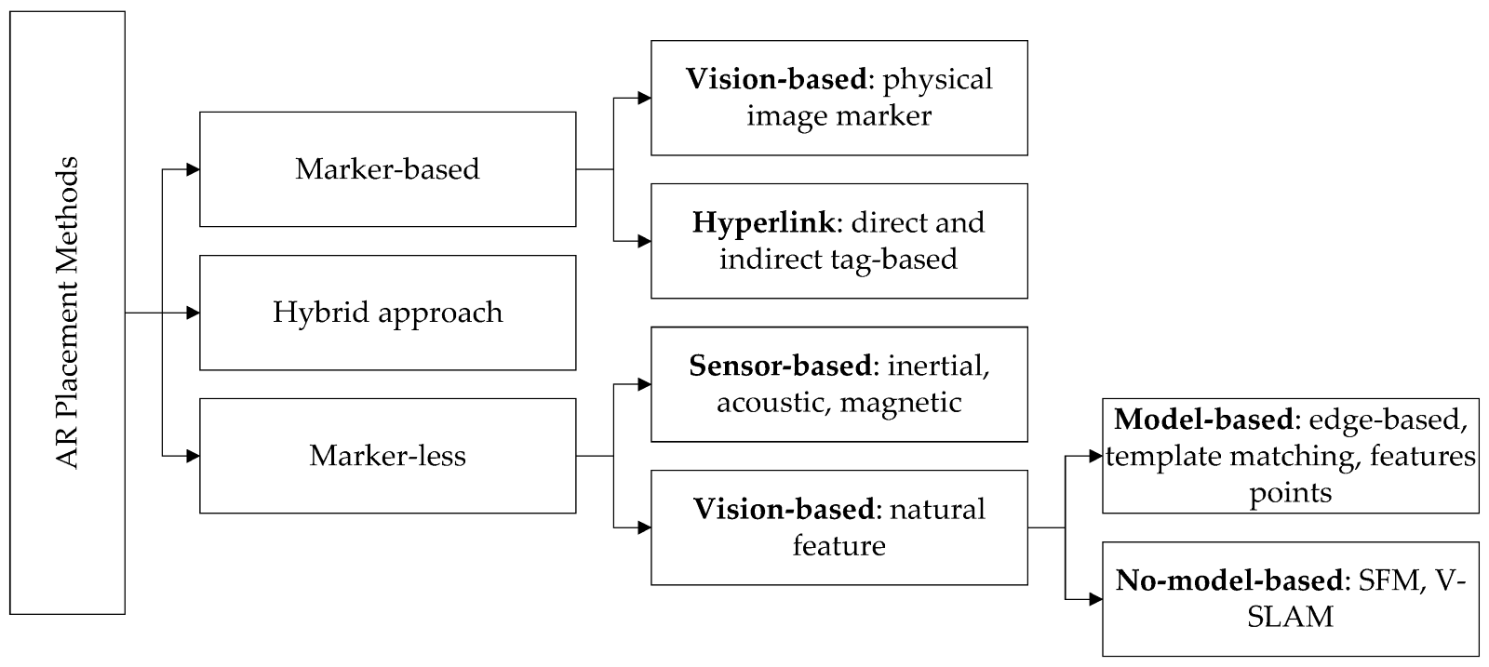

*Note.* The diagram above summarizes the method for placing 3D virtual objects. “Assessment of 3D models placement methods in augmented reality” by El Barhoumi, N., Hajji, R., Bouali, Z., Ben Brahim, Y., & Kharroubi, A. (2022). *Applied Sciences*, *12*(20), 10620.

Intelligent interaction technology - Intelligent interaction technology is closely related to various technologies, such as intelligent display technology, 3D registration technology, human factors engineering, and cognitive psychology (Chen et al., 2019). Moreover, intelligent interaction encompasses various interactions such as hardware device interaction, location-based interaction, tag-based interaction, and other information-based interactions (Chen et al., 2019). Furthermore, intelligent interaction goes beyond simply placing virtual information into the real environment, enabling interaction between people and virtual objects. Through this interaction, users can give specific instructions to virtual objects or receive feedback from virtual objects (Chen et al., 2019). Such intelligent interaction helps users of AR systems to have a better experience (Chen et al., 2019).

### **2.1.1 Classification of AR**

Generally, researchers divide AR into marker-based AR and marker less AR (Cheng et al., 2017). However, there is still no official definition for marker-based and marker less AR. Nevertheless, as their names imply, marker-based AR utilizes markers as triggers, while marker less AR can operate without markers (Cheng et al., 2017). This paper will explain the two types of AR classified in this manner below.

Marker-based AR - In the case of marker-based AR, the system needs to know where the user is and where the user is focusing. Moreover, developers can add predefined signs or markers to the system, making them detectable in the real environment, and then utilize computer vision technology to detect them. Moreover, people refer to these technologies as tracking (Boonbrahm et al., 2020). Many often create markers using 2D images, QR codes, or 3DO. Furthermore, markers identify virtual objects and their positions (Boonbrahm et al., 2020). Moreover, typically, the algorithms of Marker-based AR extract geometric features from given markers, match them with corresponding virtual objects and reference the spatial representation to display the virtual objects (Cheng et al., 2017). Furthermore, one of the critical advantages of Marker-based AR is that existing AR development tools mainly support marker-based approaches, making development more straightforward. Furthermore, Marker-based approaches are supportable on mobile and regular desktop devices, allowing for various platforms (Cheng et al., 2017). However, Marker-based approaches heavily rely on the quality of real-world markers, and issues arise if the markers become damaged, leading to the inability to place virtual objects (Cheng et al., 2017).

Marker less AR - In Marker less AR, users can place virtual objects anywhere within the camera's field of view using their smartphones' GPS and compass sensors (Boonbrahm et al., 2020). Moreover, an example of marker less AR utilizing GPS is the popular AR mobile game Pokémon Go (Boonbrahm et al., 2020). Typically, the development of Marker less AR utilizing GPS involves assigning latitude and longitude coordinates to each virtual product within the development environment. Moreover, users retrieve their current location via the GPS feature on the AR device. Then, if the difference in latitude and longitude values between the current location and virtual objects is less than 0.01 degrees, virtual objects are displayed on the device (Cheng et al., 2017). Furthermore, examples of AR systems utilizing sensors and cameras include the development of Marker less AR using platforms such as ARKit for iOS devices and ARCore for Android devices. The development tools of these two platforms leverage data from the device's motion sensors and camera to identify spatial movement across six axes, enabling precise placement of virtual objects in the real world (Boonbrahm et al., 2020). However, devices have not yet achieved a perfect level of spatial measurement. The issue with spatial measurement is the inability to determine the floor's location accurately. Technically, systems find it easy to detect floors with irregular colours but struggle with floors of uniform colour, making it challenging to place virtual objects accurately (Boonbrahm et al., 2020). The main advantage of marker less AR is that it does not require markers, reducing stability issues caused by external factors such as marker damage. Moreover, developers can utilize location technologies such as GPS, Radio Frequency Identification (RFID), Wi-Fi, or Ultra-Wide Band (UWB) to determine the position of virtual objects accurately (Cheng et al., 2017). However, marker less AR is primarily supported on mobile devices, limiting its availability across various platforms. Moreover, it lacks the diversity of development tools compared to marker-based AR, making development more complex (Cheng et al., 2017).

### **2.1.2 AR Technology**

Indeed, there are various AR technologies in the field of AR. These technologies enable users to utilize AR systems more effectively. Furthermore, these AR technologies include marker-based approaches and marker less ones. Therefore, this paper intends to investigate these technologies to identify the current AR technologies and explain their definitions.

#### **2.1.2.1 Marker Tracking**

The marker tracking technology was innovative in AR ten years ago (Wagner et al., 2008). Moreover, the first marker tracker developed for AR was Rekimoto's (1998) Matrix Code (Wagner et al., 2008). It used a square planar shape for pose estimation and a 2D barcode pattern to distinguish markers. Furthermore, Kato (1999) released ARToolKit as open-source, using a similar approach to Matrix Code (Wagner et al., 2008). Moreover, ARToolKit garnered immense popularity among AR researchers (Wagner et al., 2008). Early marker tracking systems were much less available for mobile phones compared to the many systems available for desktop computers. However, in 2004, Möhring (2004) developed a tracking solution for mobile devices, which tracks 3D marker shapes distinguished by colour (Wagner et al., 2008). Moreover, Rohs (2004) also created the VisualCodes system for smartphones (Wagner et al., 2008). However, Möhring (2004) and Rohs’ (2004) technologies provided only 2D position on the screen, 1D rotation, and very coarse distance measurements (Wagner et al., 2008). Furthermore, in 2005, Henrysson (2005) created a Symbian port based on ARToolKit, and in 2007, Rohs (2004) also utilized software for Symbian phones to track maps (Wagner et al., 2008). However, these maps are composed of regular point grids (Wagner et al., 2008). Marker tracking technology has advanced in this manner, but there are still existing challenges. In typical marker tracking, the camera captures images, and edge and corner detectors perform feature extraction (Freeman et al., 2007). Then, it analyzes these features. However, during the analysis process, various errors can occur (Freeman et al., 2007). These errors include detection errors in visual parameters, calibration errors, and errors within the analysis algorithms (Freeman et al., 2007). However, despite these errors, marker tracking systems remain popular as tracking systems.

#### **2.1.2.2 IMG Tracking**

IMG tracking or image targeting is a method of detecting and tracking images such as photographs, game boards, magazine pages, book covers, pamphlets, and other images (Indriani et al., 2016). Unlike traditional markers such as Matrix codes or QR codes, IMG tracking does not require black lines or white areas (Indriani et al., 2016). IMG tracking compares the specified images in a DB and detects and tracks the natural features of the image (Indriani et al., 2016). IMG tracking typically employs optical flow algorithms (Gorovyi et al., 2017). This approach estimates the drift of interesting pixels across adjacent camera frames. Furthermore, direct tracking methods are often applied to enhance the robustness of IMG tracking (Gorovyi et al., 2017). However, there are challenges with optical flow algorithms when there are not enough key points or if the camera movement speed is too fast, leading to the algorithm failing to recognize the image (Gorovyi et al., 2017). When considering these factors, IMG tracking can be more flexible than traditional marker tracking. Additionally, using complex images with many key points can be advantageous for tracking in IMG tracking systems.

#### **2.1.2.3 Surface Detection**

Surface detection technology in AR is a technique that detects surfaces on the device screen. Furthermore, researchers have long easily detected planes in point clouds (Kung et al., 2016). Until now, among various algorithms for extracting planes from 3D point clouds, RANSAC has been widely used (Kung et al., 2016). Furthermore, RANSAC generates a plane function based on random seeds to fit the original graph (Kung et al., 2016). However, this method is inefficient due to inappropriate local region connectivity (Kung et al., 2016). Considering these points, surface detection technology still suffers from decreased accuracy due to connectivity issues in the local region. However, as mentioned by Kung et al. (2016), there are methods such as region growing to improve accuracy. Kung et al. (2016) suggested a method of clustering points into polygon meshes based on surface average deviations, which involves vector calculations. Furthermore, Kung et al. (2016) recommended a method for classifying edges of convex and concave for curved surfaces. This method demonstrates high accuracy in surface recognition. However, there are drawbacks, as excessive segmentation may occur on broad planes, potentially demanding high-performance requirements (Kung et al., 2016). Considering these points, algorithms like RANSAC can suffice if users want simple surface recognition. However, following Kung et al. (2016)'s region-growing method is advisable for systems requiring detailed surface checking. Furthermore, surface recognition allows for determining and placing virtual objects' positions on the recognized surface.

## **2.2 Development technologies and supports related to AR Educational System**

This section introduces and defines the technologies and support required for developing AR education systems. It also provides examples of AR education system development based on Android and outlines how to develop an Android-based AR education system. By leveraging this background technology and knowledge, developers can prepare for developing AR education systems and understand how to develop AR education systems based on Android.

### **2.2.1 Development Technologies**

This section introduces the development platforms necessary for developing AR education systems, the computer languages used on these platforms, the devices required for AR development, the basic APIs used for AR development, the APIs used for mobile-based AR development, and the DBs used for AR development. The introduced platform is Unity, and the language used on this platform is C#. Furthermore, Android and Apple platforms are available for AR mobile devices. The primary APIs for AR development include AR Foundation, ARCore for Android, and ARKit for Apple. Furthermore, this section introduces Firestore as the DB used for AR development.

#### **2.2.1.1 Unity and Visual Studio**

Unity is a game engine that develops 3D and 2D video games, serving as an integrated authoring tool for creating interactive content such as AR and VR (Wikipedia contributors., n.d.a). Furthermore, Unity Technologies first unveiled Unity 3D as a game engine for Apple OSX at the Apple Worldwide Developers Conference (WWDC) in 2005 (Wikipedia contributors., n.d.a). Furthermore, according to Unity Technologies (n.d.a), as of 2016, Unity 3D accounted for 45% of the global game engine market share, making it the most popular game engine, with over 5 million registered developers. The initial versions of Unity 3D were only available for Mac OS and could only deploy Unity to a few platforms. However, starting with version 4.3.1, Unity 3D began offering support for various platforms, including Windows and Mac OS (Wikipedia contributors, n.d.a). Furthermore, currently, Unity 3D allows for creating content available on 27 platforms, including Windows, Mac OS, iOS, Android, PlayStation, Xbox, Nintendo Switch, and web browsers, and the authoring tool is available for both Windows and Mac OS (Wikipedia contributors., n.d.a). The Unity 3D engine itself comes equipped with middleware such as light mapping and physics engines, and users can access assets of various functionalities through the built-in asset store in the editor (Wikipedia contributors., n.d.a). The asset store is where Unity Technologies and community members offer a collection of free and commercial asset libraries (Unity Technologies., 2021). Furthermore, developers can access assets such as textures, models, animations, complete project examples, tutorials, and editor extension programs through the asset store (Unity Technologies., 2021). Furthermore, starting from Unity version 2020.1, the asset store window is no longer hosted within the Unity editor. However, the asset store is still accessible through the website, allowing users to purchase and download assets via the web and import them directly into the Unity project through the Package Manager window (Unity Technologies., 2021). In Unity 3D, the scripting languages used for game development are C# and JavaScript. Additionally, in Unity 3D, developers can use Unity Bolt, enabling them to visually program with shapes, making coding more accessible to non-proficient developers (Unity Technologies, n.d.a). Furthermore, developers can write or edit scripts using Windows-specific Visual Studio or Mac OS-specific MonoDevelop installed alongside Unity 3D (Wikipedia contributors, n.d.a).

Next, this section will explain Visual Studio, which developers use for scripting in Unity. Since this paper focuses on development based on Windows, this paper will exclude MonoDevelop for Mac OS from the explanation. Visual Studio is an integrated development environment developed by Microsoft for Windows, enabling programming in various languages (Wikipedia contributors., n.d.b). Developers can use Visual Studio to develop programs, websites, and web applications (Wikipedia contributors, n.d.b). Furthermore, developers can utilize Visual Studio for many functionalities, such as debugging and DB management. Microsoft's Visual Studio supports various programming languages such as C, C++, C#, and JavaScript, allowing developers to write scripts for Unity, especially using C# and JavaScript. Therefore, this paper can use the Unity game engine to build an AR environment, leverage various resources from the Unity Asset Store to design models and animations for virtual objects and write scripts for Unity using C# in Visual Studio to develop an AR educational system.

#### **2.2.1.2 AR Mobile Device**

There are various types of devices for operating AR systems. Moreover, this section will introduce and describe handheld AR devices among these various devices. Handheld devices mainly include smartphones, divided into two major platforms: Google's Android and Apple's iOS. Therefore, this section will introduce Android and iOS platforms and briefly overview the development environment.

Android - Google acquired Android Inc. in 2005 and began offering the Android platform as a free mobile operating system in 2007 (Wikipedia contributors, n.d.c). Android is a mobile operating system designed for touchscreen mobile devices such as smartphones and tablet computers, based on the Linux kernel and other open-source software (Wikipedia contributors, n.d.c). Furthermore, Android is a software stack and mobile operating system that includes an operating system, middleware, UI, and standard applications. (Wikipedia contributors, n.d.c) Android also allows developers to implement applications using the Java and Kotlin languages and offers a runtime library capable of executing compiled bytecode. (Wikipedia contributors, n.d.c). Furthermore, Android provides developers with various tools and APIs necessary for development through the Software Development Kit (SDK). (Wikipedia contributors, n.d.c). Android executes applications created in Java and Kotlin in separate processes through the Android Runtime, which differs from the traditional Java Virtual Machine (Wikipedia contributors, n.d.c). Moreover, Google distributes all Android source code under the open-source Apache v2 license, allowing companies or developers to develop and integrate their own Android programs independently. (Wikipedia contributors, n.d.c). Furthermore, Google also provides Google Play, where developers can develop and sell applications to users. (Wikipedia contributors, n.d.c). Given these points, this paper can implement an AR education system using Android's SDK and API and efficiently distribute it to users through Google Play.

IOS - Apple first introduced iOS as its iPhone, iPad, and iPod operating system in 2007 (Wikipedia contributors, n.d.d). At the time of its initial release, users were not allowed to add developed applications to iOS. However, starting in 2008, an SDK was released for developing software on iOS, allowing users to develop and distribute applications on iOS through this SDK. (Wikipedia contributors, n.d.d). Apple created iOS based on macOS and built it on the Darwin foundation, similar to the traditional macOS. Furthermore, iOS includes application frameworks such as Cocoa and Core Animation, which are elements of macOS. (Wikipedia contributors, n.d.d). Apple also provides an App Store similar to Google's Play Store, where users can develop iOS-exclusive applications and distribute or sell them through this platform. Given these points, similar to Android, developers can implement an AR education system on iOS using the SDK and API provided by Apple and efficiently distribute it to users through the App Store.

#### **2.2.1.3 AR Foundation**

AR Foundation is a framework specially designed for AR development, allowing developers to build rich experiences once and then deploy them across various mobile and wearable AR devices (Unity Technologies, n.d.a). AR Foundation allows users to access currently unavailable features when transitioning between AR platforms (Unity Technologies, n.d.a). Furthermore, when features become available on a new platform, users can easily integrate them by updating the package without the need to completely rebuild the application from scratch (Unity Technologies, n.d.a). In an AR Foundation project, users select the AR capabilities to activate by adding the corresponding manager components to the scene (Unity Technologies, n.d.a). When building and running an app on AR devices, AR Foundation utilizes the platform's native AR SDK to activate these features, enabling deployment to AR platforms with just one build (Unity Technologies, n.d.a).

The AR Foundation package includes interfaces for AR functionalities but does not implement AR features independently. (Unity Technologies, n.d.a). Therefore, separate plug-in packages for the respective platforms are required to use AR Foundation. (Unity Technologies, n.d.a). Furthermore, Unity officially provides five provider plug-ins. (Unity Technologies, n.d.a). The provider plug-ins include the Google ARCore XR plug-in for Android, the Apple XR plug-in for iOS, the Apple VisionOS XR plug-in for VisionOS, the OpenXR plug-in for HoloLens 2, and the Unity OpenXR: Meta for Meta Quest. (Unity Technologies, n.d.a). Therefore, to develop an AR educational system using AR Foundation, developers first need to choose the platform they want to target and then use the plug-in provided by that platform along with AR Foundation.

AR Foundation provides various functionalities. These functionalities include session management, device tracking, camera features, plane detection, IMG tracking, object tracking, face tracking, point clouds, raycasts, anchors, meshing, environment probes, occlusion, and participants. (Unity Technologies, n.d.a).

* Session - Sessions control the lifecycle of AR experiences by activating or deactivating AR on the target platform. (Unity Technologies, n.d.b). Sessions represent instances of AR. (Unity Technologies, n.d.b). While other functionalities can be activated and deactivated independently, sessions control the lifecycle of all AR features. (Unity Technologies, n.d.b). Turning off the AR session component means the system will no longer track functionalities. (Unity Technologies, n.d.b). However, the AR session component restores and maintains previously detected functionalities upon reactivation. (Unity Technologies, n.d.b).
* Device Tracking - Users can find a GameObject called XR Origin in AR Foundation scene settings. (Unity Technologies, n.d.c). Using the camera and tracked pose driver, the XR Origin automatically converts device tracking and trackable items into Unity's coordinate system through the XROrigin component and GameObject hierarchy. (Unity Technologies, n.d.c). The XROrigin component transforms trackable features, such as plane surfaces and feature points in the scene, into final positions, rotations, and scales. (Unity Technologies, n.d.c).
* Camera - The camera and its configuration are essential components of an AR system. In AR Foundation, available camera components include ARCamera Manager and ARCamera Background. (Unity Technologies, n.d.d). The ARCamera Manager manages the lifecycle of the XRCamera subsystem. (Unity Technologies, n.d.d). Moreover, the ARCamera Background is used to copy the texture of the colour camera to the background. (Unity Technologies, n.d.d). Next, there is a feature called Image Capture on the AR Foundation, which allows access to images captured by the device camera during the AR session. (Unity Technologies, n.d.d). Then, it saves the captured images as EXIF data. Supported EXIF data in AR Foundation includes ApertureValue, BrightnessValue, ColourSpace, ExposureBiasValue, ExposureTime, FNumber, Flash, FocalLength, PhotographicSensitivity, and MeteringMode. (Unity Technologies, n.d.d).
* Plane Detection - Plane detection is identifying and tracking flat surfaces in the physical environment. (Unity Technologies, n.d.e). Furthermore, within the plane detection feature of AR Foundation, the AR Plane Manager controls the application's plane detection functionality, and ARPlane generates trackable items for each detected plane. (Unity Technologies, n.d.e). Platforms, including Google's ARCore XR plugin, Apple's ARKit XR plugin, and Unity OpenXR: Meta, support the plane detection feature of AR Foundation. (Unity Technologies, n.d.e). The detection mode types of the AR Plane Manager consist of four categories: Nothing, which indicates no plane detection; Everything, allowing detection of planes with any alignment; Horizontal, enabling detection of horizontally aligned planes; and Vertical, facilitating detection of vertically aligned planes. (Unity Technologies, n.d.e). Furthermore, the ARPlane component in AR Foundation includes two features (Unity Technologies, n.d.e). Firstly, Destroy On Removal allows users to choose whether to destroy the GameObject of this component when they remove the trackable item for the detected plane. (Unity Technologies, n.d.e). Secondly, there is a vertex-changed threshold. (Unity Technologies, n.d.e). The vertex-changed threshold represents the maximum value by which the vertices' positions of a plane can change before triggering the boundary-changed event. (Unity Technologies, n.d.e).
* IMG Tracking - AR Foundation's IMG tracking includes the AR Tracked Image Manager. (Unity Technologies, n.d.f). The AR Tracked Image Manager is a trackable manager that can perform 2D IMG tracking. (Unity Technologies, n.d.f). The Tracked Image Manager creates GameObjects for multiple images detected in the environment. (Unity Technologies, n.d.f). Furthermore, for the Tracked Image Manager to track these images, compiled reference images must first exist in the reference image library. (Unity Technologies, n.d.f). The reason is that the Tracked Image Manager detects images only within this image library. (Unity Technologies, n.d.f). Moreover, to create this image library, users need to generate an image library from the References section in the Unity Editor and then add images by clicking the Add Image button there. (Unity Technologies, n.d.f).
* Object Tracking - AR Foundation's object tracking includes the AR Tracked Object Manager. (Unity Technologies, n.d.g). The Tracked Object Manager detects and tracks 3DO detected in the environment. (Unity Technologies, n.d.g). Furthermore, the Tracked Object Manager is also a trackable manager, similar to the Tracked Image Manager. (Unity Technologies, n.d.g). The Tracked Object Manager creates GameObjects for each object detected in the environment. (Unity Technologies, n.d.g). To enable the Tracked Object Manager to detect real objects, users must first scan and convert those objects into reference objects. (Unity Technologies, n.d.g). Then, users add the reference objects to the reference object library, which belongs to the Tracked Object Manager. (Unity Technologies, n.d.g). By scanning and adding objects of interest to the reference object library using this method, the system can track 3DO through this library.
* Face Tracking - The AR Face Tracking Manager, belonging to the AR Face Tracking, is a type of trackable manager. (Unity Technologies, n.d.h). The AR Face Tracking Manager creates GameObjects for each detected face in the environment, and this tracking manager detects only faces. (Unity Technologies, n.d.h). Furthermore, in some implementations, both the front and rear cameras of the smartphone are required for face tracking. (Unity Technologies, n.d.h). Moreover, because face tracking does not integrate well with other functionalities, such as IMG tracking or plane tracking, it is advisable to deactivate other tracking managers when using this feature. (Unity Technologies, n.d.h).
* Point Clouds - The AR Point Cloud Manager, belonging to the AR Point Cloud, is a type of trackable manager. (Unity Technologies, n.d.i). The AR Point Cloud Manager detects and tracks feature points, generating a point cloud, a set of feature points. (Unity Technologies, n.d.i). Feature points are specific points the device uses to determine its position in the real world (Unity Technologies, n.d.i). Feature points are useful functionalities typically applicable for tracking between frames (Unity Technologies, n.d.i). A point cloud is a collection of feature points that can vary from frame to frame (Unity Technologies, n.d.i). Moreover, while platforms typically construct feature points into various point clouds across diverse spaces, some generate only one point cloud (Unity Technologies, n.d.i). Furthermore, while point clouds are trackable, individual feature point tracking is not feasible (Unity Technologies, n.d.i). However, feature points have unique identifiers, enabling them to uniquely identify across frames (Unity Technologies, n.d.i). Each feature point has a position, stored as parallel arrays of vector3, ulong, and float (Unity Technologies, n.d.i). Moreover, computer vision and image processing utilize these point clouds.
* Raycasts - The AR Raycast Manager, belonging to the AR Foundation's Raycast, is also a trackable manager type (Unity Technologies, n.d.j). Ray casting, also known as hit testing, allows for determining where a ray intersects with tracking devices (Unity Technologies, n.d.j). The ray casting interface resembles the interface of the Unity physics module. However, AR Foundation provides a separate interface as AR tracking devices do not necessarily exist in the physical world (Unity Technologies, n.d.j). Typically, users utilize Raycast managers for two purposes. The first is for users to receive an API for performing single raycasts (Unity Technologies, n.d.j). The second purpose is to generate continuous ARRaycasts (Unity Technologies, n.d.j). ARRaycast is trackable and automatically updates until removed (Unity Technologies, n.d.j). However, platforms directly supporting this feature usually offer better results (Unity Technologies, n.d.j).
* Anchors - The AR Anchor Manager in AR Foundation is also a trackable manager (Unity Technologies, n.d.k). The anchor manager creates a GameObject for each anchor (Unity Technologies, n.d.k). An anchor is a point in a specific space the device wants to track (Unity Technologies, n.d.k). Devices typically undertake additional operations to update the position and orientation of anchors (Unity Technologies, n.d.k). Moreover, anchors use many resources, so this paper does not recommend using anchors excessively (Unity Technologies, n.d.k).
* Meshing - Meshing is a feature that generates meshes based on the actual shapes scanned by the device (Unity Technologies, n.d.l). The AR Mesh Manager activates and configures this feature on supported platforms (Unity Technologies, n.d.l). Therefore, to use meshing, users must first verify if their platform supports it. Additionally, every device on supported platforms does not support all the mesh manager features (Unity Technologies, n.d.l). To use meshing with AR Foundation, users must add the ARMesh Manager as a child GameObject of the XR Origin in the scene (Unity Technologies, n.d.l).
* Environment Probes - Environment probes capture authentic images from the camera and use that information to construct environment textures, such as cube maps, containing views from all directions at specific points in the scene (Unity Technologies, n.d.m). Using this environment texture to render 3DO allows the real image to be reflected onto the rendered objects, generating reflections and lighting of virtual objects influenced by the real-world view (Unity Technologies, n.d.m). Moreover, environment probes can be placed at real locations to capture environment texturing information (Unity Technologies, n.d.m). Additionally, each environment probe possesses scale, orientation, position, and bounding volume size (Unity Technologies, n.d.m). The scale, orientation, and position properties define the transformation of the environment probe relative to the XR origin (Unity Technologies, n.d.m). The bounding size defines the volume around the position of the environment probe (Unity Technologies, n.d.m). Furthermore, an infinite boundary size indicates that the environment texture can serve for global lighting (Unity Technologies, n.d.m). In contrast, a finite bounding size indicates that the environment texture captures local lighting conditions in a specific area around the probe (Unity Technologies, n.d.m). Users can place environment probes manually, automatically, or using both methods (Unity Technologies, n.d.m).
* Occlusion - This function occludes AR content with real-world objects and performs human segmentation (Unity Technologies, n.d.n). When users add an AROcclusionManager component to a camera with the ARCameraBackground component, it automatically includes depth information in the background rendering pass (Unity Technologies, n.d.n). This method allows rendered objects to be occluded by shapes detected in the real world (Unity Technologies, n.d.n). For example, on devices that support human occlusion, it detects when a person occludes rendered content behind them (Unity Technologies, n.d.n). The AROcclusion Manager component exposes per-frame images representing depth or stencil information (Unity Technologies, n.d.n). Integrating these depth images into the rendering process is a great way to realistically blend AR content with real-world content by allowing physical objects nearby in the shared AR space to occlude virtual content behind them (Unity Technologies, n.d.n). The supported types of depth images consist of environmental depth, human depth, and human stencil (Unity Technologies, n.d.n). Environmental depth is the distance to all parts of the environment within the camera's field of view on the device (Unity Technologies, n.d.n). Human depth is the distance to humans recognized within the camera's field of view on the device (Unity Technologies, n.d.n). The human stencil is a value that specifies whether a recognized human exists at each pixel (Unity Technologies, n.d.n). Developers can implement a more realistic AR system by leveraging these occlusion techniques.
* Participants - The AR Participant Manager, responsible for the participants' function in the AR Foundation, is a trackable manager (Unity Technologies, n.d.o). Moreover, participants are users within a multi-user collaboration session (Unity Technologies, n.d.o). However, this feature is supported only on some platforms (Unity Technologies, n.d.o). Like all trackable items, participants can identify themselves with a unique ID (Unity Technologies, n.d.o). Participants can add, update, or remove themselves, indicating actions such as joining a collaboration session, updating participant poses, or ending a collaboration session (Unity Technologies, n.d.o). The system automatically detects participants; users cannot create or destroy participants (Unity Technologies, n.d.o). This function lets us track different devices in a shared AR session (Unity Technologies, n.d.o).

#### **2.2.1.4 ARCore**

ARCore is Google's platform for building AR experiences (Google, n.d.a). ARCore utilises various APIs, enabling devices to detect the environment and allow users to interact with information (Google, n.d.a). Furthermore, developers can utilise ARCore APIs to provide shared AR experiences on Android and iOS (Google, n.d.a). ARCore has three main features, allowing users to integrate virtual content seen through the smartphone's camera with the real world using these features (Google, n.d.a). These three features include motion tracking, environmental understanding, and light estimation (Google, n.d.a). Moreover, with the first feature, motion tracking, users can use the device to orient and track their position relative to the surrounding world (Google, n.d.a). This feature utilises the device's camera to identify feature points and then tracks the movement of these points (Google, n.d.a). ARCore combines the movement of these points with readings from the inertial sensors to determine the device's position and orientation as it moves through space (Google, n.d.a). Next, through the second feature, environmental understanding, the device can detect the size and location of all types of surfaces, such as floors, walls, and inclined surfaces, both horizontal and vertical (Google, n.d.a). Furthermore, this feature allows ARCore to seamlessly integrate objects, annotations, or other information into the real world (Google, n.d.a). Next, through the last feature, light estimation, the device can estimate the current lighting conditions of the environment (Google, n.d.a). Google designed ARCore to operate only on validated Android devices running Android 7.0 or higher (Google, n.d.a). AR Foundation features supported by ARCore include Session, Device tracking, Camera, Plane detection, IMG tracking, Face tracking, Point clouds, Raycasts, Anchors, Environment probes, and Occlusion (Unity Technologies, n.d.a).

#### **2.2.1.5 Firestore**

Cloud Firestore is a flexible and scalable NoSQL cloud DB based on Google Cloud infrastructure, used to store and synchronize data used in client-side and server-side development (Google, n.d.b). Firestore is a mobile, web, and server development DB utilising Firebase and Google Cloud (Google, n.d.b). Firebase provides real-time listeners to maintain data synchronization between client applications and provide offline support for mobile and web, enabling systems to respond seamlessly regardless of network delays or internet connectivity (Google, n.d.b). Firestore can easily integrate with other Firebase and Google Cloud products, including Cloud Functions (Google, n.d.b). The key features of Firestore include flexibility, expressive querying, real-time updates, offline support, and designed to scale (Google, n.d.b). Firestore supports a flexible hierarchical data structure for its data model (Google, n.d.b). Secondly, Firestore allows for fetching individual documents using queries or retrieving all documents in a collection that matches query parameters (Google, n.d.b). Furthermore, Firestore enables the application of multiple filters connected to queries and allows a combination of filtering and sorting (Google, n.d.b). Additionally, these capabilities correspond to expressive queries (Google, n.d.b). Thirdly, Firestore updates data in real-time across all connected devices using data synchronization, similar to real-time DBs (Google, n.d.b). Fourthly, Firestore caches data used in the application, allowing the application to read, write, listen to, and query data even when the device is offline (Google, n.d.b). Lastly, Firestore enables scalable architecture utilizing robust infrastructure such as automatic multi-region data replication, consistency guarantees, atomic batch operations, and support for real transactions (Google, n.d.b). Utilizing Firestore with these features, developers can efficiently use it as the DB for our AR system.

### **2.2.2 Development Android AR System**

This section introduces a case study of developing an Android-based AR system and outlines the development process. The method introduced here helps us understand how to proceed with the development of an Android AR system.

Alam et al. (2019) developed an AR educational system for elementary students in Bangladesh based on Android devices. Alam et al. (2019) utilized Vuforia, an AR authoring software platform, for target detection to detect objects. Vuforia supports the development of AR systems for Android, iOS, and UWP devices (Alam et al., 2019). Furthermore, in 2017, Unity integrated the Vuforia engine, making it easier to create cutting-edge AR systems for portable and wearable devices (Alam et al., 2019). Vuforia is the most widely used platform in the world for AR development and supports all the latest devices (Alam et al., 2019). Vuforia offers innovative features such as Model Target, Ground Plane, Image Target, and Vuforia Fusion (Alam et al., 2019). Vuforia engine integration with Unity and native platforms allows users to access it alongside the Unity editor, enabling installation through the Unity Download Assistant or the editor's XR Settings panel (Alam et al., 2019). Alam et al. (2019) used C# scripting in Unity for the development process. The script can contain various information and commands (Alam et al., 2019). Alam et al. (2019) configured scripts so the engine could know how and when to use the information. Moreover, another challenge in scripting is determining where to place the scripts (Alam et al., 2019). Because player interactions and other factors, such as time, influence some scripts (Alam et al., 2019). Furthermore, scripts operate the system's objects (Alam et al., 2019). In the creation section of the Unity platform, desired objects such as 3D models, lighting, and cameras can also be created (Alam et al., 2019). Finally, to deploy the developed system on Android devices, Java Development Kit and Android SDK are required (Alam et al., 2019). First, users need to download the latest version of JDK and add the Android SDK to the Unity build properties (Alam et al., 2019). Next, users must connect the Android device to the computer and enable debug mode (Alam et al., 2019). To use the IL2CPP scripting backend for Android, users need the Android Native Development Kit (NDK) (Alam et al., 2019). NDK includes the toolchain for building the required libraries (Alam et al., 2019). Then, the android output package (APK) is generated (Alam et al., 2019). When building the APK for the first time, users can find this in the folder where they installed the Android JDK and NDK (Alam et al., 2019). Using Vuforia for target detection and the Unity platform, developers can develop an Android AR system and generate the APK for deployment through these methods.

Lu et al. (2021) designed a mobile campus navigation application by combining visual inertial odometry and ARCore-based virtual and real fusion technology based on the research progress and application status of navigation and positioning technology in China and abroad. Google provides the ARCore used here, and this ARCore offers APIs for all essential AR functions, such as motion tracking, environmental understanding, and lighting estimation (Terzopoulos et al., 2021). Through these features, developers can build entirely new AR experiences for Android devices or enhance existing systems (Terzopoulos et al., 2021). Google offers ARCore utterly free of charge and is available only on Android devices (Terzopoulos et al., 2021). Furthermore, to use ARCore applications, they must be certified by Google, and the quality of the camera, motion sensors, and design architecture must be verified to ensure they function as expected (Terzopoulos et al., 2021). Unlike Vuforia, which primarily focuses on image-based target detection, ARCore recognizes the surrounding environment through the phone's camera, tracks the device's position and orientation functionally, and implements AR without relying on markers or images, using various sensors. Lu et al. (2021) used ARCore in navigation development to overlay virtual paths onto the real environment. Moreover, using the camera, they integrated 3D augmented information with actual buildings to enhance the user's sensory experience (Lu et al., 2021). Additionally, Lu et al. (2021) used visual odometry and inertial sensors for localization and map creation to address the problem of GPS not providing satisfactory localization accuracy for users in outdoor situations. As a result, this system can provide high precision in indoor and outdoor environments (Lu et al., 2021). Lu et al. (2021) utilized Unity as the development platform for this system. Furthermore, by writing scripts provided by Unity, they designed the system to enable rich interaction between humans and computers, accommodating various scenarios and user demands (Lu et al., 2021). Finally, this system provides users with a sense of interaction with the system by offering a large amount of AR content, such as 3D text, voice, video, and other information, through a DB (Lu et al., 2021). Developers can implement marker less AR systems that do not rely on markers or images by utilizing various sensors such as the camera, GPS, and inertial sensors on Android through ARCore provided by Google. However, while Vuforia supports iOS-based devices, developing AR systems through ARCore excludes their use on iOS devices, necessitating the implementation of AR systems anew using ARKit, supported by Apple.

After examining case studies and methods of implementing AR systems using Vuforia and ARCore, it became evident that each has its strengths and weaknesses. One advantage of Vuforia is its support for various platforms, such as Android and iOS. However, Vuforia primarily focuses on image or marker-based target detection. Therefore, users can only use Vuforia for marker-based recognition of pre-defined images or objects. Unlike Vuforia, ARCore enables the development of marker less AR systems based on utilizing the camera and various sensors of Android devices, and it also allows for the implementation of marker-based AR systems using markers or images. However, ARCore restricts the use of AR systems to Android devices only. Therefore, users must redevelop the AR system using ARKit to use AR systems on iOS-based devices. Hence, developers must compare these pros and cons to set the development platform according to the AR system developers want to create. Therefore, this paper recommends using Vuforia to create marker-based AR systems that support both Android and Apple simultaneously and using ARCore to create AR systems that leverage various sensors of Android devices.

## **2.3 Convenience Educational System for the disabled**

This section introduces how individuals with disabilities can use the education system more efficiently. Individuals with disabilities often encounter significant inconvenience when using applications compared to those without disabilities. For example, individuals with visual impairments find it difficult to click buttons or read text on the screen because they cannot visually perceive information on the system. Furthermore, individuals with hearing impairments rely heavily on visual cues to receive information differently from the general population because they cannot hear the audio of the application. Moreover, individuals with mobility impairments often make many mistakes when clicking the button when using applications due to difficulties in movement. Besides these examples, there are various issues, such as colour blindness, causing inconvenience when using applications. This section will explore and introduce the essential features necessary for individuals with disabilities to utilize applications to alleviate these inconveniences. Furthermore, this section explores the implementation methods of AR systems accessible to individuals with disabilities and investigates their positive impacts on users.

### **2.3.1 Convenience features for disabilities**

This section introduces accessibility features designed to reduce the inconvenience faced by individuals with disabilities when using applications and explains their effectiveness. This section introduces features such as STT, Vibration notification, and Audio Guide for individuals with visual impairments. Furthermore, this section will investigate and introduce UI designs for individuals with hearing impairments, mobility impairments, and colour blindness.

#### **2.3.1.1 STT**

As the name suggests, STT is a technology that converts speech into text. According to Shadiev et al. (2014), STT technology has enhanced learning abilities for students with learning disabilities, physical impairments, international students, and online learners. In particular, STT is very helpful for individuals who experience difficulties in reading, writing, or spelling due to motor, visual, or specific learning disabilities (Shadiev et al., 2014). Shadiev et al. (2014) noted that students with hearing impairments often have difficulty accessing the information content because they focus on reading sentences or interpreting the shape of an interpreter's lips. The reason is that these students must simultaneously focus their visual attention on reading the interpreter's lips and taking notes, which can be very challenging (Shadiev et al., 2014). Therefore, applying assistive technologies such as speech recognition technology for these students enables them to read the interpreter's lips and the text while simultaneously taking notes, which enhances learning (Shadiev et al., 2014). Furthermore, speech recognition and STT technology can address the challenges that students with mobility impairments often face in writing letters. The same applies to individuals with visual impairments. Individuals with visual impairments cannot verify the text they have written, and using speech recognition and STT technology can solve this issue by substituting typing with speech, thereby enhancing learning abilities. In addition to enhancing the learning abilities of individuals with disabilities, STT also benefits online students. Network traffic congestion in synchronized cyber classrooms can degrade audio quality (Shadiev et al., 2014). This degradation in audio quality makes it difficult for students and instructors to clearly understand each other's speech (Shadiev et al., 2014). Furthermore, this issue makes it difficult for students to comprehend the lectures delivered, and instructors also find it challenging to ascertain whether students are actively participating in the class (Shadiev et al., 2014). Utilizing STT technology can address these issues. The reason is that the technology immediately converts the speech of students and instructors into text, allowing both parties to communicate information without any gaps in conversation. Applying these methods to educational systems, converting students' speech into text and recording it in a DB as they progress through their learning, can make it more effective for instructors to assess students' achievements. Finally, STT also proves to be highly beneficial for international students. Shadiev et al. (2014) noted that this technology is immensely helpful for foreigners learning a second language like English. Through this STT, there are many differences when comparing texts generated from the speech of foreigners and texts generated by native speakers (Shadiev et al., 2014). Moreover, through this comparison, foreigners can quickly correct their pronunciation visually. This research has discovered that using STT can play a significant supportive role in the learning of individuals with disabilities, foreigners, and diverse students. By employing these methods, it is evident that various students can access AR educational systems more comfortably.

#### **2.3.1.2 Vibration notification**

Vibration notification, as the name suggests, is a technology used to notify users of information through vibration. Moreover, depending on how one utilizes it, vibration technology offers various benefits to individuals with visual or hearing impairments. Omata and Kuramoto (2020) discussed various applications of vibration technology, including tactile representation of braille characters on smartphones using touch screens and vibration, using vibration to indicate walking locations for individuals with visual impairments, text communication methods using vibration, and utilizing a combination of vibration motors and accelerometers to transmit information between smart devices. Omata and Kuramoto (2020) also conducted experiments to compare the effectiveness of vibration and ringtone sounds. In these experiments, they used various ringtone volumes and vibration intensities. The results showed that vibrations provide a quieter environment, lower disturbance, and less attention diversion to other users than ringtone sounds (Omata & Kuramoto, 2020). Furthermore, Omata and Kuramoto (2020) proposed a method for visually impaired individuals to distinguish colours, objects, or specific areas on a touchscreen using vibration-tactile interaction. This method applies vibrations with varying intensity for each colour, object, or specific area. By employing different intensities of vibrations, visually impaired users can more easily discern colours, objects, and specific areas. This method enhances the system's accessibility for users. Furthermore, Omata and Kuramoto (2020) also mentioned the vibration feedback function. This vibration feedback lets users quickly identify any issues arising while using the system. Developers can apply the use of such vibrations to AR educational systems, enabling people with disabilities to quickly discern the purpose of buttons or various areas, thereby enhancing the accessibility of the system. Furthermore, this paper believes that during learning, using vibration feedback to indicate whether an answer to a question is correct or incorrect can allow individuals with disabilities to quickly and accurately verify their answers, thereby increasing learning efficiency.

#### **2.3.1.3 Audio guide**

Audio guides, as the name suggests, are a technology used to deliver auditory information to users. Moreover, audio guides benefit individuals with visual impairments depending on their utilisation. For individuals with visual impairments, viewing visual components is limited. Therefore, developers need a method to describe visual elements for individuals with visual impairments during system development, and audio descriptions fulfil this need (Petrie et al., 2005). Furthermore, developers need to pay attention to the design of the UI to apply these audio descriptions (Petrie et al., 2005). For instance, the additional time required for visually impaired individuals to navigate UI, such as operating keyboards, finding toolbars with a mouse, or touching the screen, may conflict with listening to audio descriptions (Petrie et al., 2005). Therefore, developers must allocate temporal allowances for users and subdivide time to find the optimal moment for adding audio descriptions, considering the system's users. This approach enables users with visual impairments to use the system more efficiently. Moreover, there are no algorithmic methods for generating audio descriptions for individuals with visual impairments (Petrie et al., 2005). So, developers must consider adding audio descriptions for each content during system implementation. Applying such audio guides to AR educational systems would enable visually impaired individuals to perceive various contents auditorily, facilitating easy access to the system. Moreover, audio guides allow general users to engage their visual and auditory senses simultaneously, enhancing their concentration during education. Additionally, Petrie et al. (2005) recommended sign language videos for individuals with hearing impairments. However, since the AR educational system described in this paper utilises AR technology to visually convey information by placing 3DO in the real world, it surpasses the effectiveness of sign language videos. Therefore, this paper did not include a separate introduction to sign language.

#### **2.3.1.4 UI design for disabilities**

To design UI for people with disabilities, it is necessary first to understand the requirements of disabled users (Lopes, 2001). The requirements of disabled users include limits to input devices used, object size, colour, animations, coordination, reading, and writing (Lopes, 2001). These requirements are of great help to developers in creating UI for people with disabilities. First, let us discuss the limitations related to input device use. People with severe disabilities have limited hand control (Lopes, 2001). Some people with cerebral palsy can somewhat control their hands but typically cannot use their fingers and have limited hand movements (Lopes, 2001). People with these disabilities find it difficult to accurately point to and click on icons on the screen (Lopes, 2001). Therefore, icons should be sufficiently large to be easily clickable for these individuals (Lopes, 2001). Another issue is that individuals with cerebral palsy tend to continue pressing a device once they click it (Lopes, 2001). Individuals with these disabilities often find simple single-click actions quite challenging (Lopes, 2001). Therefore, pressing and releasing buttons may be significantly prolonged (Lopes, 2001). Therefore, developers should consider these prolonged pressing actions when designing the UI. Additionally, depending on the severity of the disability, there are also individuals with disabilities who press buttons for a long time and cannot release, thus performing drag-and-drop actions (Lopes, 2001). Developers should also consider these situations when designing UIs. Therefore, developers should design the system to allow buttons to function even when performing actions like drag-and-drop. Alternatively, the swipe-and-click method Lopes (2001) recommended is also one approach. The second description is about Object Size, Colour, and Animation. The size, colour, and animation of icons are crucial (Lopes, 2001). Individuals with severe disabilities indeed have visual issues (Lopes, 2001). Therefore, individuals with such disabilities find it difficult to distinguish between foreground and background due to poor colour contrast (Lopes, 2001). On the other hand, when there is too much contrast due to bright colours, regular users may not be able to see the content displayed on the screen because their eyes cannot simultaneously process areas with a significant difference in brightness (Lopes, 2001). Therefore, most web pages use white as the predominant colour (Lopes, 2001). Additionally, if text characters are too large, users may encounter difficulties viewing the entire page (Lopes, 2001). Therefore, developers should carefully consider these aspects when designing UIs. Moreover, generally, animations are not highly recommended (Lopes, 2001). The third description is about coordination. Generally, individuals with severe disabilities often experience difficulties even with simple button clicks (Lopes, 2001). Therefore, it is a good approach for developers to consider alternative methods for individuals with disabilities to access the system and coordinate it to be usable through these methods (Lopes, 2001). Finally, this section will explain reading and writing. Generally, individuals with severe disabilities, especially those with conditions like quadriplegia or those who acquired disabilities early in life, find it challenging to engage in reading or writing (Lopes, 2001). Therefore, it is preferable for developers to design UI using graphic languages such as Picture Communication System (PCS) or Makaton rather than using plain text for individuals with disabilities (Lopes, 2001). This section has analyzed the requirements of users with such disabilities, and based on this, applying them to the UI of the AR educational system can create an educational system accessible to a wide range of users.

### **2.3.2 AR Educational System for disabilities**

This section introduces the methods and tools required to create an AR system for individuals with disabilities and the positive impacts that this system can have on users.

AR, VR, and MR provide new ways for digital media and users to interact (Biswas et al., 2021). However, individuals with diverse abilities have yet to widely utilise these technologies (Biswas et al., 2021). Due to this reason, commercial AR systems still receive limited adoption among individuals with disabilities and the elderly, as they remain confined to specialised hardware and software (Biswas et al., 2021). However, recent research by Biswas et al. (2021) investigated accessibility technologies for AR that various individuals with disabilities can use. One includes various multimodal interaction technologies for AR media (Biswas et al., 2021). Multimodal feedback allows a broader range of users to utilise it compared to traditional AR systems that rely solely on visual output (Biswas et al., 2021). Furthermore, using spatial audio interaction tools and technologies can enable individuals with visual impairments to access AR systems (Biswas et al., 2021). Moreover, SeeingVR is a recent research tool on Unity Store designed for individuals with visual impairments (Biswas et al., 2021). Another technology includes AR-based educational tools with voice and olfactory feedback designed for students with cognitive impairments (Biswas et al., 2021). Additionally, there are user research sets related to robot manipulators for users with severe motor impairments and integrated eye-controlled video transparency systems (Biswas et al., 2021). Furthermore, Biswas et al. (2021) stated that through research collaboration between the University of Maryland, Baltimore County (UMBC) and the University of Washington, they developed the Robot Web Interface Suite, which supports individuals with disabilities through five different approaches utilising AR, multimodal interaction, various visual observations, and machine learning algorithms. Additionally, AR systems utilising such technologies are helpful for healthy individuals (Biswas et al., 2021). For example, mobile amplification controls for individuals with hearing impairments can be helpful in noisy environments (Biswas et al., 2021). Furthermore, audio cassette versions of books for individuals with visual impairments and subtitles for individuals with hearing impairments make information more easily understood by the general user (Biswas et al., 2021). Developers can implement AR educational systems that positively impact individuals with disabilities and general users by applying appropriate technologies to the AR systems.

## **2.4 Conclusion**

This chapter introduces background knowledge about AR, such as concepts, features, types of technology, and structure. Additionally, this chapter categorizes AR into Marker-based and Marker less and introduces corresponding AR technologies. AR technologies include Marker tracking and IMG tracking, which belong to Marker-based AR, and Surface detection, which falls under Marker less AR. Furthermore, this chapter introduces the tools and support necessary for implementing AR educational systems. Essential tools for implementing an AR educational system include the development platform Unity, AR support tools such as AR Foundation, and mobile development platforms like ARCore and ARKit. Lastly, this chapter introduces accessibility features for individuals with disabilities to implement an AR educational system tailored to their needs. These accessibility features include STT, Vibration notifications, Audio guides, and UI designs. This chapter introduced this background knowledge about AR, and this paper will implement an AR English educational system using these methods.

# **3. Literature Review**

## **3.1 Introduction**

This chapter presents a literature review to implement an AR educational system that individuals with disabilities can use. The researcher conducted a literature review by searching for papers on Google Scholar. Additionally, the researcher found 29 papers relevant to the purpose of this study and reviewed each paper by reading all of their texts. Furthermore, the researcher created six themes related to the purpose of this study and classified the reviewed papers into each theme. This chapter comprises the following themes: Benefits and Challenges for the AR Educational System, Requirements Analysis for AR Application Development, Perception and Preparedness of Educators for AR Educational Systems, Personalized AR Educational System for Various Students, The Impact of AR Educational System on students with disability, and Approaches to Enabling Accessibility for Individuals with Disabilities in AR Systems. As a result of classifying the papers into themes, the first theme comprised eight papers, the second theme comprised six papers, the third theme comprised four papers, the fourth theme comprised two papers, the fifth theme comprised three papers, and the sixth theme comprised six papers. The researcher will review the papers according to the themes to find the necessary information for implementing the AR educational system and apply it accordingly.

## **3.2 Benefits and Challenges for the AR Educational System**

Today, educational systems utilizing AR offer many advantages to students. However, there are also many challenges in applying these AR educational systems to the educational environment. Therefore, the researcher must highlight the benefits of AR educational systems and work towards improving the challenges to develop AR educational systems. Hence, the researcher conducted a literature review by finding eight relevant papers to analyze AR educational systems' benefits to learners and the challenges encountered in implementing current AR educational systems. Firstly, the advantages of AR educational systems can be found in the papers by Radu et al. (2022), Sáez-López (2022), Hatta et al. (2022), Soraya (2022), and Salmiyanti et al. (2023). Radu et al. (2022) stated that AR enhances specific cognitive, motivational, and social processes. Sáez-López (2022) and Hatta et al. (2022) mentioned that AR makes education enjoyable and enhances learning. Soraya (2022) noted that AR has advantages suitable for remote learning, while Salmiyanti et al. (2023) said that AR's visual capabilities contribute to increased educational efficiency. However, Zuniari et al. (2022), Marrahí-Gómez and Belda-Medina. (2022), and Cevikbas et al. (2023) mentioned challenges such as accessibility, educational system integration, technical issues, and costs.

Currently, educators have a significant interest in AR and virtual reality (VR), as noted by Radu et al. (2022). Radu et al. (2022) points out that one of the reasons for this is that AR combines 3D graphics with the real world, enabling experiences that would be impossible in reality. Therefore, Radu et al. (2022) indicates that educators evaluate AR technology as having significant educational potential. Furthermore, Radu et al. (2022) expects these AR technologies to accelerate students' learning and transform educational methods. However, Radu et al. (2022) notes that there still needs to be a more systematic understanding regarding whether AR technology is effective or ineffective in education. Furthermore, Radu et al. (2022) mentions that large-scale implementation of AR technology in classroom settings is still challenging. So, Radu et al. (2022) wrote this paper to comprehensively address public opinions about AR in education and synthesize scientific research findings on this technology's realistic advantages and disadvantages. Radu et al. (2022) used academic papers and website posts as datasets for this research. Radu et al. (2022) collected academic papers, including recent publications, peer-reviewed papers from conference journals, educational AR systems, statistical analyses, and AR research. Furthermore, Radu et al. (2022) gathered 2023 papers, applied filters to remove duplicates, and ultimately selected 39 papers for the study. In addition, Radu et al. (2022) collected websites, including recent publications, blogs, educational AR systems, and discussions about AR programs. Moreover, Radu et al. (2022) conducted Google searches using the keywords ("augmented reality") AND ("teachers" OR "education" OR "classroom" OR "students" OR "learning"). Furthermore, after finding 83 websites and applying filtering criteria, Radu et al. (2022) selected 53 websites. As a key conclusion drawn from this study, Radu et al. (2022) discovered that AR enhances specific cognitive, motivational, and social processes. Furthermore, Radu et al. (2022) identified popular subjects and AR applications while uncovering various factors educators should consider when integrating AR into the classroom. Through this research, the researcher can identify the benefits of AR and the factors that educators should consider when implementing AR. These conclusions will assist educators in creating content that enhances the learning experience for students even further.

Furthermore, AR educational systems make mundane essential education more enjoyable, enhancing learners' learning abilities. According to Hatta et al. (2022), people refer to English as a global language and use it to communicate between countries. Moreover, Hatta et al. (2022) said that the United Nations (UN) has also officially recognized English as one of its public languages. Furthermore, Hatta et al. (2022) stated that communicating effectively in English is highly important. So, according to Hatta et al. (2022), even in countries where English is not in everyday use, governments actively encourage students to learn English. Furthermore, Hatta et al. (2022) emphasized that for meaningful English learning, educators need innovative teaching methods to capture students' interest. Therefore, Hatta et al. (2022) wrote this paper intending to develop a media application for English education using smartphone-based AR technology. Hatta et al. (2022) developed the English educational system utilizing AR in an Android environment to build this system. Additionally, Hatta et al. (2022) chose a marker less approach and used the Vuforia SDK toolkit for the development process. Hatta et al. (2022) designed this application with ten objects and created a questionnaire to test the application. Moreover, Hatta et al. (2022) made a seven-question questionnaire about learners' interest in English learning through AR-based educational media. Additionally, Hatta et al. (2022) introduced a 5-point scale to this questionnaire. Next, Hatta et al. (2022) administered tests to kindergarten and first and second-grade students in Samarinda, East Kalimantan Province, Indonesia, and obtained results through their completed questionnaires. Hatta et al. (2022) main conclusion drawn from their study is that survey participants largely agreed that English education through AR makes learning enjoyable and is suitable for use during the learning process. These advantages also engage learners in dull English education, improving their learning abilities.

Furthermore, the researcher can enhance the benefits of AR educational systems that stimulate this interest, thereby increasing efficiency. Sáez-López (2022) mentioned that there has been an increase in research promoting education through game-based learning recently. Moreover, Sáez-López (2022) stated that these approaches influence reasoning abilities, leadership, collaborative skills, and learning motivation in elementary education. However, Sáez-López (2022) noted that researchers have conducted relatively less research on the outcomes of applying game-based learning and AR in classroom environments. So, Sáez-López (2022) wrote this paper intending to analyze the impact of integrating ubiquitous game approaches and AR on learning. Sáez-López (2022) conducted quasi-experiments involving elementary school students to achieve the research objectives and derived conclusions from the experimental data. Sáez-López (2022) recruited 91 participants from sixth-grade elementary school students enrolled in art education classes. Additionally, Sáez-López (2022) included pre-tests and post-tests in the quasi-experiment. Moreover, in the pre-test, Sáez-López (2022) had students locate images of artworks related to European art history within their surroundings and utilized the AR application WallaMe to help them learn information like the title of the artwork, the artist's name, and the country of origin. Next, Sáez-López (2022) evaluated students' academic achievements in the post-test and distributed questionnaires to analyze motivation, dedication, enjoyment level, and collaboration variables. Sáez-López (2022) noted that this experiment showed statistically significant improvements among students in academic achievement, motivation, information retrieval and analysis, enjoyment level, and collaboration. In conclusion, Sáez-López (2022) asserted that integrating AR and ubiquitous game approaches enhances teaching and learning processes and facilitates innovation. By implementing methods like this to make education more gamified, the researcher can further enhance the advantages of the educational system.

Furthermore, AR educational systems can effectively operate remote learning. Soraya. (2022) mentioned that due to the recent COVID-19 pandemic, all countries are implementing social distancing measures. Furthermore, Soraya (2022) noted that these distancing measures have particularly impacted education. Soraya (2022) mentioned that traditional education usually involves interactions between teachers and students, but the outbreak of infectious diseases has led to suspending all in-person classes. As a result, it has become challenging to continue education in a usual manner. However, Soraya (2022) mentioned that in AR-enabled learning, students can engage in education virtually and proceed with their studies more normally. Therefore, Soraya (2022) wrote this paper to develop Android-based educational media using AR technology to address these issues. Furthermore, Soraya (2022) stated that the learning media includes materials and object images, daily quizzes accessible through links, and user manuals. Finally, Soraya (2022) developed the application in APK format and generated a barcode for easy distribution. Soraya (2022) referred to the ADDIE development model for the development process. Soraya (2022) mentioned that ADDIE consists of the phases of Analysis, Design, Development, Implementation, and Evaluation. Soraya (2022) chose the ADDIE model because it offers versatility in applying it to the development of various types of products. Soraya (2022) stated that these five phases constitute frameworks with distinct objectives and functions, each playing a different role in educational design. As a central conclusion of the study, Soraya (2022) reported that the validation results from media experts were 88%, while the validation results from instructional material specialists were 95%. Soraya (2022) said that this indicates that the application successfully met high school students' requirements as a learning medium. Furthermore, Soraya (2022) mentioned that this application provides a sense of conducting laboratory experiments as if in a real laboratory setting. These advantages of AR educational systems allow learners to study anytime and anywhere.

Additionally, AR educational systems provide learners with visualization, enhancing learning. Salmiyanti et al. (2023) reviewed the literature on using AR in education in this paper. Salmiyanti et al. (2023) conducted the literature review by searching for relevant material. Salmiyanti et al. (2023) noted that the literature study includes concise descriptions of the research topic and organizes them based on chronology and themes. Additionally, Salmiyanti et al. (2023) explained that the literature review focuses on ideas within the research field and encompasses theories and case studies. Furthermore, Salmiyanti et al. (2023) indicated that they conducted data collection through various research papers and that the collected theories support the topic of the study. Finally, Salmiyanti et al. (2023) edited the data and connected it to relevant theories. As a conclusion of this study, Salmiyanti et al. (2023) stated that AR, a technology that consistently visualizes two-dimensional or three-dimensional objects, can enhance student's learning processes in education. Additionally, Salmiyanti et al. (2023) mentioned that it is possible to further develop AR into advanced learning tools with the current technology. This visualization technology allows learners to experience educational content firsthand, increasing the focus and efficiency of their learning.

Despite these advantages, AR educational systems have yet to achieve full commercialization due to various challenges. Zuniari et al. (2022) pointed out that weaknesses in science learning arise from learning techniques and materials that emphasize memorization factors. So, Zuniari et al. (2022) emphasized the need for educators to have supportive means of teaching. Therefore, Zuniari et al. (2022) conducted this research to verify the learning effectiveness of the AR system ARLOOPA, which supports solar system education. Additionally, Zuniari et al. (2022) pointed out that this research could determine whether this application enhances students' comprehension, critical thinking skills, and questioning abilities. Zuniari et al. (2022) employed a quasi-experimental research method using a qualitative approach for this study. Furthermore, Zuniari et al. (2022) stated that the quasi-experimental research method utilized a pre-test and post-test control design. Zuniari et al. (2022) developed a 3D interactive AR learning media for this study, and ARLOOPA supports this program. Moreover, Zuniari et al. (2022) selected students from two Semboro State Elementary School classes for the testing phase. Zuniari et al. (2022) included 28 students from the first class as control group participants and 28 students from the second class as experimental group participants in the research. Furthermore, Zuniari et al. (2022) experimented using a mixed-methods approach. Zuniari et al. (2022) concluded from this research that AR learning media is suitable for conveying solar system-related information in teaching and learning. Furthermore, Zuniari et al. (2022) highlighted that ARLOOPA significantly aids in enhancing students' curiosity and critical thinking skills by allowing them to engage with the materials visually. However, Zuniari et al. (2022) noted that some students need help with using AR. These conclusions indicate that some students encounter difficulties when using AR educational systems. Therefore, to address these issues, the researcher needs ways to make AR easily accessible for learners.

Another challenge is applying AR devices in education. Marrahí-Gómez and Belda-Medina. (2022) stated that AR has experienced significant growth across various fields. Furthermore, Marrahí-Gómez and Belda-Medina. (2022) mentioned that the integration of AR into language education is still in its early stages. Nevertheless, Marrahí-Gómez and Belda-Medina. (2022) said that there have been some studies conducted in recent years. However, Marrahí-Gómez and Belda-Medina. (2022) stated that a significant portion of these studies has focused on investigating the impact of AR on student motivation and engagement. So, Marrahí-Gómez and Belda-Medina. (2022) wrote this paper to review the current trends in introducing AR technology in language learning and its impact on student motivation. Marrahí-Gómez and Belda-Medina. (2022) analyzed recent research on AR-based English as a Foreign Language (EFL) projects to achieve this goal. Additionally, Marrahí-Gómez and Belda-Medina. (2022) investigated the critical features of AR-based use in EFL education and discussed future implementations of AR-based projects in EFL classrooms. Marrahí-Gómez and Belda-Medina. (2022) defined their paper selection criteria as papers published from 2010 to 2020, papers published in English, papers published in WoS and Scopus DBs, and papers considering all education levels. Additionally, Marrahí-Gómez and Belda-Medina. (2022) analyzed the collected papers through a comparative approach. Marrahí-Gómez and Belda-Medina. (2022) stated that a critical conclusion of this study is that there are many benefits, such as performance improvement, associated with using AR as an educational tool. However, Marrahí-Gómez and Belda-Medina. (2022) noted the presence of some drawbacks. Marrahí-Gómez and Belda-Medina. (2022) identified the difficulty of integrating new technological devices into the educational system as one of these drawbacks. Through the results of this study, the researcher confirmed the difficulty of integrating new technological devices into the educational system. For this reason, Marrahí-Gómez and Belda-Medina. (2022) mentioned technical constraints, such as inadequate network connectivity, and educational constraints, such as a lack of knowledge about new educational methods. Through these conclusions, the researcher can understand the need to address issues like network connectivity and a lack of knowledge about new educational methods. Furthermore, the researcher believes that providing tutorials can also address this knowledge gap.

The researcher must address significant challenges, including technical shortcomings and costs, to commercialize AR educational systems. Cevikbas et al. (2023) mentioned that there is also a need for a systematic review regarding the advantages and disadvantages of AR and VR's potential impact on mathematics education. So, Cevikbas et al. (2023) undertook a literature review to understand the research trends. Furthermore, based on existing research, Cevikbas et al. (2023) explored the advantages and disadvantages of AR/VR's impact on mathematics education. Cevikbas et al. (2023) followed the PRISMA guidelines for systematic review and meta-analysis to conduct the literature review. Cevikbas et al. (2023) utilized two electronic DBs, WoS and SCOPUS, for the literature search. Moreover, Cevikbas et al. (2023) searched the literature using the search strings Title (augmented reality OR virtual reality) AND Abstract (math*) to retrieve relevant articles. Through the search, Cevikbas et al. (2023) identified 740 papers, organized them using MS Excel and EndNote X9, and removed 60 duplicate papers. During the paper selection phase, Cevikbas et al. (2023) used five selection criteria, which included the presence of empirical data in the paper, its writing in English, recent publication, relevance to mathematics education, and the presentation of advantages or disadvantages of AR/VR technology. Using these criteria, Cevikbas et al. (2023) filtered the papers, reducing them to 59, and systematically reviewed them. Furthermore, to enhance reliability, Cevikbas et al. (2023) compared all the codes and achieved a high level of agreement. The primary conclusion of Cevikbas et al. (2023) is that in mathematics education, the advantages of AR/VR outweigh the disadvantages. Cevikbas et al. (2023) identified advantages such as increased learning interest, motivation, achievement, and utility. However, Cevikbas et al. (2023) also confirms disadvantages such as technical glitches, cost, lack of interaction, and cognitive load. These findings show that AR/VR have particular technical challenges in education. Furthermore, the researcher needs to improve the identified challenges for the future development of AR educational systems.

This literature review has discovered many advantages of AR educational systems and ways to enhance these advantages further. The researcher could ascertain through the paper by Radu et al. (2022) that AR enhances specific cognitive, motivational, and social processes in learners. Furthermore, through Hatta et al. (2022) and Sáez-López (2022), the researcher also learned that AR makes education enjoyable and can further enhance these advantages through game-like elements. Additionally, through the papers by Soraya (2022) and Salmiyanti et al. (2023), the researcher also discovered that AR enables remote learning and provides visualization, thereby increasing the efficiency of education. However, to fully commercialize AR educational systems, the researcher must address many challenges. According to Zuniari et al. (2022) and Marrahí-Gómez and Belda-Medina. (2022), learners face difficulties accessing AR educational systems due to a lack of knowledge. Furthermore, as per Cevikbas et al. (2023), AR educational systems still have technical shortcomings, costs, a lack of interaction, and cognitive load. However, the researcher believes that advancements in hardware can address technical shortcomings and costs. Therefore, the researcher has determined that it is advisable to address educational constraint issues like a lack of knowledge about AR educational systems first. Providing tutorials or manuals for learners is considered one of the methods for addressing these issues. Through this literature review, the researcher can identify methods to enhance the advantages of AR educational systems and address the challenges they face. Furthermore, the researcher believes this information will greatly assist the future development of AR educational systems.

## **3.3 Requirements Analysis for AR Application Development**

AR technology is widely used in education today. Furthermore, developers need various development requirements to create AR educational systems efficiently. Among these development requirements are methodologies, frameworks, platforms, and tools. The researcher has identified six relevant papers to address these requirements, each introducing AR educational system roadmaps, development methodologies, frameworks, platforms, and tools. Meccawy (2022) provides a roadmap for developers to create AR educational systems, while Lai and Cheong (2022) have presented a framework. Additionally, Campos-Pajuelo et al. (2022) and Gattullo et al. (2022) have presented methodologies necessary for system development, while Ekanayake and Gayanika. (2022) and Wu et al. (2023) have introduced platforms and tools.

According to Meccawy (2022), extended reality (XR) technologies are highly beneficial in classrooms and provide numerous advantages to learners. However, Meccawy (2022) noted that creating educational tools, applications, or learning environments using XR is highly complex. So, Meccawy (2022) investigated websites, technical articles, academic journals, reports, and mobile application stores related to using XR technology. Furthermore, based on this information, Meccawy (2022) wrote this paper intending to provide a roadmap for individuals interested in creating XR systems for learning and training purposes. Additionally, Meccawy (2022) included factors to consider when selecting options to introduce immersive learning experiences in this paper. Meccawy (2022) divided the research methodology into seven steps for this paper and proceeded sequentially. Meccawy (2022) mentioned that the seven steps included research questions, search process, inclusion criteria, investigation of research/academic DBs, exploration of technical and educational articles and websites, app store investigation, and data analysis. Meccawy (2022) stated that the inclusion criteria required relevance to AR, VR, and mixed reality (MR), being designed for educational purposes, and having an English interface. Meccawy (2022) used research/academic DBs such as Google Scholar, IEEE Xplore, Springer Link, ACM Library, and Science Direct and utilized Google in the website case. Furthermore, Meccawy (2022) primarily utilized the App Store, Play Store, and Quest Store for app store investigation. Moreover, Meccawy (2022) employed an inductive approach as the data analysis method. According to Meccawy (2022), the main conclusions involve categorizing various situationally relevant platforms, such as programming platforms, minimal coding platforms, subscribing to educational XR environments, and subscribing to non-educational XR environments. Based on this roadmap, developers can swiftly identify the necessary platforms for educational system development, reducing development time.

Frameworks are also crucial for developers to efficiently create AR educational systems. Lai and Cheong. (2022) noted that while all educational methods have recently evolved into digital formats, some education still needs to catch up in adopting advanced technologies. Therefore, Lai and Cheong. (2022) emphasized the need to develop innovative approaches to education and learning to advance some education. Lai and Cheong. (2022) said that these approaches should aim to facilitate conceptual understanding, engage in experiential learning, and create opportunities for dialogue to solve problems applicable to real-life situations. Lai and Cheong. (2022) focused on the immersive meaning of AR in teaching and learning engineering mathematics at higher education institutions for this purpose and investigated existing research on AR. In addition, Lai and Cheong. (2022) researched various interactive multimedia related to AR before investigating the meaning of AR as a tool for traditional mathematics education methods. Moreover, Lai and Cheong. (2022) searched these existing research investigations using keyword searches on Google Scholar and the Education Resources Information Center (ERIC) DB. Lai and Cheong. (2022) conducted searches exclusively for papers published after 2015 and verified the presence of educational categorization within those papers. Lai and Cheong. (2022) concluded by successfully integrating a versatile framework for implementing an educational AR system. Additionally, Lai and Cheong. (2022) highlighted the continuous evolution of learning technologies and emphasized the need for separate educational designers when implementing AR. Lai and Cheong. (2022) mentioned that educational designers should also possess practical knowledge of AR to receive education training and to adjust learning requirements and task affordances. Furthermore, Lai and Cheong. (2022) mentioned that educational designers should engage in continuous experimentation, and finally, it would be advisable for these educational designers to use the integrated framework. Developers can utilize the introduced frameworks to build various AR educational systems. Furthermore, developers also require the assistance of educational designers to build innovative AR educational systems.

There are various methodologies available to help developers efficiently develop AR applications. According to Gattullo et al. (2022), the public health emergency caused by SARS-CoV-2 reduced or minimized human-to-human physical contact. So, the task given to Gattullo et al. (2022) was to explore new methods and tools for distance education (DE). So, Gattullo et al. (2022) proposed MR applications to support laboratory lectures in science, technology, engineering, and mathematics (STEM) DE. To achieve the objectives of this paper, Gattullo et al. (2022) suggested dividing the method into seven steps and proceeding through them sequentially. According to Gattullo et al. (2022), the first step involves reviewing key open issues for using MR in STEM DE. Furthermore, Gattullo et al. (2022) mentioned that the second step involves gathering specific user requirements from the target field. Gattullo et al. (2022) stated that the third step involves defining user and system requirements to design the application. Gattullo et al. (2022) mentioned that the fourth step entails developing the application framework after preparing the system requirements. Gattullo et al. (2022) referred to the fifth step as conducting a preliminary evaluation of the first version. Additionally, Gattullo et al. (2022) emphasized introducing MR support to all students and conducting a secondary evaluation. Finally, Gattullo et al. (2022) asserted that one can implement the learning activities upon completing the testing. According to Gattullo et al. (2022), they collected critical open issue data through interviews with individuals and gathered requirements through surveys of students who had participated in previous education. The critical conclusion of Gattullo et al. (2022) emphasized that when assessing the usability and cognitive load of MR, it showed excellent usability and moderate cognitive load scores for 48 and 36 students, respectively. This paper can confirm that Gattullo et al. (2022) achieved positive results using these methodologies to develop MR applications. Since MR is similar to AR, this paper suggests that researchers can also apply these methodologies to develop AR educational systems efficiently.

Campos-Pajuelo et al. (2022) highlighted that implementing technologies like AR promotes learning by enabling students to interact with virtual elements in real-world environments. Therefore, Campos-Pajuelo et al. (2022) aimed to design and implement a mobile application using AR for learning chemical elements. Campos-Pajuelo et al. (2022) represented QR codes as 3D patterns incorporating features like positioning, alignment, and synchronization to facilitate students' mobile application usage. Campos-Pajuelo et al. (2022) designed this application to support educators and students in their education rather than replacing traditional teaching methods. Campos-Pajuelo et al. (2022) employed the Mobile-D methodology for these purposes. Campos-Pajuelo et al. (2022) mentioned that this methodology consists of five stages: exploration, initiation, production, stabilization, and system testing. During the exploration stage, Campos-Pajuelo et al. (2022) identified the scope of the research, functionalities, and non-functional requirements. Furthermore, during the initialization stage, Campos-Pajuelo et al. (2022) defined the preparation of the development environment and team training. In the production stage, Campos-Pajuelo et al. (2022) implemented the interface design and functionalities of the modules. In the stabilization stage, Campos-Pajuelo et al. (2022) aligned and integrated all application modules. Lastly, Campos-Pajuelo et al. (2022) conducted tests and analyzed the results in the system testing stage. As a critical conclusion, Campos-Pajuelo et al. (2022) highlighted that this application supplemented traditional learning, aiding students in achieving higher learning outcomes. Furthermore, Campos-Pajuelo et al. (2022) noted that the application demonstrated strong performance in scenarios with lighting of 30 lux or more, and the recognition time of the marker technology used in development was less than 1.5 seconds, showcasing excellent performance. Furthermore, Campos-Pajuelo et al. (2022) recommended using QR codes with the latest smartphones due to compatibility issues with APIs. Developers can efficiently proceed with system development on mobile platforms through the Mobile-D methodology used in this paper, enhancing performance through the employed AR tools.

Additionally, developers must be familiar with currently popular platforms and AR tools to develop AR educational systems effectively. Furthermore, this information can be beneficial for enhancing the performance of AR educational systems. Ekanayake and Gayanika. (2022) authored this paper to conduct a systematic literature review to comprehend the current state of AR research and explore future research possibilities. Ekanayake and Gayanika. (2022) followed the guidelines presented in Evidence-based Software Engineering (EBSE) to achieve their objectives. Ekanayake and Gayanika. (2022) stated that EBSE involves planning, conducting, and reporting phases. In the planning phase, Ekanayake and Gayanika. (2022) recognized the necessity for a systematic literature review, while in the conducting step, they collected relevant papers. Ekanayake and Gayanika. (2022) collected data using well-regarded DBs such as IEEE Xplore and ScienceDirect. Additionally, Ekanayake and Gayanika. (2022) located 129 articles and refined their selection to 39 papers through filtering. Furthermore, Ekanayake and Gayanika. (2022) categorized their research groups based on the characteristics of the papers, including categories like child education, elementary education, middle school education, high school education, graduate education, and others. Ekanayake and Gayanika. (2022) primarily conducted this research focusing on opportunities, challenges, and potential prospects. Furthermore, Ekanayake and Gayanika. (2022) increased the credibility of their research by applying criteria such as recent publications and the English language. Ekanayake and Gayanika. (2022) indicated as key conclusions that most AR applications have undergone development through mobile platforms. Furthermore, Ekanayake and Gayanika. (2022) mentioned that technologies like Unity and Vuforia are primarily used, with various tools available, including ARCore, ARToolkit, and EasyAR. This research lets Developers gain insights into currently popular platforms and AR tools. Additionally, this information will be of significant help to them when determining future development directions.

Wu et al. (2023) mentioned that many countries implemented social distancing measures due to the COVID-19 pandemic. Therefore, Wu et al. (2023) wrote this paper to develop the MR.Brick is a remote education game based on MR and tangible interaction technology. For this purpose, Wu et al. (2023) designed the application based on multiple perceptual and learning theories. Wu et al. (2023) utilized Unity3D to develop MR.Brick and employed the Fusion networking package to reduce network latency for the development. Additionally, Wu et al. (2023) utilized Vuforia for image recognition and employed the Unity client replication tool, Parrel Sync. Wu et al. (2023) used hardware components such as a tangible board (game map), tangible cards (bricks), and tangible clickers (input devices). As a result, Wu et al. (2023) created superior remote learning utilizing MR compared to traditional remote classes. Because MR and AR are similar, developers can learn about AR tools and platforms required to reduce network latency and perform image recognition through this research. Furthermore, they can also obtain knowledge about hardware components such as input devices.

Developers can gain insights into efficient AR educational system roadmaps, development methodologies, frameworks, platforms, and tools through papers related to this theme. Developers can identify the optimal platform for developing educational systems through Meccawy's (2022) roadmap, and they now have the foundation for creating various educational systems using the framework presented by Lai and Cheong (2022). Furthermore, developers can systematically advance their development by employing the methodologies used by Gattullo et al. (2022) and Campos-Pajuelo et al. (2022). Moreover, developers can identify currently popular platforms and AR tools based on the research of Ekanayake and Gayanika (2022) and enhance the performance of their educational systems by using the platforms and AR tools employed by Wu et al. (2023). This information will significantly assist future developers in building AR educational systems.

## **3.4 Perception and Preparedness of Educators for AR Educational Systems**

Today, AR is bringing about significant changes in the educational environment, and many educators have varying opinions, either in favour of or against these changes in the educational landscape. So, the researcher has found and conducted a literature review on four relevant papers to examine teachers' perceptions of AR educational systems and why they may favour or oppose such systems. The paper by Seel et al. (2022) demonstrates the reasons why teachers are in favour of AR educational systems. Furthermore, the papers by Sırakaya and Alsancak. (2022), Ali et al. (2022), and Daling et al. (2022) illustrate the reasons why teachers are opposed to AR educational systems and potential ways to address those reasons.

Seel et al. (2022) stated that health education aids in enhancing students' health knowledge and literacy and is typically initiated in education from elementary school. Furthermore, Seel et al. (2022) mentioned that health education encompasses factual knowledge, theoretical understanding, and practical skills. Therefore, Seel et al. (2022) noted that health education can be complex in content, and information related to organs and bodily functions might be challenging for students to grasp. So, Seel et al. (2022) wrote this paper intending to develop an Android-based application called kid-friendly AR learning (KARLI), an AR program designed to make understanding such challenging education more accessible. For this study, Seel et al. (2022) conducted experiments involving 38 students from the 3rd and 4th grades of Austrian elementary schools, along with three teachers, as participants to test the prototype. Furthermore, after the experiment, Seel et al. (2022) employed two customized questionnaires and KARLI worksheets to survey the participants on usability, perceived learning experience, and task appropriateness. Seel et al. (2022) created the student questionnaire based on the Fun Toolkit and used tools like Smileyometer, AgainAgain-Table, and a fun-sorter. Moreover, Seel et al. (2022) constructed the teacher questionnaire based on Nielsen's Usability Heuristics and Child Usability Heuristics, incorporating aspects such as usability, child-friendliness, and in-classroom usability. As a significant conclusion of this study, Seel et al. (2022) found that 97% of the students expressed interest in the application and a desire to use the system in their lessons. Additionally, Seel et al. (2022) noted that 92% of the students believed that the application would assist them in learning new content. Furthermore, Seel et al. (2022) reported that all three teachers agreed on the application's usability, child-friendliness, and in-classroom use, approving its future use. Through these research findings, the researcher can confirm that AR educational systems benefit students. For this reason, teachers believe that these systems are suitable for classroom use.

However, despite the positive aspects of AR, some teachers still oppose its implementation. Sırakaya and Alsancak. (2022) conducted this research to focus on Science, Technology, Engineering, and Mathematics (STEM) education, aiming to identify the general characteristics, benefits, and challenges of AR. Sırakaya and Alsancak. (2022) selected papers for this study and conducted data coding and analysis. Sırakaya and Alsancak. (2022) used the Web of Science (WOS) for paper selection and conducted searches using the query string augmented reality AND (STEM OR science OR technology OR engineering OR mathematics) to gather relevant research papers. Furthermore, Sırakaya and Alsancak. (2022) selected the academic category as a search filter and collected 180 papers. Additionally, using inclusion criteria based on a review of AR literature, Sırakaya and Alsancak. (2022) filtered down to 42 papers. Next, Sırakaya and Alsancak. (2022) used Microsoft Excel to code the data and employed an inductive approach to analyze the collected data. According to the conclusion of Sırakaya and Alsancak. (2022), AR's characteristics and advantages include its role in supporting learning outside the classroom. Furthermore, Sırakaya and Alsancak. (2022) mentioned that AR offers various benefits, such as educational outcomes and interactions. Additionally, Sırakaya and Alsancak. (2022) pointed out challenges, including technical issues and teacher resistance. Sırakaya and Alsancak. (2022) said that one reason for teachers' resistance is that they are reluctant to invest time in adopting new educational systems. Sırakaya and Alsancak. (2022) suggested that to address these challenges, there is a need for high-quality, specialized development and the availability of educational AR materials or ARAT that teachers can use for free. Through this research, the researcher can understand that despite the advantages of AR educational systems, teachers may still oppose them. Additionally, the researcher needs tools to generate interest among teachers to address these issues.

Daling et al. (2022) wrote this paper to address research questions about the perception, utility, and suitability of MR as a remote educational tool in mining engineering education. Daling et al. (2022) conducted two different 60-minute remote lectures in the field of mining engineering education for this study, involving 23 students and two instructors. Furthermore, Daling et al. (2022) focused on usability, user experience, and remote education to assess the effectiveness and utility of the MR system in the study. Through email invitations and mining lectures, Daling et al. (2022) recruited participants, including lecturers from Freiberg Mining Academy and University of Technology, RWTH Aachen University, and Montanuniversität Leoben. Additionally, Daling et al. (2022) assigned 13 students to the underground longwall mining lecture and ten students to the continuous surface mining methods lecture. Furthermore, Daling et al. (2022) distributed questionnaires that included statements about the effectiveness of MR, covering aspects such as the quality of the technology, criteria for the software, and the suitability of MR. Daling et al. (2022) concluded from this study that remote education utilizing MR is more effective in delivering knowledge than other traditional remote teaching methods. Furthermore, Daling et al. (2022) said students found it easier to comprehend theoretical concepts through MR-based remote education than conventional educational approaches. Additionally, Daling et al. (2022) noted that educators acknowledged the superiority of education using MR over traditional remote classes. However, Daling et al. (2022) mentioned that educators spend significant time preparing lessons due to the need to provide content and technical support. These challenges are one of the significant reasons why educators resist changes in the educational environment. Providing easily accessible MR guides for educators is essential to address these issues.

Educators also need to prepare for changes in the educational environment. Ali et al. (2022) wrote this paper to systematically review many papers on utilizing AR technology in education, existing challenges and types of AR learners. Ali et al. (2022) divided the research into four stages to achieve these objectives and proceeded sequentially. In the first stage, Ali et al. (2022) reviewed some AR papers in the field of education. Furthermore, Ali et al. (2022) mentioned that this education field includes education for K-12 and university students. In the second stage, Ali et al. (2022) discussed the primary AR technologies in education. Additionally, Ali et al. (2022) mentioned that primary AR technologies include various technologies such as mobile devices, personal computers, and head-mounted displays. Furthermore, Ali et al. (2022) stated that mobile-based AR applications account for over 60% of the total AR applications. In the third stage, Ali et al. (2022) analyzed the key issues when using AR technology in education. Moreover, these issues primarily encompass technological problems, pedagogical challenges, and learning-related concerns, as Ali et al. (2022) pointed out. Lastly, Ali et al. (2022) summarised the benefits and challenges of educational AR in the fourth stage. As a significant conclusion drawn through these methods, Ali et al. (2022) highlighted that AR significantly enhances learners' understanding of subjects and their academic achievements. However, Ali et al. (2022) also pointed out that AR has disadvantages. Ali et al. (2022) mentioned that this disadvantage is educators' lack of technical proficiency. Moreover, Ali et al. (2022) stated that due to various advantages and the rapid growth of AR, significant changes will occur in the educational environment, and educators need to predict and prepare for what lies ahead. This research shows that educators must still gain significant competence in utilizing AR technology. Furthermore, AR will shortly apply in the educational environment, and educators should prepare for this development. Researchers can also recognize the need for resources like AR manuals that educators can easily access for such preparations.

Through research related to this theme, the researcher has gained insights into educators' perceptions of AR educational systems and why they support or oppose them. Seel et al. (2022) mentioned that educators perceive AR educational systems as highly beneficial for enhancing learning outcomes for students, and they intend to implement this technology in classrooms in the future. However, Sırakaya and Alsancak. (2022) noted that some educators oppose implementing AR educational systems in the educational environment. The reason for this opposition is that educators need to invest a significant amount of time in lesson preparation due to the requirement of content preparation and technical support (Daling et al., 2022). Nevertheless, people predict rapid implementation of AR technology in the educational environment due to its many advantages and rapid growth. Hence, Ali et al. (2022) emphasized that educators should anticipate and prepare for the rapid changes in the educational environment. Furthermore, Sırakaya and Alsancak. (2022) said that manuals and authoring tools for educators are needed to reduce resistance among educators. Through this information, the researcher has gained insights into educators' perceptions of AR educational systems and how to garner their support.

## **3.5 Personalized AR Educational System for Various Students**

Today, many learners use various AR educational systems, which are typically readily available for download on app stores. Furthermore, these educational systems may not be customized for educators, potentially leading to a decline in the quality of education. So, the researcher conducted a literature review by finding two papers related to this theme to explore implementing customized AR educational systems that meet the needs of diverse users. The paper by Shaghaghian et al. (2022) divided the content into novice learning and advanced learning, considering the learners' learning abilities. Furthermore, Cai et al. (2022) mentioned that the efficiency of AR educational systems varies slightly depending on the learners' gender and preferences. Hence, based on these papers, the researcher can build customized AR educational systems for diverse learners by segmenting content according to learners' learning abilities and identifying preferences among learners at similar levels.

Shaghaghian et al. (2022) wrote this paper intending to present a newly developed educational AR mobile application that enables students to intuitively learn geometric inference of transformation matrices and the resulting trigonometric equations through play. Furthermore, Shaghaghian et al. (2022) stated that the developed application facilitates understanding the fundamental principles of spatial transformations and the mathematical representation of self-learning methods. Shaghaghian et al. (2022) developed an application called BRICKxAR/T for this study and conducted tests with seven elementary students. Additionally, Shaghaghian et al. (2022) mentioned that this application consists of two prototypes designed for learning at both beginner and advanced levels. Shaghaghian et al. (2022) stated that the first prototype is composed of a game aimed at helping students understand the mathematical concepts of spatial transformations and the mathematical elements of transformations. Shaghaghian et al. (2022) mentioned that the second prototype deals with advanced concepts, such as trigonometric equations behind transformation matrices. Lastly, Shaghaghian et al. (2022) used the Unity game engine with C# to develop this application and built it based on iOS devices. Additionally, Shaghaghian et al. (2022) mentioned utilizing AR Foundation and ARKit IMG tracking methods. One critical conclusion of Shaghaghian et al.'s (2022) research is that they developed an application by segmenting content for novice and advanced learners, and learners who used it showed improvements in their learning abilities. Through these methods, the researcher has learned that it is possible to progress through various learning stages within a single application. Additionally, incorporating elements like games into the beginner stage makes it easier for learners to engage, thus lowering the entry barrier. This method will likely lead to higher learner participation in education when addressing advanced concepts in the advanced stage.

Even when dividing educational content based on learners' levels, it is essential to ensure that learners effectively learn through these contents. Cai et al. (2022) conducted this paper to investigate and analyze learners' perspectives and perceptions to understand better how learners can acquire knowledge more effectively. To achieve this goal, Cai et al. (2022) recruited participants, designed and tested an AR-based application, and collected information through surveys and interviews. Cai et al. (2022) selected 82 elementary school students from Anhui Province, China, as participants. Furthermore, Cai et al. (2022) developed an AR software called Magical Sound to meet the requirements of elementary schools. Cai et al. (2022) mentioned that this AR software has three types of education. Cai et al. (2022) mentioned that educational categories include relationships between auditory organs and the body, motion of objects and sound wave laws, and exploration of scientific laws using 3D. Additionally, Cai et al. (2022) used Cheng's science learning conceptions (CLSAR) and learner's scientific epistemic beliefs (SEB) questionnaires for surveys. Moreover, Cai et al. (2022) designed interviews to investigate students' attitudes towards the AR software. Furthermore, to enhance the reliability of the questionnaires and interviews, Cai et al. (2022) conducted an exploratory factor analysis and recorded the interviews using a recording device. One of Cai et al.'s (2022) main conclusions was slight differences in CLSAR and SEB based on gender. This result implies that AR educational systems may have slightly different levels of effectiveness based on gender. Through these findings, the researcher can discern that the efficiency of educational systems may vary based on learners' gender and preferences. Therefore, by creating content using various AR technologies to cater to a diverse range of learners, the researcher can create a system that satisfies the preferences of a wide range of learners.

Through these papers, the researcher has gained insights into how to develop customized AR educational systems that can meet the requirements of various users. Shaghaghian et al. (2022) developed an application by dividing the content for novice and advanced learners. Furthermore, Cai et al. (2022) mentioned that the efficiency of the content varies slightly depending on the learner's gender and preferences. Utilizing the insights gained from such research, the researcher can segment content targeting learners of various educational levels. Furthermore, create diverse content using various AR technologies to cater to the preferences of a wide range of learners. This approach can enhance the effectiveness of education.

## **3.6 The Impact of AR Educational System on students with disability**

Educational systems utilizing AR today have a significant impact not only on typical students but also on the education of various individuals with disabilities. Furthermore, these systems assist individuals with disabilities in effectively learning. However, people are not well aware of the positive impact that AR educational systems have on individuals with disabilities. Therefore, this section conducted a literature review by finding three relevant papers to analyze the positive impact of AR educational systems on individuals with disabilities. Moreover, the papers related to the impact of AR educational systems on disabled learning are Hassan (2024), Quintero et al. (2019), and Rahman et al. (2020). First, Hassan (2024) stated that games effectively promote student learning, and AR should be used to enable individuals with disabilities to engage in learning related to such games. Next, Quintero et al. (2019) asserted that AR positively impacts all students, including those with disabilities. Lastly, Rahman et al. (2020) developed an anatomy application for individuals with disabilities and investigated its impact on their learning. Through these papers, researchers can understand the positive impact of AR educational systems on individuals with disabilities.

Hassan (2024) stated that games and game-based educational approaches have become part of online and offline learning. Furthermore, Hassan (2024) noted that such learning encourages student engagement and effectively facilitates learning. Moreover, Hassan (2024) emphasised that educational tools should be accessible to people with diverse abilities and disabilities. However, accessing such technologies is challenging for students with learning, auditory, visual, or cognitive impairments (Hassan, 2024). Furthermore, Hassan (2024) noted that when individuals with disabilities cannot access educational tools, especially those with learning disabilities, the quality of education for these individuals is likely to decrease. Therefore, Hassan (2024) conducted a literature review to identify the latest technologies related to accessibility in game-based education for individuals with disabilities. Hassan (2024) used the knowledge systematic literature review approach and thematic analysis to conduct a literature review. This combined approach allows for systematically analysing relevant literature according to the topic of interest (Hassan, 2024). Furthermore, Hassan (2024) began a literature search in January 2021 and employed an exploratory search method to determine the available keywords. Additionally, Hassan (2024) only examined papers published after 2016 to investigate the most recent research. Hassan (2024) used SCOPUS, a technology-focused DB where most accessibility journals and conferences are indexed, as the search DB. As a result, Hassan (2024) obtained 1,156 papers as initial findings. Afterwards, Hassan (2024) reviewed these findings using multiple criteria for filtering. These criteria entail that papers must be in English, Arabic, or Finnish, emphasise game-based technology and accessibility for disabilities, focus on education, and ensure that all text of the papers is available for use in university libraries and online repositories (Hassan, 2024). Additionally, Hassan (2024) conducted the initial review based on titles and abstracts and ultimately read the full texts of the papers to make the final selection. As a result of conducting this research, Hassan (2024) concluded that AR and VR technologies in game-based learning are essential for effectively enhancing learning. Furthermore, these technologies can improve accessibility for individuals with disabilities in learning (Hassan, 2024). Therefore, researchers can learn about the impact of AR educational systems on enhancing student learning and providing benefits for individuals with disabilities through Hassan's (2024) paper.

Next, it is possible to ascertain the impact of AR on all students, including those with disabilities. Quintero et al. (2019) stated that advancements in information and communication technology have expanded the educational scope by utilizing various online platforms for education. Quintero et al. (2019) cited examples such as ubiquitous learning, AR, VR, mobile learning, and gamification of education as expansions of the educational scope. Furthermore, Quintero et al. (2019) mentioned that these technologies are increasingly used in education for various learners with disabilities due to recent technological advancements. Quintero et al. (2019) emphasized that AR is useful because it combines and overlays real objects with information and virtual objects, and augmented information can apply to all senses, including auditory, olfactory, and tactile, not just visual. Moreover, Quintero et al. (2019) stated that through such AR, students with disabilities can understand concepts more quickly and effectively. However, Quintero et al. (2019) noted that there has not been a deep exploration of using AR to achieve educational integration. Therefore, Quintero et al. (2019) et al. (2019) described the current state of using AR as an educational technology, considering the needs of all students, including those with disabilities, through systematic review. Quintero et al. (2019) proceeded with the research for a systematic literature review in the following sequence: review planning, search, literature analysis, and reporting of results. Quintero et al. (2019) conducted this literature review by analyzing factors such as AR usage's positive or negative effects, including its advantages, limitations, applications, challenges, and scope in the educational field. Additionally, Quintero et al. (2019) searched and analyzed 50 studies published from 2008 to 2018 for this literature review, using three academic DBs: SCOPUS, Web of Science, and Springer Link. Moreover, Quintero et al. (2019) included participants with auditory, visual, motor, or cognitive disabilities and conducted experiments. Through these methods, Quintero et al. (2019) discerned that there is increasing research on using AR for integrated science education. Additionally, Quintero et al. (2019) stated that one of the most significant advantages of using AR for individuals with disabilities is enhancing student motivation, interaction, and engagement. Furthermore, Quintero et al. (2019) noted that the most significant impact was the considerable improvement in communication skills among students with disabilities, particularly those with hearing impairments, who gained numerous benefits. Through these findings, researchers can ascertain that AR technology is highly beneficial for the education of mainstream students and students with disabilities.

This section showcases educational system implementations using AR for individuals with disabilities, demonstrating the impact of such AR systems on the learning of individuals with disabilities. Rahman et al. (2020) stated that mobile applications are proliferating in the recent educational environment, each developed for specific purposes. Rahman et al. (2020) mentioned that these new applications not only make learning and training more effective but also more enjoyable. Moreover, Rahman et al. (2020) noted a significant increase in the development of AR educational games alongside current technological advancements. Furthermore, Rahman et al. (2020) mentioned that AR technology supports various multimedia elements such as graphics, text, videos, animations, and audio. Rahman et al. (2020) mentioned that these elements positively impact educational outcomes, such as learning achievement, attitudes, motivation, and the concentration of the learning process. Therefore, Rahman et al. (2020) implemented AR applications to positively impact children with learning disabilities, who always require engaging approaches. Rahman et al. (2020) stated that this application, BadanKu, assists students with learning disabilities in learning human anatomy subjects. Rahman et al. (2020) used the ADDIE model to develop this new application. Furthermore, Rahman et al. (2020) utilized development software such as Adobe Photoshop, Unity, and Vuforia to develop various multimedia elements, including text, audio, graphics, video, and animations. Rahman et al. (2020) designed the virtual objects used in this application to depict three main parts of human anatomy: the head, torso, and limbs. Additionally, Rahman et al. (2020) developed this system to assist teachers in teaching the subject matter. Rahman et al. (2020) stated that as a result of implementing and experimenting with such systems, these AR educational systems can be effective and enjoyable to learn. Additionally, Rahman et al. (2020) obtained results indicating that these systems particularly impact the learning efficacy of students with learning disabilities. Teachers mentioned that multimedia-rich mobile AR learning applications, including audio, graphics, animations, and videos, can also be used in learning activities for students with learning disabilities (Rahman et al., 2020). However, Rahman et al. (2020) emphasized that developers must consider all crucial aspects in developing new learning applications to realize these impacts. Through this paper, the researchers gained insight into how AR educational systems can assist students with learning disabilities in their learning process and identified which factors are beneficial.

Through this literature review, the researchers can discern the positive impact of AR educational systems on individuals with disabilities in their learning process. Through Hassan's (2024) paper, researchers have learned that gamifying education positively impacts learning activities. Although it may be challenging for individuals with disabilities to participate in such education, the utilization of AR enables sufficient participation even for individuals with disabilities. Next, through the paper by Quintero et al. (2019), researchers have discovered that individuals with disabilities can understand concepts more quickly and effectively by utilizing augmented information that engages all senses, not just vision but also auditory, olfactory, and tactile senses. Moreover, researchers can observe that AR educational systems utilizing such augmented information are helpful for typical students and students with disabilities in their education. Finally, through the paper by Rahman et al. (2020), researchers can ascertain that multimedia elements such as text, audio, graphics, video, and animation in AR educational systems particularly positively affect individuals with disabilities. Furthermore, researchers have come to understand that in utilizing these elements to create systems, developers must carefully consider and develop all crucial aspects. Through this literature review, researchers can confirm the potential of AR educational systems in facilitating learning for individuals with disabilities and the positive impact they can have.

## **3.7 Approaches to Enabling Accessibility for Individuals with Disabilities in AR Systems**

AR systems provide various benefits in everyday life. Moreover, when individuals with disabilities use these AR systems, they will bring various benefits to them. However, individuals with disabilities still find it challenging to use these AR systems. Thus, this section searches for approaches aimed at facilitating easy access to AR systems for individuals with disabilities and conducts a literature review to examine the effectiveness of these approaches. The researchers conducted a literature search for six papers related to approaches for enhancing accessibility for individuals with disabilities in AR systems. First, Creed et al. (2023a), Creed et al. (2024b), Dudley et al. (2023), and Guedes et al. (2020) have written papers on solutions for facilitating easy access to AR systems for individuals with disabilities. Next, Seigneur and Choukou. (2022) have written a paper on methods for facilitating easy access for individuals with disabilities to the new technology of metaverse in AR. Finally, Zilak et al. (2022) demonstrate methods for individuals with disabilities to access AR systems and the benefits of these methods. Moreover, these approaches demonstrate the benefits not only for individuals with disabilities but also for the general population. Through this literature review, researchers can understand solutions for individuals with disabilities to access AR systems easily and the positive impact of these solutions on the general population.

Creed et al. (2023a) stated that AR offers new opportunities for changing the way people work, communicate, collaborate, and interact with others. However, Creed et al. (2023a) mentioned that AR presents significant barriers for individuals with disabilities, making it challenging to engage in immersive platforms fully. Creed et al. (2023a) pointed out that issues related to lack of customization regarding neurodiversity and cognitive aspects, difficulties in interpreting interpersonal spaces, confusion, anxiety, and misunderstandings about reality hinder the AR experience. Furthermore, Creed et al. (2023a) emphasized that current devices and applications do not support visually impaired individuals. Similarly, Creed et al. (2023a) highlighted barriers for individuals with hearing impairments, including issues related to hearing aids, lack of integration with other assistive devices, and lack of synchronization in group conversations. Creed et al. (2023a) stated that these issues potentially exclude individuals with disabilities from future growth, widening the digital gap between individuals with disabilities and the general population. Moreover, Creed et al. (2023a) mentioned that there has been a lack of significant design and development for individuals with disabilities. As a result, this led critical stakeholders in the current field to demand an urgent resolution of these issues by considering disability as a core consideration across all elements of work. Therefore, Creed et al. (2023a) led two multidisciplinary sandpits consisting of academic researchers, AR industry experts, individuals with disabilities, charities, special schools, and assistive technologists to thoroughly understand the barriers felt by individuals with disabilities in using AR. Creed et al. (2023a) utilized the sandpit methodology to facilitate a collaborative approach where individuals from diverse fields could easily share knowledge and expertise. The motivation behind utilizing this approach is to expose participants to diverse perspectives (Creed et al., 2023a). Moreover, facilitators divided the participants into four groups, focusing on physical, visual, auditory, and cognitive aspects (Creed et al., 2023a). Next, participants present the barriers identified through the experiment that day (Creed et al., 2023a). Moreover, the facilitators introduced three main themes: software, hardware, and ethics, and the participants proceeded to discuss and share solutions for overcoming barriers (Creed et al., 2023a). As a result, Creed et al. (2023a) noted that individuals with physical disabilities mainly discussed input methods, while individuals with visual impairments mainly discussed how integrated surround sound enriches the AR experience. Furthermore, Creed et al. (2023a) mentioned that individuals with hearing impairments discussed remote support devices, while individuals with cognitive impairments primarily focused on recreating familiar environments to make users comfortable. Through this literature review, the researchers gained insights into methods for enhancing accessibility to AR systems for the four groups of individuals with disabilities.

Next, this section will explore accessibility improvement solutions for AR systems through another paper by Creed et al. (2024b). Creed et al. (2024b) stated that immersive experiences like AR offer individuals with disabilities significant potential to bridge the digital gap by providing new opportunities for social interaction within virtual environments. Creed et al. (2024b) remarked that the impact of immersive environments on daily life continues to expand, and the concepts proposed in the metaverse, such as multi-user interactions, social collaboration, and accessibility, demonstrate how they will become integral parts of how people all work, play, communicate, interact, and collaborate. Creed et al. (2024b) aimed to explore immersive technology and virtual environments targeting individuals with disabilities in recent research to elucidate the potential of these emerging technologies. However, Creed et al. (2024b) noted that despite these potentials, little research had addressed accessibility barriers. Moreover, Creed et al. (2024b) expects that the development of the metaverse will promote significant adoption of future AR technologies across the population. However, Creed et al. (2024b) cautioned that failing to address accessibility barriers would pose significant challenges for individuals with disabilities. So, Creed et al. (2024b) led the sandpit to address these issues, and the event included individuals with physical, visual, auditory, and cognitive disabilities and critical experts. Creed et al. (2024b) divided the participants into three groups, each consisting of seven participants, to explore and discuss existing accessibility barriers related to immersive technology. Additionally, Creed et al. (2024b) balanced perspectives by selecting diverse participant groups, including academic researchers and individuals with disabilities, to offer a range of viewpoints. As a result, Creed et al. (2024b) noted that individuals with physical disabilities easily experienced fatigue during software usage and encountered difficulty in physical manipulation during hardware usage, leading to challenges with button or menu navigation in the UI. Additionally, Creed et al. (2024b) emphasized that individuals with visual impairments require integrated audio for environment descriptions, navigation, and interaction cues in software and expressed concerns about developing consumer products tailored specifically for individuals with visual impairments, such as headsets, in hardware. Next, Creed et al. (2024b) pointed out that individuals with hearing impairments initially find it challenging to access AR systems and emphasized the importance of textual representation. Additionally, Creed et al. (2024b) expressed concerns about the physical space for hearing aids and the compatibility of assistive devices commonly used by individuals with hearing impairments with AR systems. Lastly, Creed et al. (2024b) expressed concerns that individuals with cognitive impairments may face adverse effects such as cybersickness and potential physical or mental injury risks when fully immersed in AR. Through this research, the researcher was able to identify the issues that arise when individuals with disabilities access AR systems and contemplate how to address these problems.

The following presents alternative ideas for facilitating easy access to AR for individuals with disabilities. Dudley et al. (2023) asserted that AR is emerging as a critical technology in the next generation of personal computing. However, Dudley et al. (2023) noted that these AR technologies restrict user groups and do not comprehensively accommodate specific user requirements. Therefore, Dudley et al. (2023) discussed research and commercial efforts aimed at enhancing the accessibility of AR. Moreover, Dudley et al. (2023) mentioned that over 60% of individuals with one form of ability loss experience at least one more form of loss. So, Dudley et al. (2023) emphasised the need for broad awareness of accessibility issues in AR due to the frequent co-occurrence of ability losses among individuals with disabilities despite the clear benefits of focusing on specific disabilities. Hence, Dudley et al. (2023) proposed comprehensive immersion to cater to the diversity of accessibility requirements among users with disabilities. Furthermore, Dudley et al. (2023) conducted a brief survey of research and commercial efforts related to the goals of comprehensive immersion to explore comprehensive immersion. Moreover, Dudley et al. (2023) discussed the challenges that need to be overcome to enhance the accessibility of AR and established a proven track record to enhance the comprehensiveness of AR applications and technologies. Dudley et al. (2023) searched Scopus to investigate relevant papers. Moreover, Dudley et al. (2023) classified the relevant papers into six groups: accessibility, disability simulation, technical training, assistive technology, health, and reviews, conducting the investigation accordingly. Furthermore, Dudley et al. (2023) conducted surveys, primarily focusing on immersive content design as the main scope. Dudley et al. (2023) noted that this design includes interface and interaction design. As a result of this method, Dudley et al. (2023) introduced the concept of comprehensive immersion. Dudley et al. (2023) contextualised it within the broader research and commercial landscape of accessible AR and emerging metaverses. Moreover, Dudley et al. (2023) laid the foundation for two subsequent significant contributions through the survey. The main contributions include identifying proven strategies to enhance the accessibility of AR content and the identification of key barriers that hinder high-accessibility participation in immersive technologies (Dudley et al., 2023). Through the literature review in this paper, the researcher gained insight into comprehensive immersion that can accommodate various disabilities, thus discovering how to implement highly accessible AR.

The following showcases implementations of AR systems designed to be easily accessible for individuals with disabilities. Guedes et al. (2020) defined AR as overlaying virtual information onto the real environment. Moreover, Guedes et al. (2020) noted that AR utilizes modern devices such as smartphones. Additionally, Guedes et al. (2020) emphasized the importance of developing AR, considering people with diverse abilities. Guedes et al. (2020) stated that inclusive AR applications assist individuals with special requirements in interacting with the technology. So, Guedes et al. (2020) developed an application called AlMuseum for this accessibility research. Furthermore, Guedes et al. (2020) implemented this system to allow people with various abilities to access and interact with cultural environments. Guedes et al. (2020) used the Unity game engine and the C programming language to develop this AR system and employed Vuforia for AR development. Additionally, Guedes et al. (2020) developed a screen reader to enhance accessibility, and they implemented it using the Unity UI Accessibility Plugin. Furthermore, Guedes et al. (2020) utilized Blender, an open-source program for creating models, animations, and textures for 3D modelling. Moreover, Guedes et al. (2020) designed the system interface to be intuitive and straightforward. Additionally, Guedes et al. (2020) ensured that users could adjust font size and language settings. Furthermore, Guedes et al. (2020) mentioned that when the screen reader is activated, users can hear all additional information in this system. Guedes et al. (2020) emphasized that this inclusive feature is crucial for individuals with visual impairments or intellectual disabilities. Guedes et al. (2020) conducted experiments with participants, including five individuals with disabilities, to test this inclusive AR system. As a result, Guedes et al. (2020) found that participants with visual impairments could acquire information from the system in a new visual way, and individuals with dyslexia reported that the system greatly assisted them in concentrating, playing a positive role. The researcher was able to identify screen readers that are helpful for individuals with visual impairments and dyslexia, as well as the tools used in developing these screen readers, through the literature review of this paper. Additionally, the researcher identified that these tools help implement systems for individuals with disabilities.

The following demonstrates how individuals with disabilities can access the metaverse, a new AR technology. According to Seigneur and Choukou. (2022), the metaverse is a new paradigm defined by Matthew Ball in 2020. Additionally, Seigneur and Choukou. (2022) stated that the metaverse goes beyond AR, offering a persistent, real-time synchronized, and unlimited concurrent user experience. Moreover, the metaverse allows direct ownership of a fully functional economy and assets, encompasses both digital and physical worlds, provides interoperability, and enables diverse experiences created by various contributors (Seigneur & Choukou, 2022). Therefore, Seigneur and Choukou. (2022) argued that the metaverse should be accessible to people with disabilities as well. However, Seigneur and Choukou. (2022) pointed out that Ball did not explicitly mention disabilities or explain how to achieve accessibility and inclusivity. So, Seigneur and Choukou. (2022) discussed relevant research and then examined search results related to disabilities in the Decentraland metaverse. Additionally, Seigneur and Choukou. (2022) discussed a vision for future work and recommendations for a more inclusive metaverse. As a result, Seigneur and Choukou. (2022) found that even when they searched for features catering to individuals with disabilities, they did not obtain any relevant results in the metaverse. However, Seigneur and Choukou. (2022) noted that developers have already built Decentraland to implement such features. Therefore, Seigneur and Choukou. (2022) stated that by leveraging these features, people can provide a metaverse tailored for various disabilities. For instance, the metaverse for individuals with disabilities includes rehabilitation, learning, socialization, and real-world training (Seigneur & Choukou, 2022). Seigneur and Choukou. (2022) noted that considering these points, it is evident that individuals with disabilities can also leverage the metaverse for augmentation. Moreover, through these metaverses, individuals with disabilities can effectively utilize AR. The researcher learned from the literature review of this paper that metaverses have a high potential as a technology to facilitate easy access for individuals with disabilities to AR.

The following paper presents solutions for individuals with disabilities to access AR systems easily and demonstrates the impact of these solutions on the general population. Žilak et al. (2022) stated that mobile applications on smartphones and tablets have become integral parts of our daily lives. Additionally, Žilak et al. (2022) noted that various applications of AR technology are expanding, including education, marketing, training, and navigation, and researchers have proven these applications effective in various aspects of human life. Žilak et al. (2022) emphasized that everyone has the right to access and utilize available technology, yet not everyone has equal opportunities. So, Žilak et al. (2022) often stresses the importance of accessibility in digital technologies, including mobile AR, to contribute to the digital inclusion of marginalized individuals. Therefore, Žilak et al. (2022) analyzed portable AR solutions developed for individuals with various disabilities and identified accessibility issues related to interaction when performing various tasks in AR. Additionally, Žilak et al. (2022) explored and proposed future research directions related to accessibility features, other accessibility best practices, and personalization and customization of individual solutions. Žilak et al. (2022) thoroughly read all the literature to classify them into five categories for the review. The categories for classification include AR features used in solutions developed for people with disabilities, common interactions required for handheld AR solutions for people with disabilities, interaction techniques used in performing common tasks in AR solutions for people with disabilities, identified accessibility features in AR solutions developed for people with disabilities, and research methods applied in the design and evaluation of portable AR solutions for people with disabilities (Žilak et al., 2022). Žilak et al. (2022) obtained solutions such as marker-based approaches considering marker position for individuals with physical disabilities, providing auditory feedback for individuals with visual impairments, and features like partial button deactivation on screens for individuals with cognitive impairments, based on the literature review. Moreover, Žilak et al. (2022) stated that these features are accessibility solutions that can benefit not only individuals with disabilities but also non-disabled individuals. The researcher learned through this literature review about solutions that enable individuals with disabilities to access AR systems easily and discovered that these solutions positively impact the general population.

Through this literature review, the researcher discovered solutions for individuals with disabilities to easily access AR systems. Through the papers by Creed et al. (2023a), Creed et al. (2024b), Dudley et al. (2023), and Guedes et al. (2020), researchers learned how developers should implement AR systems to enable easy access for individuals with visual, cognitive, auditory, and mobility impairments. Additionally, researchers gained an understanding of the metaverse through the paper by Seigneur and Choukou (2022), realizing that leveraging such metaverses could enhance accessibility for individuals with disabilities in AR systems. Finally, researchers learned about solutions enabling individuals with various disabilities to access AR systems easily through the paper by Žilak et al. (2022). Researchers also discovered that these solutions have a positive impact not only on individuals with disabilities but also on general users. Through this literature review, the researchers can implement an AR educational system using these solutions to enable individuals with disabilities to access the AR system easily. Furthermore, they can positively impact general users' utilization of AR systems through these solutions as well.

## **3.8 Conclusion**

In this chapter, a literature review was conducted by searching for papers that align with the purpose of this paper, which is to implement an AR educational system. Additionally, the researcher created six themes to conduct this literature review, and the researcher categorized the retrieved papers according to each theme for further review. As a result of this review, the researcher gained insights into AR educational systems' current strengths and challenges through the first theme. The researcher identified the requirements, platforms, and roadmap for implementing AR educational systems through the second theme. Additionally, through the third theme, the researcher discovered solutions to address educators' perceptions and negative perceptions towards AR educational systems. Furthermore, the researcher learned how to create an AR educational system that meets the needs of students with varying requirements through the fourth theme. Additionally, the researcher gained insights into the impact of AR educational systems on individuals with disabilities through the fifth theme. Finally, the researcher learned how individuals with disabilities can easily access AR systems and which methods positively impact general users. The researcher will implement an innovative AR English educational system based on the findings of this literature review.

## **3.9 Discussion**

Table 3.1 is a discussion table that summarises the papers referenced in the literature review. Through this table, the researcher can understand the contents of the literature review more quickly.

**Table 3,1**

*Literature Review Themes and Findings Summary*

|  |  |  |  |
| --- | --- | --- | --- |
| Author | Research aim | Methodology | Key Findings |
| Radu et al. (2022) | Analysis of advantages and disadvantages of AR. | Establishing datasets and systematic review. | Strengthen cognitive functions, motivation, and social processes. |
| Hatta et al. (2022) | Development of media applications for English education using smartphone-based AR technology. | Application testing and Surveys. | AR makes English education enjoyable and is suitable for use in the learning process. |
| Sáez-López (2022) | Analyzing the effect of integrating ubiquitous game approaches and AR into learning. | Conducting a quasi-experiment on elementary school students. | Students' academic achievement, motivation, information retrieval and analysis, enjoyment levels, and collaboration have improved. |
| Soraya. (2022) | Develop Android-based training media using AR technology for remote classes. | The author developed the application using the ADDIE development model and verified the application through media experts. | The author concludes that this application meets higher education requirements and provides a similar feeling to conducting experiments in a real-world laboratory environment. |
| Salmiyanti et al. (2023) | Analysis of the impact of AR technology on education. | Search for relevant data and conduct a literature review. | AR Visualization technology improves students' learning process in education |
| Zuniari et al. (2022) | An Analysis of the Learning Effects of the AR System ARLOOPA Supporting Solar System Education. | The author divided elementary school students into control and experimental groups and conducted the test. | The system dramatically improves students' curiosity and critical thinking skills, but some students find it challenging to use AR. |
| Marrahí-Gómez and Belda-Medina (2022) | Review current trends in introducing AR technology into language learning and its impact on student motivation. | Collect relevant papers and analyze them with a comparative approach. | There are many advantages to using AR as a training tool, but there are technical constraints and a need for knowledge of new teaching methods. |
| Cevikbas et al. (2023) | Review the potential impact of AR/VR on math education. | For systematic review and meta-analysis, we followed the PRISMA guidelines and conducted a literature review. | The author found shortcomings such as technical flaws, costs, lack of interaction, and cognitive load. |
| Meccawy (2022) | Development of a roadmap for individuals seeking to create an XR system for learning and training purposes. | The author divided the research methodology into seven stages and conducted the study. | The author classified the related platforms according to the AR development situation. |
| Lai and Cheong. (2022) | Development of innovative approaches to education and learning to advance some education. | The author paid attention to the immersive meaning of XR in mathematics teaching and learning in higher education institutions and investigated existing research on XR. | The author has successfully integrated a versatile framework for implementing educational XR systems. |
| Gattullo et al. (2022) | Development of new applications for distance education (DE) using MR. | The author divided the methodology into seven steps to develop the application. | The author obtained positive results using the author's methodology to develop MR applications. |
| Campos-Pajuelo et al. (2022) | Design and implement mobile applications using AR for chemical element learning. | The author used the Mobile-D methodology to develop an AR training system. | The author said the application developed through the mobile-D methodology shows strong and superior performance. |
| Ekanayake and Gayanika (2022) | Conduct a systematic literature review to understand the current status of AR research and explore future research possibilities. | The author conducted a literature review in compliance with the guidelines given in Evidence-Based Software Engineering (EBSE). | Most developers develop applications through mobile platforms and use technologies such as Unity and Vuforia. Developers can also use tools such as ARCore, ARToolkit, and EasyAR. |
| Wu et al. (2023) | Development of remote educational system using MR. | The author designed the application based on various perceptual and learning theories and used various MR tools to improve performance. | The author created excellent distance learning using MR and improved problems such as network delay. |
| Seel et al. (2022) | The author aimed to develop an Android-based application called kid-friendly AR learning (KARLI) to make difficult training more accessible. | The author tested the prototype with 38 elementary school 3rd and 4th graders and three teachers as participants. | All three teachers reported approving the application's usability, child-friendliness, and in-class availability and approved future use. |
| Sırakaya and Alsancak (2022) | The author conducted this research to focus on Science, Technology, Engineering, and Mathematics (STEM) education, aiming to identify the general characteristics, benefits, and challenges of AR. | The author selected the paper and conducted data coding and analysis. | The author found that teachers opposed the AR educational system because they did not want to spend time on the new educational system. |
| Daling et al. (2022) | The author conducted this research to address questions about the perception, utility, and suitability of MR as a remote educational tool in mining engineering education. | The author tested a total of 23 students and two instructors. | The author found that it takes much time to prepare lectures because educators must provide content preparation and technical support. |
| Ali et al. (2022) | The author conducted this study to analyze the various advantages and problems of AR. | For the study, the author divided the methods into thesis review, AR technology discussion, fundamental problem analysis, and summary of the benefits and challenges of AR and proceeded sequentially. | The author found that teachers lacked the ability to utilize technology and said that teachers should prepare for changes in the educational environment. |
| Shaghaghian et al. (2022) | Introducing an educational AR mobile application that provides intuitive learning of trigonometric equations | The author divided the content into two parts for beginners and advanced people. The beginner level, such as games, makes learning more accessible, and the advanced level mainly learns advanced learning concepts. | The author developed an application by dividing content for beginner and advanced learners, and the learner's learning ability using it has improved. |
| Cai et al. (2022) | The author conducted this paper to investigate and analyze learners' perspectives and perceptions to understand better how learners can acquire knowledge more effectively. | The author recruited participants, designed and tested an AR-based application, and collected information through surveys and interviews. | The author found differences in scientific learning concepts and knowledge beliefs according to gender. This result implies that AR educational systems may have slightly different levels of effectiveness based on gender. |
| Hassan (2024) | The author aimed to identify the latest technologies related to accessibility in game-based education for people with disabilities. | The author conducted a literature review using a knowledge systematic literature review approach and thematic analysis. | The author concluded that AR and VR technologies in game-based learning are essential for effectively enhancing learning. |
| Quintero et al. (2019) | The author's objective is to investigate and describe the current status of using AR as an educational technology, considering the needs of all students, including those with disabilities. | The author conducted a systematic literature review following the steps of review planning, search, literature analysis, and reporting of results. | The author concluded that one of the most significant benefits of using AR for individuals with disabilities is enhancing students' motivation, interaction, and engagement. Additionally, AR enhances the communication abilities of individuals with hearing impairments. |
| Rahman et al. (2020) | The author aims to implement AR applications that have a positive impact on children with learning disabilities, who always require an engaging approach. | The author utilized development software such as Adobe Photoshop, Unity, and Vuforia to develop various multimedia elements, including text, audio, graphics, video, and animations. | The author found that AR systems particularly impact the learning outcomes of students with learning disabilities. Additionally, the author noted that students with learning disabilities can utilize multimedia-rich mobile AR learning applications, including audio, graphics, animations, and videos, in their learning activities. |
| Creed et al. (2023a) | The author's purpose is to fully understand the barriers that individuals with disabilities encounter when using AR. | The author led two multidisciplinary sandpits, which included academic researchers, AR industry experts, individuals with disabilities, charitable organizations, special schools, and assistive technologists. | The author presented barriers that individuals with physical disabilities, visual impairments, hearing impairments, and cognitive disabilities encounter when accessing AR systems. |
| Creed et al. (2024b) | The author's objective is to provide solutions to the barriers experienced by individuals with disabilities when using AR. | The author led the sandpit, which included individuals with physical, visual, auditory, and cognitive impairments, as well as critical experts. | The author provided solutions for barriers encountered by individuals with physical disabilities, visual impairments, auditory impairments, and cognitive impairments in accessing AR systems. |
| Dudley et al. (2023) | The author aims to investigate comprehensive immersion to meet the diversity of accessibility requirements among users with disabilities. | The author conducted a brief investigation into research and commercial efforts related to the goal of comprehensive immersion to explore comprehensive immersion. Additionally, the author classified relevant papers into six groups: accessibility, disability simulation, technology education, assistive technology, health, and reviews, and conducted an investigation. | The author introduced the concept of comprehensive immersion. Additionally, the author established a foundation for two subsequent significant contributions through a survey. The key contributions include identifying validated strategies to enhance the accessibility of AR content and identifying significant barriers that hinder high accessibility engagement with immersive technologies. |
| Guedes et al. (2020) | The author aims to implement an AIMuseum application to research accessibility among users with disabilities. | The author used the Unity game engine and the C programming language to develop this AR system and employed Vuforia for AR development. Additionally, the author employed the Unity UI Accessibility Plugin for screen reader development and utilized Blender for 3D modelling purposes. | The author discovered that participants with visual impairments could obtain information from the system through new visual means. Additionally, the author found that the AR system was significantly helpful in aiding individuals with dyslexia in concentrating. |
| Seigneur and Choukou. (2022) | The author aims to enable users with disabilities to utilize AR's new technology, the metaverse. | The author discussed relevant studies and then examined the disability-related search results in the Decentraland metaverse. Additionally, they discussed the vision for future work and recommendations for a comprehensive metaverse. | The author discovered developers can already implement features for people with disabilities in Decentraland. Furthermore, these features enable individuals with disabilities to use the metaverse, enabling them to easily access AR. |
| Žilak et al. (2022) | The author's objective is to analyze portable AR solutions developed for various disabilities and identify accessibility issues related to interaction when performing various tasks in AR. | The author classified the relevant literature into five categories for review. The categories for classification include AR features used in solutions developed for people with disabilities, common interactions required for handheld AR solutions for people with disabilities, interaction techniques used in performing common tasks in AR solutions for people with disabilities, identified accessibility features in AR solutions developed for people with disabilities, and research methods applied in the design and evaluation of portable AR solutions for people with disabilities. | The author obtained solutions such as marker-based approaches considering marker positioning for individuals with physical disabilities, providing auditory feedback for individuals with visual impairments, and partially disabling buttons on the screen for individuals with cognitive disabilities. Additionally, the author discovered that these features could benefit not only individuals with disabilities but also non-disabled individuals. |

# **4. Methodology**

This chapter presents methods for implementing an AR English educational system accessible to individuals with disabilities. First, the researchers will use the Kanban methodology to implement this system. Therefore, the researchers will briefly introduce Kanban and categorise the tasks necessary for implementing this system using Kanban. Next, the researchers will provide an overview of the system, along with functional requirements, non-functional requirements, external interface requirements, use cases, and data requirements needed to implement this system. Additionally, the researchers will present performance requirements, design constraints, and quality attributes to maintain the minimum performance of the implemented system. Lastly, the researchers will create a testing plan to evaluate the system's performance. The testing plan will include the types of tests to conduct on this system and a brief description of each test.

## **4.1. Kanban**

### **4.1.1. Kanban Background**

The Kanban methodology was developed in the late 1940s by Taiichi Ohno for use at Toyota (Zayat & Senvar, 2020). This idea involves filling inventory based on demand rather than sales representatives replenishing stock according to supplier shipments (Zayat & Senvar, 2020). Furthermore, this Kanban concept was introduced into software development and information technology systems by David J (Zayat & Senvar, 2020). Anderson in 2004. Anderson synthesised ideas from various individuals to introduce Kanban with pull, flow, and queuing theory for knowledge work (Zayat & Senvar, 2020). As a result, the Kanban methodology has become one of the prevalent frameworks in current Agile systems (Zayat & Senvar, 2020). One of the significant advantages of Kanban is to visualise each developer's assigned tasks, communicate priorities, and minimise work in process (WIP), thus encouraging the development of only requested items and maintaining a continuous flow of tasks (Zayat & Senvar, 2020). Furthermore, Kanban shortens the feedback loop by managing workflow and eliminating unnecessary activities (Zayat & Senvar, 2020).

Key elements of the Kanban framework include Visualize Work, WIP management, Focus on the Flow, and Continuous Improvement (Zayat & Senvar, 2020). For Visualize Work, the Khanban divides the whiteboard into columns representing the station of the workflow, and the card mimics what is happening in the real system and moves from column to column, making it easy to observe, track, and evaluate all progress (Zayat & Senvar, 2020). WIP management reduces the time it takes for items to move through a Kanban board by minimising the size of work required before completion. Focus on the flow means that a Kanban system can optimise the workflow by analysing the work process (Zayat & Senvar, 2020). Additionally, this element helps ensure a smooth workflow by avoiding bottlenecks in the system (Zayat & Senvar, 2020). Continuous Improvement means that users can use the Kanban system to identify and remove issues within the system to achieve shorter lead times, improved quality, and consistent flow (Zayat & Senvar, 2020).

Fundamentally, a Kanban board comprises three primary columns. These columns include To Do, In-progress, and Done. The To Do column lists all tasks that still need to start. Developers typically sort tasks based on their arrival time, but sometimes they sort them based on priority (Zayat & Senvar, 2020). The in-progress column lists tasks that are currently in progress. Finally, the Done column lists completed tasks. Through this simple approach, users can gain a precise understanding of their tasks and effectively identify any existing bottlenecks (Zayat & Senvar, 2020).

### **4.1.2 Applied Kanban in AR English Educational System**

As shown in Figure 4.1, the researcher created a Kanban board to apply the Kanban methodology to this system. Additionally, the researcher divided the Kanban board into three sections: To do, in progress, and completed. Furthermore, the researcher categorised the priority of tasks into Urgent, High, Medium, and Low based on their importance. However, since no tasks require immediate, the researcher did not assign any tasks to the Urgent category.

**Figure 4.1**

*Kanban board for AR English educational system*

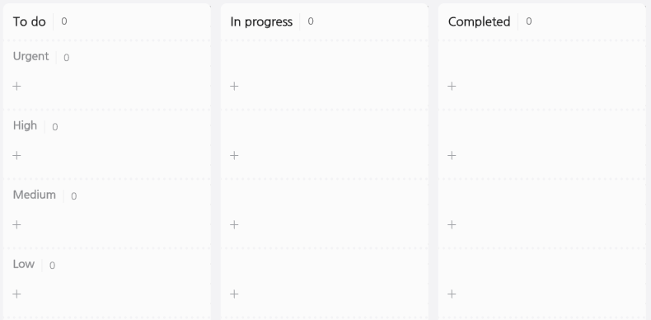

Figure 4.2 represents the High Kanban cards. These cards represent the most critical and top-priority tasks within the project. These tasks typically include building a DB, storing user permissions through the DB, saving AR content achievements, creating one AR content using MLT technology, and creating one AR content using IMG tracking. The reason for creating these tasks as High Kanban cards is that they are prerequisites for initiating the other Kanban cards. For example, to retrieve data from the DB, it is essential to have the DB constructed and store the data. Therefore, the researcher made the DB construction and data storage functionalities as high-priority Kanban cards. Furthermore, to create various AR contents, the researcher needed to study the usage of AR production kits and the methods of AR development using MLT and IMG tracking. Therefore, the researcher created one AR content using the MLT technique and one AR content using the IMG tracking technique as High Kanban cards. Moreover, the AR content included in the High Kanban cards will be the foundation for developing other AR content.

**Figure 4.2**

*High Kanban cards for AR English educational system*

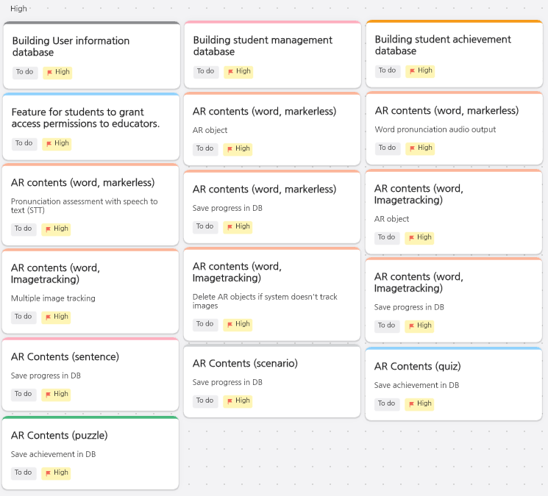

Figure 4.3 represents Medium Kanban cards. These cards represent important project tasks that developers do not need to do immediately. These tasks typically involve retrieving data from the DB, deleting data from the DB, and creating AR content. The researcher created these tasks as Medium Kanban cards because they can only progress after completing the tasks in the High Kanban cards. For instance, to retrieve or delete data from the DB, the DB construction and data storage tasks in the High Kanban cards must be completed first. Therefore, the researcher created these tasks as Medium Kanban cards. Furthermore, to create various AR content, the researcher must learn how to use AR production kits and development methods in advance. Therefore, the researcher created the remaining AR content production tasks, excluding those from the High Kanban cards, as Medium Kanban cards. The AR contents in the Medium Kanban cards were mainly created based on the source code of the AR contents in the High Kanban cards.

**Figure 4.3**

*Medium Kanban cards for AR English educational system*

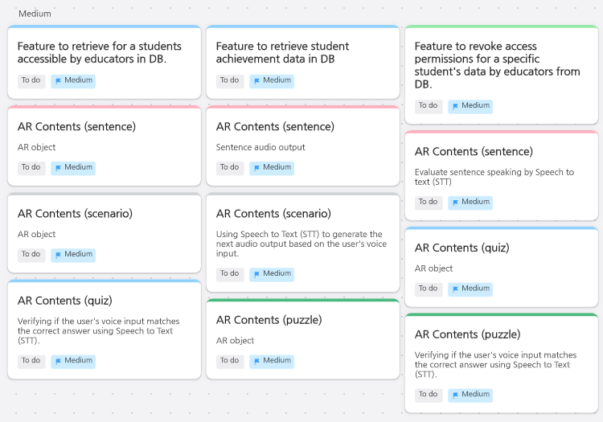

Figure 4.4 represents Low Kanban cards. These cards represent tasks of low importance in the project, and developers do not need to operate these tasks immediately. These tasks typically consist of UI design, UI functionality, login and registration features, access features for individuals with disabilities and developing an AR educational system tutorial. The researcher created these tasks as Low Kanban cards because they are typically not critical to the AR educational system's functionality and may not require a significant amount of development time. Additionally, the development approach for these tasks might change depending on the situation. For instance, the researcher created them as Low Kanban cards because user requirements can change UI design, login method, registration method, access features and tutorial.

**Figure 4.4**

*Low Kanban cards for AR English educational system*

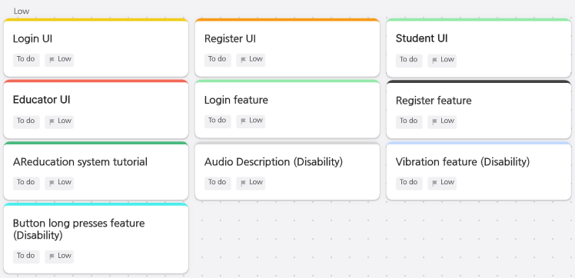

By creating these Kanban boards and Kanban cards, the researcher has made it easy to track the progress of AR educational system development visually. Furthermore, prioritising tasks has allowed us to carry out development more effectively.

## **4.2. Overall Description**

### **4.2.1. AR English Education System Overview**

The primary aim of the AR English education system is to enhance learners' English proficiency. Figure 4.5 is an architecture diagram representing the basic structure of the AR English education system. The primary target users of this system are all students, including students with disability who want to learn English. Moreover, the second target user of this system is educators who teach students. Furthermore, this system has been developed based on Android smartphones and tablets to ensure easy accessibility for users. Therefore, all users require an Android smartphone or tablet to access this system. Users can access either the educator or learner interface based on their permissions and utilise the features corresponding to their permissions. This system offers educators features to assess learner achievements quickly and provides AR usage tutorials. Furthermore, this system enables learners to use AR for vocabulary and sentences learning and creates environments like ordering in a restaurant or conversing with friends to enhance users' conversation skills. Furthermore, this system provides learners with game-like puzzles and quizzes. The system processes the score of puzzle/quiz and learning progress data obtained through this feature into data they can use to assess student achievements. Learners can also access AR usage tutorials. This system interacts with users through the speech-to-text and text-to-speech package (STTS) in the Unity assets store. Moreover, the researcher will create AR content used in education based on MLT and IMG tracking. Moreover, this AR content will incorporate accessibility features to make it usable for students with disabilities. The researcher utilises the Firestore for the DB, and the researcher can broadly categorise the data into access permission data, user data, and learner achievement data. Firestore is a DB belonging to Google's Firebase, boasting excellent physical and network security for data. Additionally, developers can interact with the DB by inputting, modifying, and deleting data through the Firestore API provided by Google.

**Figure 4.5**

*Architecture diagram for AR English educational system*

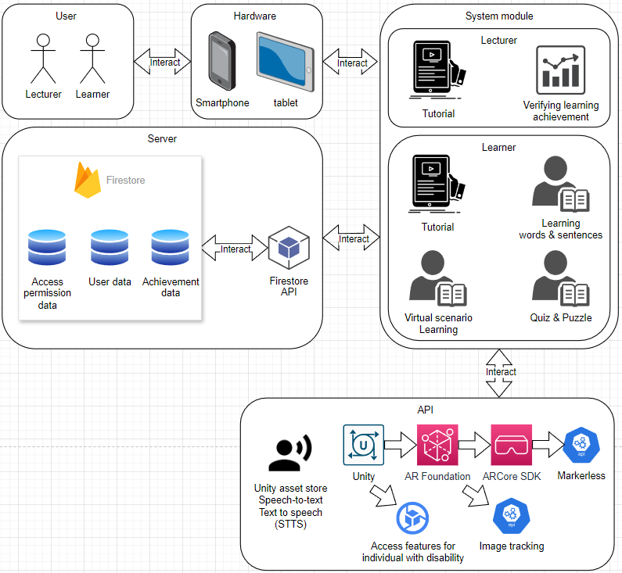

### **4.2.2. Context and Interaction with External Systems**

* User Devices

External Systems: Learner's smartphone, tablet

Interaction:

* The learner runs the system and accesses the learning content through the AR device.
* Use the camera to scan the physical environment to display 3DO.
* Speech Recognition and Speech Synthesis System

External Systems: Speech-to-Text and Text-to-speech (STTS) asset

Interaction:

* While operating educational content, the system recognises the learner's voice and proceeds the instruction accordingly to suit the context.
* User DBs

External Systems: Firestore

Interaction:

* Educators can understand learners' achievements quickly through stored learners' personal information, learning records, and achievements in a DB.

### **4.2.3. Components**

* Components

Learner Interface Services

* Provides a UI for learners to access the system and explore content.
* Displays the AR environment and enables learning activities.
* When the user enters, it forwards it to another service and responds.

Educator Interface Services

* It provides a UI for educators to access the system and find and view students' achievements.
* When the user enters, it forwards to another service and responds.

User Data Management Services

* Manage data such as learners' profiles, progress, and achievements.
* It can work with the DB to save and inquire about user information.
* It analyses and organises the learner's performance.

Interaction and voice processing services

* Recognise speech and process interactions between learners and systems.
* Converts voice input to text and operates the system depending on the text.

Accessibility for individual with disability services

* Providing features that enable easy access for learners with disabilities to the system.

Content Services

* Manage and provide learning content such as vocabulary, sentences, and conversation.

Gaming Services

* It provides and manages quizzes, puzzles, and tutorials like games.

## **4.3. Functional Requirements**

### **4.3.1. Use Case Diagram**

Figure 4.6 is a use-case diagram depicting the system usage case. This system has two types of users. It is educators and learners. Educators and learners can initially utilise login and registration functionalities. Educators and learners can access either the learner interface or the educator interface based on their authorisation. These two interfaces fall under the extended category, accessed based on the particular authorisation condition. These two interfaces include the tutorial functionality without special conditions, so the tutorial falls under the included category. The learner interface allows the user to access vocabulary and sentence learning, virtual scenario learning, puzzles, and quizzes. However, this case falls under the extended category as it is subject to the particular condition of the presence of learner AR content. The educator interface allows educators to check the learning achievement of selected learners. This case also falls under the extended category as it is subject to the particular condition of the presence of learner achievement data. Learners can update their learning progress and achievement; this case falls under the included category as it has no special conditions.

**Figure 4.6**

*Use Case Diagram for AR English educational system*

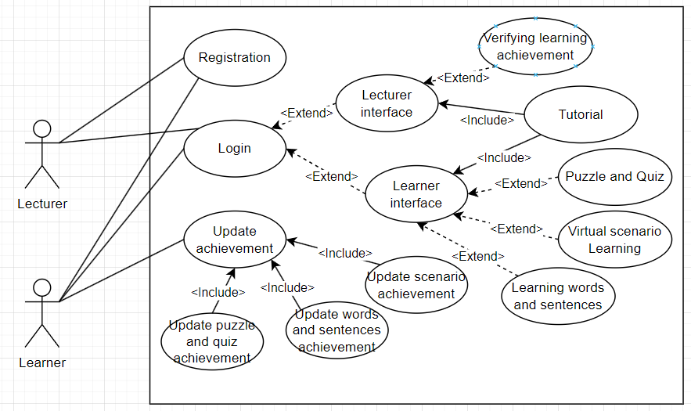

### **4.3.2. Data Flow Diagram**

Figure 4.7 is a Data Flow Diagram representing the flow of data. As shown in Figure 4.7, the researcher has classified users into two categories: learners and educators. Users input their ID and Password into the 1.0 feature or access the 2.0 feature to create an ID to use this system. In this process, D1 stores user information. Learners receive 3DO and pronunciation output in the 3.0 and 4.0 functions and input their answers using voice data. Furthermore, users can receive the answer result. In the case of the 5.0 function, learners receive quiz/puzzle questions and 3DO, input their answers, and receive their scores at the end. Upon completing the learning process, the 3.0, 4.0, and 5.0 functions store the learner's training data in D2. Educators first verify if they can access the learner's data in D3. Then, they request learner achievement and progress data from the 6.0 function, and then 6.0 requests this data from D2 and provides it to the educators. Both learners and educators can use the 7.0 function.

**Figure 4.7**

*Data Flow Diagram for AR English educational system*

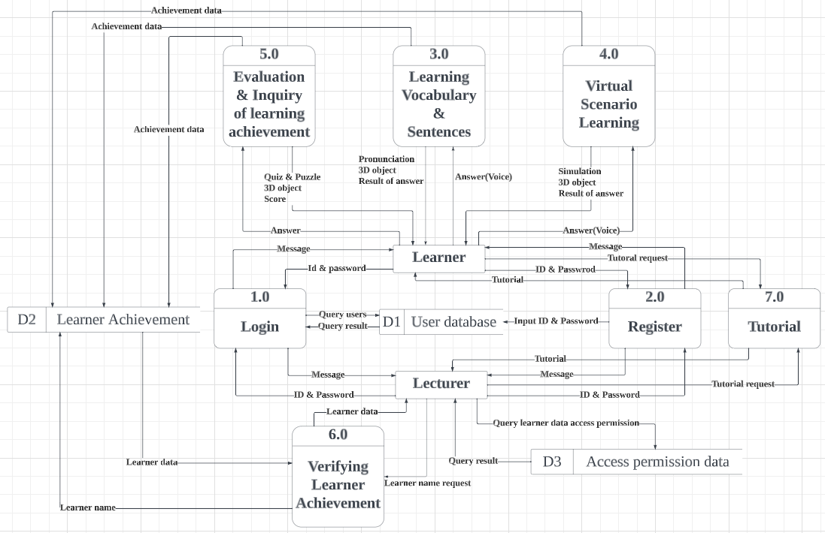

### **4.3.3. Feature 1: Login and register**

Feature: This feature enables users to sign in and sign up for the system. During registration, users choose whether they are educators or learners, gaining appropriate access permissions accordingly.

Input data requirements:

* User ID: Users require a unique ID for login
* Password: Login requires a password registered by the user.
* User Information: Registration requires user information such as name, email address, ID, and password.

Processing steps and algorithms:

* Login: When the user enters the ID and password, the system queries the DB for the data and gives the appropriate permissions.
* Registration: When a user enters user information, the system stores the data in the DB.

Expected output results:

* Login: Outputs the learner or educator interface.
* Registration: Outputs a login screen.

User interaction details: Users interact with the system through buttons and the data entry window on the UI.

* Login: It consists of an ID, password input window, and button.
* Registration: It consists of a user information input window and a button.

### **4.3.4. Feature 2: Learning vocabulary and sentences**

Feature: Enables learners to learn vocabulary and sentences visually through AR.

Input data requirements:

* Vocabulary data: Word.
* Sentence data: Sentences.
* Audio data: pronunciation.
* Image data: an image of an object, an image that means a sentence.

Processing steps and algorithms: When the user selects the desired content, the system imports the data. And then, the system uses MLT or image traking to set the location to display virtual objects. The system then outputs words or sentences, images, and voices.

Expected output results:

* Output images corresponding to user-selected words and sentences.
* Output corresponding vocabulary and sentence pronunciation.

User interaction details: The system allows users to interact by voice to check their pronunciation of words and sentences.

UI:

* Users can learn sequentially through buttons that move to word and sentence.
* Users can view words, sentences, and images through the UI.

### **4.3.5. Feature 3: Virtual Scenario Learning**

Feature: The system provides the user with an experience of using English in real-world situations through simulations.

Input data requirements:

* Scenario: The system needs a description and background information about the conversation environment.
* Conversation script: The system requires a script for a given conversation or situation within the scenario.
* Sentence data: The system requires various English sentences that users can use in the scenario.
* Audio data: The system requires audio data that users can use in the scenario.
* Visual materials and images: The system needs objects, places, and people data associated with the scenario.

Processing steps and algorithms: When the user selects the desired content, the system imports the data. And then, the system uses MLT to print out the image by setting the location to display the virtual object, and then proceed with the conversation between the object and the user in order of the scenario. When the user enters the correct sentence in the scenario, the system outputs the following script to provide the experience of interacting with each other.

Expected output results: The system outputs the script for the scenario by voice after printing the image. After that, it recognises the user's voice to determine if the sentence is correct, and if it is, proceed to the following script to provide a conversation-like environment.

User interaction details: Users can communicate with the system through voice to suit the scenario.

UI: The user can see objects, places, and people that fit the scenario through the interface.

### **4.3.6. Feature 4: Evaluation and inquiry of learning achievement**

Feature: The system provides learners with quizzes and puzzles to collect and analyse learning achievement data.

Input data requirements:

* Question content and question type: The system needs the question content and type that users can use in quizzes and puzzles.
* Correct answers: The system requires the correct answers to each question.
* Audio data: The system requires audio data that users can use in quizzes and puzzles.
* Visual materials and images: The system needs images, pictures, and other visuals related to the problem.

Processing steps and algorithms: When the user selects the desired content, the system imports the data. And then, the system uses MLT to print out an image related to a quiz or puzzle. The user enters the answer via voice. Users can get the result of the answer. Additionally, the system stores the processed learning achievement data in the DB.

Expected output results: The system outputs quizzes and puzzles to learners, uses them to evaluate their learning abilities, and stores evaluation data in a DB.

User interaction details: The interaction between the user and the system allows the user to enter the correct answers to the quiz and puzzle through voice, and the system outputs a result of an answer through visual elements.

UI: This interface allows users to view quizzes and puzzles in 3D and view an answer's result.

### **4.3.7. Feature 5: Verifying learner achievement**

Feature: Educators can see learners' learning achievements in the DB and easily understand students' learning status. In addition, educators can add and delete learners.

Input data requirements:

* Learner profile: Learner's information is required.
* Learning results and quiz score: The score data of the quiz or puzzle the learner solves is required.
* Learner progress data: Learner's learning progress data is required.

Processing steps and algorithms: When the educator selects the learner they want through the educator interface, the system queries the learner-related data in the DB, organises it, and outputs it to the educator. In addition, educators add or delete the desired learner through the educator interface and add or delete access data for that learner from the DB.

Expected output results: The system outputs basic information, learning progress data, and score data for the selected learner.

User interaction details: Users can interact with the system through buttons on the UI.

UI: The system provides the educator interface separately, displaying the button and learner data output values.

### **4.3.8. Feature 6: Tutorial**

Feature: Train how to use AR to make it easy for educators and learners to access.

Input data requirements:

* Tutorial Content: The system needs content for the tutorial.
* Visual Material: The system requires images, drawings, and icons for use in the tutorial.
* Demonstration Data: The system requires demonstration data to showcase the usage process and help users quickly understand.
* User Interaction Examples: Example data is needed to illustrate interactions that users need to perform, making it easier for them to understand the actions they should take.
* Simulation Data: Data is needed to conduct simple simulations that help users quickly understand the system.

Processing steps and algorithms: When a user accesses the tutorial, visual data demonstrate how to use AR and show examples of user interaction. The user can then check the usage of AR through simulation.

Expected output results: The system demonstrates the use of AR through image output and illustrates examples of interactions. It also outputs a simple simulation.

User interaction details: The user can interact with the system through the buttons on the UI. In addition, in tutorial simulations, users can interact simply through button.

UI: The interface consists of a tutorial, list, and button. It also shows 3DO in tutorial simulations.

### **4.3.9. Feature 7: Vibration Feedback**

Feature: This feature allows users to feel vibrations on their devices when clicking UI elements within the system.

Input data requirements:

Button Click: The user needs to click the buttons within the system.

Processing steps and algorithms: When the user clicks UI elements within the system, the system triggers vibration through the device.

Expected output results:

Vibration: The device outputs vibration.

User interaction details: The vibration indicates that the user clicked UI elements.

### **4.3.10. Feature 8: Audio description**

Feature: This feature allows Users to listen to audio descriptions when they activate all functions within the system.

Input data requirements:

Activating functions: The user needs to execute the functions within the system.

Processing steps and algorithms: When the user executes the functions within the system, audio descriptions related to those functions are output.

Expected output results:

Audio: The device outputs an audio description.

User interaction details: The audio description lets the user perceive what function the system has activated.

### **4.3.11. Feature 9: Drag-and-Drop**

Feature: This feature allows users to activate events for all buttons in the system by dragging and dropping them instead of clicking them.

Input data requirements:

Button drag-and-drop: The user needs to drag-and-drop the buttons within the system.

Processing steps and algorithms: The system activates the button when the user drags and drops the buttons within the system.

Expected output results:

Drag-and-Drop: The system outputs the button's event.

User interaction details: The event still triggers even if physically impaired users accidentally press and hold the button for too long and drag-and-drop.

### **4.3.12. Activity Diagram**

Figure 4.8 represents the workflow of the system or process, depicted as an Activity diagram. When a user first accesses the login screen and enters their ID and password, the client accesses the server's user DB to verify authorisation and response results. If the response indicates educator authorisation, the system directs the user to the educator interface; if it indicates learner authorisation, the system directs them to the learner interface. To select content, learners access the content data from the learner interface. Subsequently, the system displays the data of the selected content to the interface as requested by the learner. The learning content includes vocabulary and sentence learning, virtual scenario experiences, puzzles, and quizzes. Finally, when the learner completes the learning content, the system transmits their progress and puzzle/quiz scores to the user achievement DB, concluding the process. Educators can check the students they have access from the access permissions DB through the educator interface. Additionally, educators can verify the learner's data through the user achievement DB. For tutorials, both the learner interface and the educator interface provide access. Additionally, the users access the tutorial data in the client to proceed with the tutorial.

**Figure 4.8**

*Activity Diagram for AR English educational system*

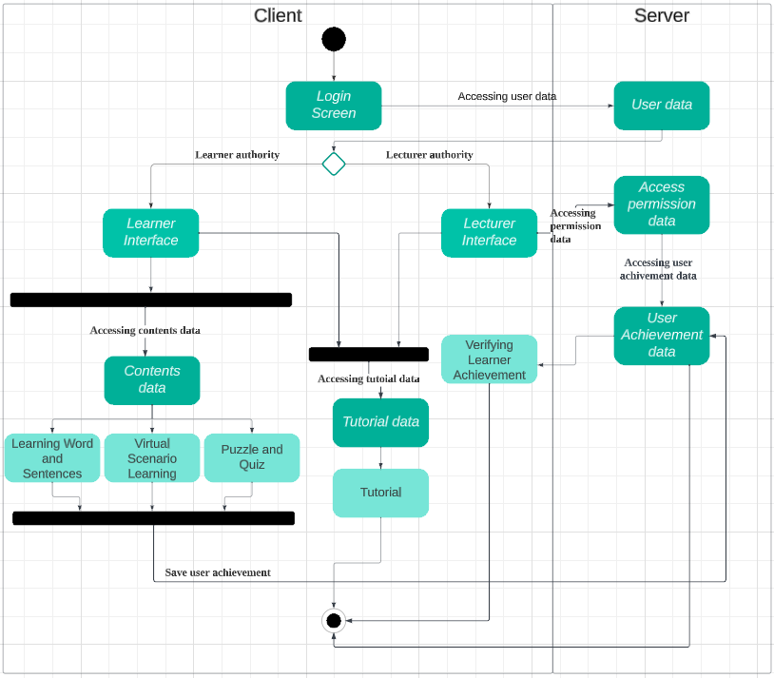

## **4.4. Non-functional Requirements**

**Performance requirements**

* Response Speed: The researcher should optimise to minimise content loading and interaction delays.

**Scalability and flexibility**

* Support for future model updates: The researcher should consider the easy addition of new content during development.

**Reliability and availability**

* Error handling: Write the error precisely in the error message so the user can understand the error.
* Backup and recovery plans: The system saves progress when the learner moves on to the next lesson to protect the learner's progress.

**Regulatory compliance**

* No regulatory or legal compliance requirements.

**Usability and accessibility**

* Intuitive UI: The researcher utilises an intuitive interface to enable users, including those with disabilities, to find and utilise learning content efficiently.
* Compliance with accessibility standards: Learn from voice input and output, use appropriate fonts and sizes, and utilise touch devices such as smartphones and tablets.
* Compliance with accessibility standards for individuals with disabilities: The system incorporates accessibility features such as audio descriptions, vibration feedback, and drag-and-drop functionality to facilitate easy access for individuals with disabilities.

**Constraints**

* Hardware dependencies: Android smartphones and tablets
* Software dependencies: Unity, AR Foundation, ARCore SDK, DBs and servers

## **4.5. External Interface Requirements**

**Learner interface:** An interface learners use to access and proceed with learning content through the system.

**Login and authentication interface:** Users use this interface for user authentication. It includes login and registration. It verifies the user's identity and grants access based on whether they are learners or educators.

**Content provision and navigation interface:** This interface allows learners to access and navigate through various learning content. It includes categories.

**Word and sentence learning interface:** Learners utilise this interface for learning and practicing vocabulary and sentences. It includes word and sentence lists, learning exercises, and revisiting learned words and sentences.

**Virtual simulation learning interface:** This interface allows learners to converse with virtual characters according to simulated scenarios. It encompasses interfaces like scenario selection, interaction with virtual simulations, and review of the outcomes of these simulations.

**Puzzle and quiz interface:** This interface allows learners to assess their achievements through puzzles and quizzes. It encompasses interfaces such as puzzle and quiz question generation, displaying puzzle and quiz results of answer, and user interaction for answering questions.

**Educator interface:** Educators use this interface to track the progress of learners in the system.

**Learner management interface:** This interface enables educators to navigate, and remove their learners. It includes learner lists, and deletion interfaces.

**Learning progress and achievement interface:** This interface allows educators to check learners' learning progress and achievements. It provides information about learning status, quiz scores, and puzzle scores.

**AR system tutorial interface:** This interface provides a simple tutorial to guide learners and educators on how to use the AR education system.

**Unity:** Unity is the system's development environment and is the platform for implementing AR education systems.

**Speech-to-text and Text-to-speech (STTS):** An API that allows the system to use voice commands.

**Vibration:** An API that allows the system to use vibration feedback.

**AR Foundation:** AR Foundation is a framework for supporting various AR platforms and devices in Unity engines.

**ARCore SDK:** ARCore SDK is a software development kit for developing AR content on Android-based devices.

**Firestore:** Firestore is a DB management system used to manage data.

**DB data storage, retrieval, update, and deletion API:** The system uses these to store, retrieve, update, and delete learning data and user information generated in Firestore.

## **4.6. Use Cases**

### **4.6.1. Feature 1: Learning words and sentences**

Preconditions:

* The learner must be a registered user of the system.
* Users need an Android smartphone or tablet that supports AR functionality.

Progress:

**Figure 3.9**

*Progress of Learning words and sentences*

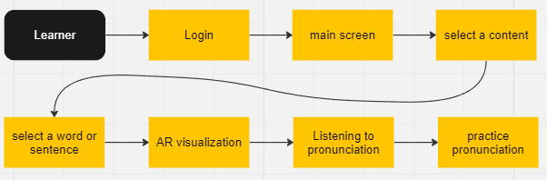

Alternative paths:

* If the AR does not visualise when the learner selects a word or sentence, guide them to free up space to visualise it.
* If the system does not recognise the pronunciation, print out the correct pronunciation and guide users.

Postconditions:

* Learners learned the selected word or sentence by visualising.
* The learner practiced correct pronunciation through pronunciation practice.

### **4.6.2. Feature 2: Virtual scenario learning**

Preconditions:

* The learner must be a registered user of the system.
* Users need an Android smartphone or tablet that supports AR functionality.

Progress:

**Figure 4.10**

*Progress of Virtual scenario learning*

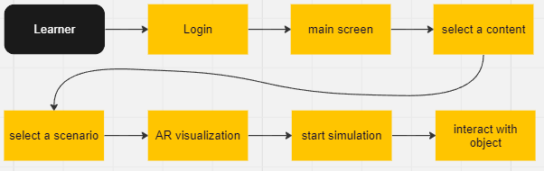

Alternative paths:

* If the AR does not visualise when the learner selects a scenario, guide them to free up space to visualise it.
* If the system does not recognise the pronunciation, the system will guide users to make accurate pronunciation.

Postconditions:

* Learners experienced the conversation experience by visualising and interacting with the selected scenario.

### **4.6.3. Feature 3: Evaluation of learner achievement**

Preconditions:

* The learner must be a registered user of the system.
* Users need an Android smartphone or tablet that supports AR functionality.

Progress:

**Figure 4.11**

*Progress of Evaluation of learner achievement*

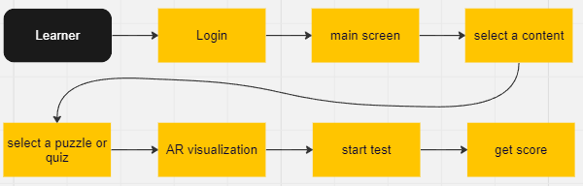

Alternative paths:

* If the AR does not visualise when the learner selects quizzes and puzzles, guide them to free up space to visualise the AR.

Postconditions:

* Learners evaluated their achievements in a fun way by visualising the selected puzzles and quizzes.
* Learners confirmed learning achievement through achievement evaluation.

### **4.6.4. Feature 4: Verifying learner achievement**

Preconditions:

* The lecturer must be a registered user of the system.
* Users need an Android smartphone or tablet that supports AR functionality.

Progress:

**Figure 4.12**

*Progress of Verifying learner achievement*

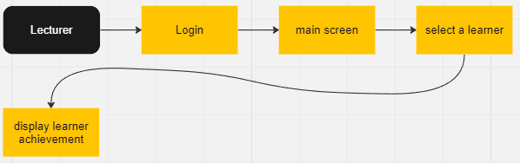

Alternative paths:

* If the educator cannot verify the data when checking the learner's achievement, the system sends the correct error message to the educator.

Postconditions:

* The educator identified learners' achievements through the analysed learners' achievement data.

### **4.6.5. Feature 5: Tutorial**

Preconditions:

* The users must be a registered user of the system.
* Users need an Android smartphone or tablet that supports AR functionality.

Progress:

**Figure 4.13**

*Progress of Tutorial*

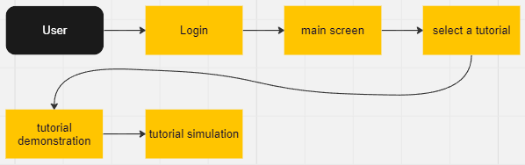

Alternative paths:

* If the AR does not visualise when the user proceeds with the tutorial, guide them to free up space to visualise the AR.

Postconditions:

* Users learned how to use AR in a fun way by visualising the tutorial.

### **4.6.6. Sequence diagram**

Figure 4.14 represents a sequence diagram illustrating the flow of the system. Initially, the learner and educator users can simultaneously proceed with the login process. Next, both users can simultaneously engage in the tutorial. Educators check learners' learning progress and achievement, so learners should initiate the learning process first. After completing the tutorial, learners proceed with learning vocabulary and sentences by selecting contents. The system stores their progress in the DB when the learner completes this learning. Next, for the second stage, learners select and experience the virtual scenario learning content. Upon completion of this learning as well, the system stores the progress in the DB. Thirdly, based on the data learned up to this point, learners select and engage in quizzes and puzzles. Upon completion of this learning as well, the scores are stored in the DB. Once learners complete their roles, educators access the DB to check learner's data access permission. Then, educators can access a DB to check learners' progress and achievement.

**Figure 4.14**

*Sequence diagram for AR English educational system*

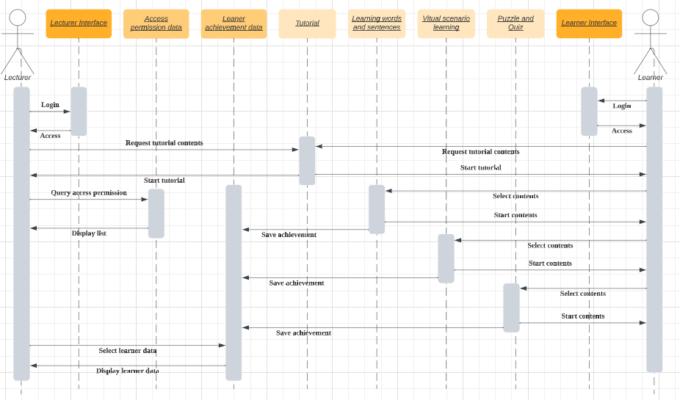

## **4.7. Data Requirements**

### **4.7.1. Data types**

* User data: This data is basic information for learners and educators.
* Word and sentence data: This data is words, sentences, 3D model, and pronunciation data needed for learning.
* Scenario data: This data is the scenarios, backgrounds, and 3D models where users can experience the conversation experience.
* Puzzle and quiz data: This data is puzzle/quiz questions and answers data that can evaluate learners' achievements.
* User interaction data: This data is input data for users to interact with the system, like user's voice, system responses, and scenario interactions.
* Learner's progress and achievement data: This data is the learner's progress data and the achievement data obtained through quizzes/puzzles, which are also accessible to educators.
* Tutorial data: This data is tutorial content, images, and AR usage guidance data that users use.
* Audio description data: This data is voice data used for audio descriptions within the system.

### **4.7.2. Data structures**

Figure 4.15 represents an entry relationship diagram illustrating the structure of the DB. The researcher has categorised the tables into user, access permission, and achievement tables. In the user table, the researcher has included a column for the user's unique ID to identify users. Additionally, the researcher has included a column for user type in the user table to determine whether they are a learner or educator. Moreover, Firestore does not support foreign keys. So, the researcher directly searched for data in another table using a unique ID instead of table referencing. The researcher set the educator's ID column in the access permission table as the unique key. Moreover, Firestore allows developers to create columns as arrays, just like in Figure 4.16. So, the researcher built it to allow the addition of various learner IDs to the learner ID column. The researcher set the learner's ID column in the achievement table as the unique key. Moreover, the researcher created columns for the progress and achievement of each learning type. Also, this system is a prototype; the researcher created the tables in this way, but in future development, the researcher can make columns for each learning type as arrays to manage data for multiple contents.

**Figure 4.15**

*Entity Relationship Diagram for AR English educational system*

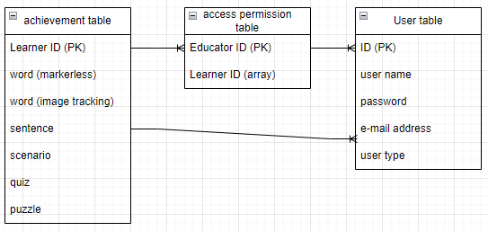

**Figure 4.16**

*Access permission table for AR English educational system*

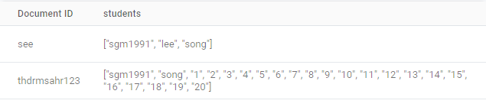

### **4.7.3. Data relationships**

* User table data can access the achievement table data and the access permission table data through a unique ID.

### **4.7.4. Data constraints**

* The ID in the user table must be unique. Also, the password must be encrypted.
* The ID in the access permission table and achievement table must be unique.

## **4.8. Performance Requirements**

* Response time and speed: The researcher must minimise response time between users and systems.
* Stability and reliability: The system must operate without failure, and the user must be properly guided in the event of a failure.
* Accuracy of AR function: AR visualisation should work properly, and the virtual element and the real world should be well integrated.
* Data Processing and Management: Developers need to build a DB efficiently to manage data.
* Personal Information Protection: Users' personal information must be transmitted using encryption and protected from the outside.

## **4.9. Design Constraints**

* Hardware constraints: The system should only work with specific AR devices or sensors and will not work in environments that do not meet them.
* Network constraints: The system requires access to the DB to log in, which requires a stable Internet connection.
* Device Compatibility Constraints: The system was developed on Android and must be compatible with various Android smartphones and tablets.

## **4.10. Quality Attributes**

**Performance:** The system must provide content and interaction without delay.

* Response time measurements
* Throughput tests

## **4.11. Testing plan**

### **4.11.1. Test overview**

* Project name: AR English educational system
* Test purpose: Perform quality assurance by verifying the system's functionality, user experience, and functional requirements.

### **4.11.2. Test targets**

Targeted modules

* AR Learning module
* UI
* User data management
* Student achievement assessment module
* Others

### **4.11.3. Test types**

* Functional Testing: Validate the system's core functions. And the researcher will conduct this test through table 4.1, table 4.2, table 4.3, table 4.4, and table 4.5.

**Table 4.1**

*MLT test results table*

|  |  |  |  |
| --- | --- | --- | --- |
| No | Description | Result | pass/fail |
| 1 | Word education MLT test |  |  |
| 2 | Sentence education MLT test |  |  |
| 3 | Scenario education MLT test |  |  |
| 4 | Quiz evaluation MLT test |  |  |
| 5 | Puzzle evaluation MLT test |  |  |

**Table 4.2**

*IMG tracking test results table*

|  |  |  |  |
| --- | --- | --- | --- |
| No | Description | Result | pass/fail |
| 1 | Test IMG tracking with watermelon word card |  |  |
| 2 | Test IMG tracking with butterfly word card |  |  |
| 3 | Test IMG tracking with coffee word card |  |  |

**Table 4.3**

*Rendering test results table*

|  |  |  |  |
| --- | --- | --- | --- |
| No | Description | Result | pass/fail |
| 1 | 3DO rendering associated with word education based on MLT |  |  |
| 2 | 3DO rendering associated with word education based on IMG tracking |  |  |
| 3 | Sentence education associated 3DO rendering |  |  |
| 4 | Scenario education associated 3DO rendering |  |  |
| 5 | Quiz evaluation related 3DO rendering |  |  |
| 6 | Puzzle evaluation related 3DO rendering |  |  |

**Table 4.4**

*Interaction test results table*

|  |  |  |  |
| --- | --- | --- | --- |
| No | Description | Result | pass/fail |
| 1 | In the learning process, users interact with the system by inputting their voices |  |  |
| 2 | During the learning process, users click the main button to save the results to the DB |  |  |
| 3 | The educator retrieves a student's data from the DB by clicking the student's name button in the UI |  |  |

**Table 4.5**

*Disability Accessibility test results table*

|  |  |  |  |
| --- | --- | --- | --- |
| No | Description | Result | pass/fail |
| 1 | Does the drag-and-drop function of a button or input-field trigger the same event as a button or input-field click? |  |  |
| 2 | Does the vibration function occur when the user clicks the button, input-field or creates the AR object? |  |  |
| 3 | Do audio descriptions occur when users click a button or input-field or progress through the study? |  |  |

* Compatibility Testing: Validate if it operates smoothly with various hardware. And the researcher will conduct this test through table 4.6.

**Table 4.6**

*Compatibility test results table*

|  |  |  |  |
| --- | --- | --- | --- |
| No | Description | Result | pass/fail |
| 1 | System operation on Samsung Galaxy S20 FE |  |  |
| 2 | System operation on Samsung Galaxy tab S8 |  |  |
| 3 | System operation on Realme 7 Pro |  |  |
| 4 | System operation on Samsung Galaxy Z Flip3 |  |  |

* Performance Testing: Evaluate system performance. And the researcher will conduct this test through table 4.7.

**Table 4.7**

*Performance test results table*

|  |  |  |
| --- | --- | --- |
| No | Description | Result |
| 1 | Frame rate |  |
| 2 | Plane recognition latency based on MLT |  |
| 3 | AR object creation latency based on MLT |  |
| 4 | Image recognition latency based on IMG tracking |  |
| 5 | AR object creation latency based on IMG tracking |  |
| 6 | Battery consumption |  |

* Content Testing: Verifying whether the content used in the system, such as 3D models, animations, and UI, appears accurately and consistently. And the researcher will conduct this test through table 4.8.

**Table 4.8**

*Content test results table*

|  |  |  |
| --- | --- | --- |
| No | Description | Result |
| 1 | Is the AR object generated in each education content and the AR object's animation suitable for the respective educational content? |  |
| 2 | Is the audio output of each educational content appropriate for the educational material and pronounced accurately in English? |  |
| 3 | Are the UI elements such as audio output buttons, education start buttons, question text, and answer text appropriately positioned in each educational content screen? |  |
| 4 | Is the button design used in the system user-friendly and easy to understand the button function? |  |
| 5 | Are there any typos in the text used in each content? |  |
| 6 | Can the user, from the educator's UI, view a student's progress and achievements on a single screen? |  |
| 7 | Is the audio description useful for students with visual impairments using this educational system? |  |
| 8 | Is the drag-and-drop helpful feature for students with physical disabilities using this educational system? |  |
| 9 | Using this educational system, is vibration feedback useful for students with visual and auditory impairments? |  |

* Integration Testing: The system interacts with other services and verifies that these integrations work as expected. And the researcher will conduct this test through table 4.9.

**Table 4.9**

*Integration test results table*

|  |  |  |
| --- | --- | --- |
| No | Description | Result |
| 1 | Is the STT API functioning properly in word education content? |  |
| 2 | Is the STT API functioning properly in sentence education content? |  |
| 3 | Is the STT API functioning properly in scenario education content? |  |
| 4 | Is the STT API functioning properly in quiz evaluation content? |  |
| 5 | Is the STT API functioning properly in puzzle evaluation content? |  |
| 6 | In word education content, is the system correctly storing the learner's progress in the DB using the Firestore API? |  |
| 7 | In sentence education content, is the system correctly storing the learner's progress in the DB using the Firestore API? |  |
| 8 | In scenario education content, is the system correctly storing the learner's progress in the DB using the Firestore API? |  |
| 9 | In quiz evaluation content, is the system correctly storing the learner's progress in the DB using the Firestore API? |  |
| 10 | In puzzle evaluation content, is the system correctly storing the learner's progress in the DB using the Firestore API? |  |
| 11 | In the Educator UI, is the system correctly loading the list of educators' students into the DB using the Firesore API? |  |
| 12 | In Educator UI, is the system using Firesore API to load student progress and achievement into the DB correctly? |  |
| 13 | Is the vibration API functioning properly on all clickable elements? |  |

* User Acceptance Testing: Collect user feedback to evaluate learning experiences and improvements. And the researcher will conduct this test through table 4.10 and table 4.11.

**Table 4.10**

*UAT questionnaire*

|  |  |  |  |  |  |  |
| --- | --- | --- | --- | --- | --- | --- |
| No | Description | 1 | 2 | 3 | 4 | 5 |
| 1 | Does this system help enhance learning? |  |  |  |  |  |
| 2 | Does using this system help improve learning concentration? |  |  |  |  |  |
| 3 | Does using this system make education more engaging? |  |  |  |  |  |
| 4 | Does it seem like learners would continue their education through this system continuously? |  |  |  |  |  |
| 5 | Is there a need for other learning methods besides the ones used in this system? |  |  |  |  |  |
| 6 | Does the system's tutorial help with AR learning? |  |  |  |  |  |
| 7 | Would using audio descriptions, vibration feedback, and drag-and-drop functionality be helpful for individuals with disabilities in using this system? |  |  |  |  |  |
| 8 | Would audio descriptions, and vibration feedback also be useful for general users? |  |  |  |  |  |

**Table 4.11**

*UAT comment*

|  |  |  |
| --- | --- | --- |
| No | Description | Comment |
| 1 | What are the advantages of this system in learning? |  |
| 2 | What are the areas for improvement in this system during the learning process? |  |
| 3 | What are some excellent learning methods that researchers can add to this system? |  |
| 4 | What are the improvements needed in the tutorial of this system? |  |
| 5 | How should researchers improve this system to make it more comfortable for people with disabilities to use? |  |

### **4.11.4. Test environment**

* Test Device: Android device.
* Test Data: Generate virtual data and sample content.

### **4.11.5. Risk management**

* Manage risks associated with issues encountered during testing and establish response plans.

## **4.12. Conclusion**

In the next chapter, the researcher will implement the AR English educational system based on the methods outlined in this chapter. First, the researcher will use the Kanban methodology to develop this system. Therefore, the researcher created Kanban cards using the features of this system and prioritized these cards into high, medium, and low categories. Then, the researcher will proceed with the development according to the prioritization of these Kanban cards. Next, the researcher crafted an overall description to explain the system's structure and supplemented it with an architecture diagram for further elaboration. Additionally, the researcher elucidated the requirements of the system's key functionalities and illustrated how the system operates and how data flows by creating use case diagrams, data flow diagrams, and activity diagrams. Moreover, the researcher described non-functional and external interface requirements. Non-functional requirements encompass performance, reliability, and accessibility, while external interface requirements include the system's interfaces, development tools, and APIs. Next, the researcher illustrated the use cases of each key functionality and supplemented the explanation by creating sequence diagrams. Furthermore, the researcher described the data handled by the system and designed the DB structure accordingly. Finally, the researcher compiled performance requirements, design constraints, and quality attributes to maintain the minimum quality of the system. Additionally, the researcher drafted a testing plan to evaluate the completed system. The researcher laid the groundwork for implementing an AR English education system accessible to disabled and non-disabled individuals through this chapter. Furthermore, the researcher will use the testing plan designed in this chapter to test the implemented system.

# **5. Implementation and Result**

In this chapter, the researcher provides a detailed explanation of the AR English educational system's implementation and analyses this system by testing it using the methods introduced in Chapter 4. Next, the researcher explains the results obtained from the testing.

## **5.1. Implementation of AR English Educational System**

This section provides information about implementing the AR English educational system. It includes details about setting up the system development environment, information about the system structure, DB construction and setup, and the implementation of key features. Furthermore, implementing key features includes login, registration, the learner module, the educator module, tutorials, and accessibility features for students with disabilities. Additionally, Table 5.1 shows this system's development environment and tools.

**Table 5.1**

*Development environment configuration for AR English educational system*

|  |  |
| --- | --- |
| Development Environment and Tools | Details |
| Operating System | Windows 11 |
| Devices used in the development | Galaxy S20 FE |
| Development Framework | Unity |
| AR Development Environment | AR Foundation |
| Android AR Development Environment | ARCore |
| System Development Languages | C# |
| DB | Firestore |

### **5.1.1. System Development Environment Set Up**

In this section, the researcher describes the development environment setup before program development. This development environment setup includes configuring the Android development environment in Unity and the AR development environment setup in Unity.

#### **5.1.1.1. Android Development Environment Set Up**

This section demonstrates setting up the Unity environment to make the system operable in the Android environment. The Unity package version used was 2022.3.9f1, and in this package, the researcher added the Android Build Support module, as shown in Figure 5.1. This Android module allows us to proceed with Android system development within Unity.

**Figure 5.1**

*Add Android Modules*

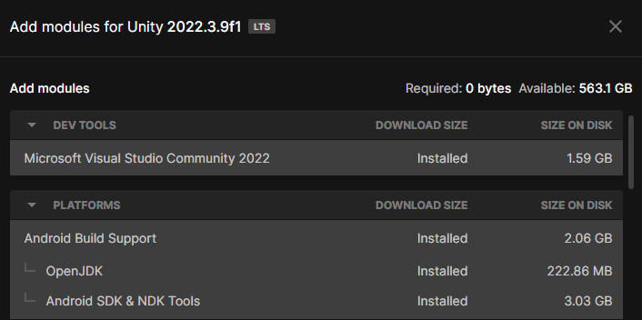

Figure 5.2 shows the Android API setup. This setup allows a developer to modify the contents of the APK file generated when building the program. The package name and version correspond to the current program's package name and version number. Furthermore, developers can use the APK file to run the system on Android development platforms like Android Studio and for future deployment in app markets. The API Level indicates the Android development version. Additionally, Android supports AR only in versions from Nougat (7.0) and later. Therefore, the researcher developed this system on Android 7.0 'Nougat' (API level 24).

**Figure 5.2**

*Android API Setup*

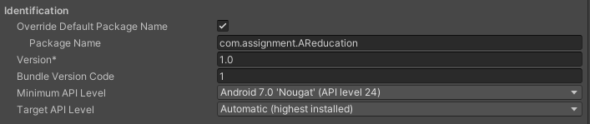

Typically, when developers run a Unity project, it is initially set up for the Windows platform. However, the AR English educational system must operate in an Android environment, and developers should change the platform to Android, as shown in Figure 5.3. By making this change, Unity will automatically generate an APK file when developers build the system. Additionally, when developers connect an experimental device to the developer's computer, they can choose an experimental device using the Run Device option. The Run Device setup allows developers to build the system while simultaneously running it on the experimental device using the Build and Run button. However, the experimental device must have developer options enabled in advance for the system to run correctly.

**Figure 5.3**

*Switch Platform to Android for Building*

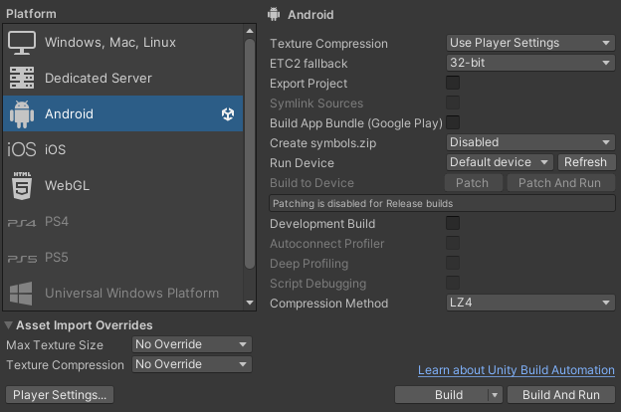

Completing these settings within Unity finishes the basic Android development environment setup.

#### **5.1.1.2. AR Development Environment Set Up**

This section demonstrates how to set up Unity for AR development. Figure 5.4 provides the necessary packages required for AR development in Unity. This system is an Android platform-based system. Therefore, it requires AR Foundation and the Google ARCore XR Plugin. Developers can download and update these two packages through Unity's Package Manager. AR Foundation provides essential tools for AR development, while ARCore enables the AR system to operate in the Android environment.

**Figure 5.4**

*Packages included for AR Development*

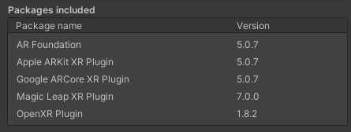

Once developers download the AR Foundation and ARCore packages, they can add AR Session and AR Session Origin to the Hierarchy, as shown in Figure 5.5. AR Session plays a role in managing and controlling AR within the system. AR Session Origin, on the other hand, is responsible for placing virtual objects on the screen in the AR system. These two elements play a crucial role in developing AR within Unity.

**Figure 5.5**

*Add AR Session and AR Session Origin to Hierarchy sub-items for AR development*

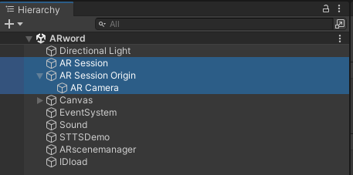

When developers initially create scenes in Unity, the main camera is in the Hierarchy by default, and Unity sets this element as the main camera. However, developers must change the camera setup in this system for AR development. Therefore, they should set the AR Camera as the main camera, as depicted in Figure 5.6. Additionally, developers should delete the existing main camera element. Furthermore, as seen in Figure 5.5, developers can observe that under AR Session Origin, there is an AR Camera sub-item.

**Figure 5.6**

*Main Camera Setup for AR execution*



Lastly, developers need to run AR in the Android environment. Therefore, they should select Google ARCore in the XR Plug-in Management's Plug-in Providers, as shown in Figure 5.7.

**Figure 5.7**

*XR Plug-in Management Setup*

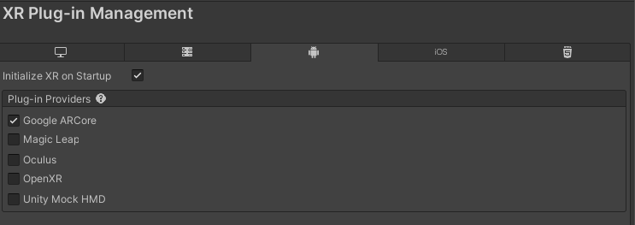

With these settings finished, the basic XR setup in Unity is complete.

### **5.1.2. System Structure Implementation**

The researcher created a project in Unity named AReducation to implement the system structure. Figure 5.8 represents the assets directory of the AReducation project, which includes source scripts, 3DO, APIs, scenes, and audio files. Firstly, in the 3DO directory, there are basic 3DO downloaded from the Unity Asset Store. Secondly, the researcher can find all the sound files used to develop the audio description feature in the Audio description directory. Thirdly, the DBmanager directory has source scripts for reading and writing data to the DB. Fourthly, in the distriqt directory, the researcher can find API related to the vibration feedback. Fifthly, in the ExampleAssets directory, the researcher can find source scripts related to MLT functionality. Sixthly, there are API files related to the DB in the Editor Default Resources, ExternalDependencyManager, and Firebase directories. Seventhly, the researcher can find this system's image files in the image directory. Eighthly, in the imagetracker directory, the researcher can find source scripts related to IMG tracking. Ninthly, the researcher can find ARCore-related files in the Plugins and XR directories. Tenthly, in the prefab directory, the researcher can find all the prefabs used in developing this system. Eleventhly, in the Scenemanager directory, the researcher can find source scripts that manage scenes. Twelfthly, in the Scenes directory, the researcher can find this system's scenes. Thirteenthly, in the Sound directory, the researcher can find all the sound files used in the development of this system. Fourteenthly, the StreamingAssets directory has an API key for using the Firestore API. Fifteenthly, in the STTS directory, the researcher can find source scripts related to STT. With this system structure, the researcher has organized files into groups, making it easy to find the desired files.

**Figure 5.8**

*Assets Directory Structure of AR English Educational System*

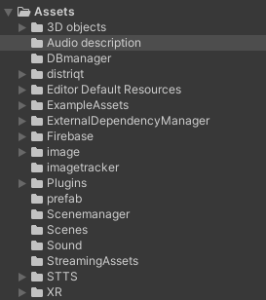

Figure 5.9 displays the package directory of the AReducation project. The package directory is where Unity stores a variety of packages that it provides by default. By default, this directory contains various function code files provided by Unity. Furthermore, when developers download default packages from Unity's package manager, Unity stores these packages in this directory. For AR implementation in the Android platform environment, the researcher has downloaded AR Foundation or ARCore, and related files reside in this directory.

**Figure 5.9**

*Packages Directory Structure of AR English Educational System*

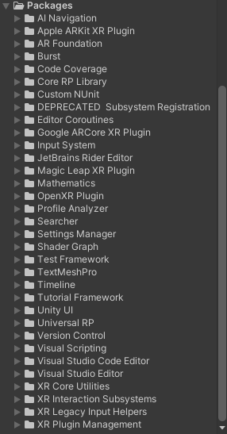

### **5.1.3. DB Construction and Set Up**

This section explains how to construct a Firestore DB in Google's Firebase and apply APIs for reading and writing data in Unity. First, to construct Firestore, developers must sign up for Google's Firebase and create a project. When developers create the project, they must also choose the framework for connecting with this DB. The researcher is developing this system in Unity, so the researcher chose Unity as the framework. After creating the project, creating the Firestore in Firebase completes the process. Next, the researcher downloads the API for use in Unity and the google-services.json file, which is the API key, from the Firebase website. The researcher imports the downloaded API file into Unity using the import package feature. However, as this system uses Firestore, the researcher only imported the Firestore-related API. Developers need to store the google-services.json file in the assets directory of this system. Storing this API key in the assets directory automatically applies the API key to the Firestore-related API, allowing developers to use the API. With this step, the setup for using Firestore-related APIs in Unity is complete.

Next, the researcher created the DB tables used in this system. Figure 5.10 provides the user information table. This table includes fields such as the user ID, email, name, password, and user type. In addition, UserID serves as the primary key in this table. Furthermore, the user type field is of boolean type, where true corresponds to an educator, and false corresponds to a learner.

**Figure 5.10**

*User table in DB for AR English Educational System*

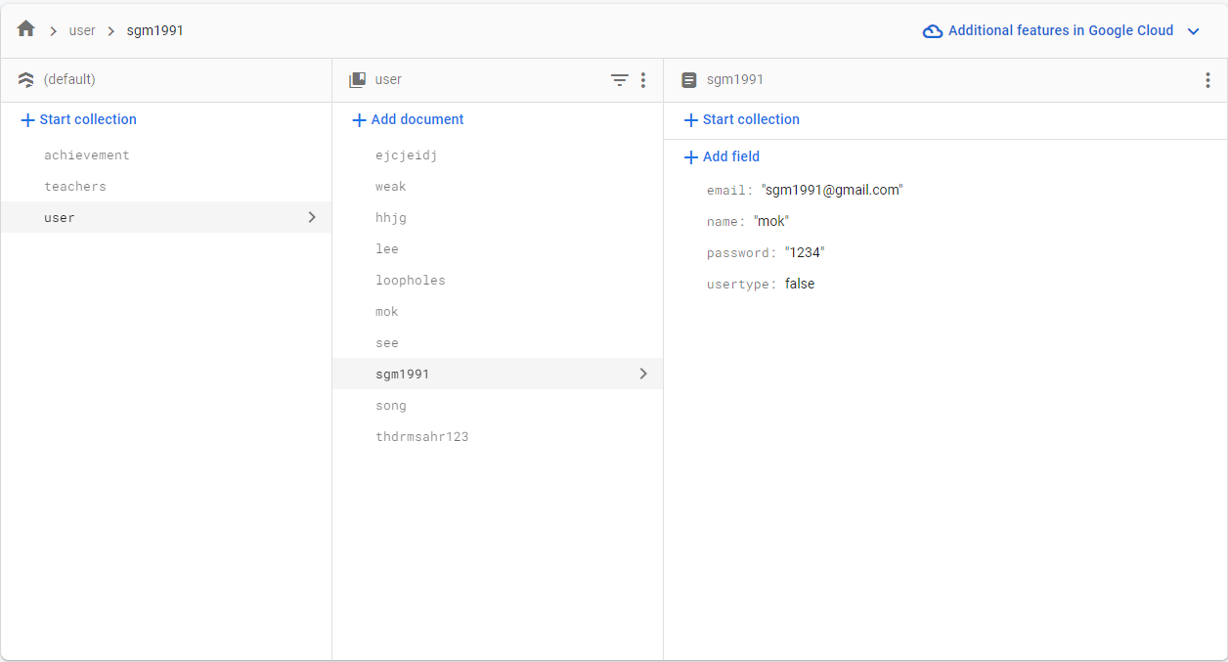

Figure 5.11 provides the achievement table for students. This table includes fields such as studentID, word1, word2, sentence, scenario, quiz, and puzzle. Moreover, studentID serves as the primary key in this table. The fields other than studentID are of a boolean type, with true indicating complete learning and correct answers, while false indicates incomplete learning and incorrect answers. Additionally, word1 corresponds to MLT based word learning, while word2 corresponds to IMG tracking-based word learning.

**Figure 5.11**

*Achievement table in DB for AR English Educational System*

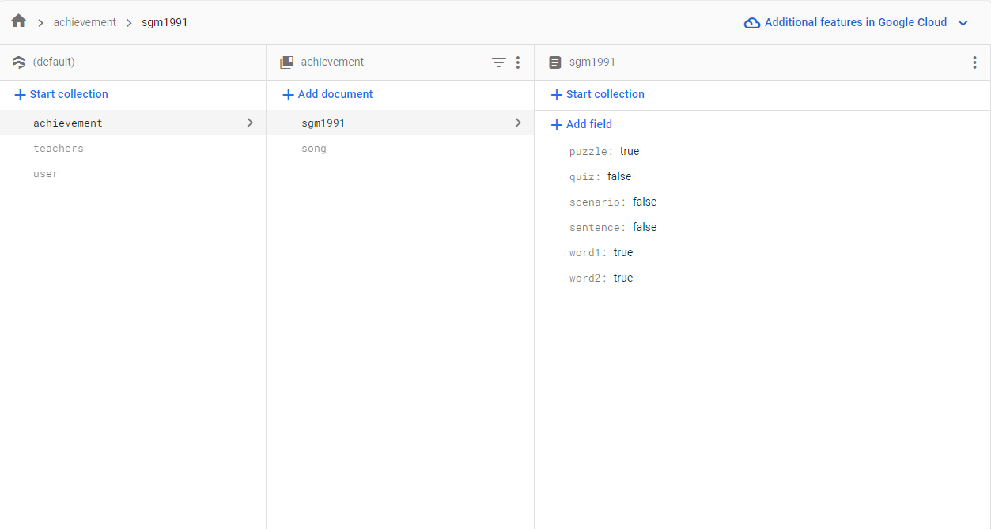

Figure 5.12 represents a table of student lists accessible by educators. This table contains fields such as teacherID and students. Moreover, teacherID is the primary key. In addition, Firestore allows developers to create fields as arrays. Therefore, the researcher designed the field of students as an array, allowing the addition or removal of userID of students accessible to a particular educator.

**Figure 5.12**

*Teachers table in DB for AR English Educational System*

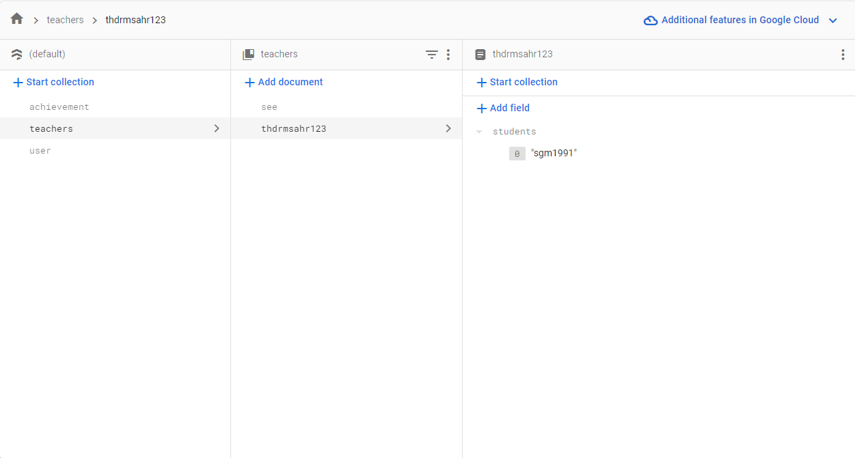

### **5.1.4. Implementation of Main Functional Module**

This section explains the implementation of the core functionalities of the system. Furthermore, the core functionalities encompass login, registration, learner modules, educator modules, tutorials, and accessibility features for students with disabilities.

#### **5.1.4.1. Login and Registration Function Implementation**

This section describes the implementation of the login and registration functionalities. In addition, the descriptions of the login and registration implementations include explanations of UI design and explanations of critical functions.

##### **5.1.4.1.1. Login UI**

This section describes the login UI. Figure 5.13 provides the login screen of this system. The login UI consists of two input-fields and two buttons. In addition, to create a user-friendly UI, the researcher utilized a gradient image for the background, giving it a clean and appealing appearance. Additionally, the researcher selected button images and text fonts familiar to users from the Unity Asset Store for a user-friendly UI design.

**Figure 5.13**

*AR English Educational System Login Screen*



##### **5.1.4.1.2. Login Function Module Implementation**

This section describes the main functionalities related to the login feature. Unity, unlike some other frameworks, does not provide a password input-field. So, developers must create a password input-field using the code, as shown in Figure 5.14. The code in Figure 5.14 changes the text in the input-field to appear as dots.

**Figure 5.14**

*Password Input-Field Text Change Code*

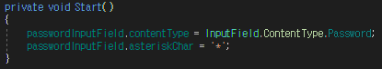

Figure 5.15 provides the code that executes the login functionality. This code executes when the user clicks the Login button, and it initially verifies the user's existence in the User table of the DB. Moreover, if the user exists, it retrieves their ID, password, and user type. Next, this system compares the user's ID and password with the values in the ID and password input-fields on the login screen, and if they match, the Figure 5.15 code executes. Based on the user type value, this code determines whether the user is an educator or a learner and switches to the corresponding screen accordingly. Furthermore, this code stores the user's ID as a global variable using PlayerPrefs. Therefore, the system can reference this ID in different scenes.

**Figure 5.15**

*Main Scene Movement Code*

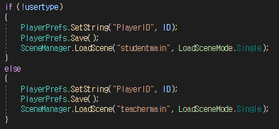

Figure 5.16 provides the code for transitioning to the registration screen. This code executes when users click the Register button, and this code transitions the screen to the Scene corresponding to the parameter value at the time of the button click event. This event is the one that transitions to the registration screen. Therefore, this code gets the name of the registration scene as a parameter when executing the event.

**Figure 5.16**

*Scene Movement Code*



##### **5.1.4.1.3. Registration UI**

This section describes the registration UI. Figure 5.17 provides the registration screen of this system. The registration UI consists of four input-fields, one toggle button and two buttons. Moreover, the UI design is similar to the login UI. Users can input their information into four input-fields and choose whether they are educators or learners using a single toggle button.

**Figure 5.17**

*AR English Educational System Registration Screen*

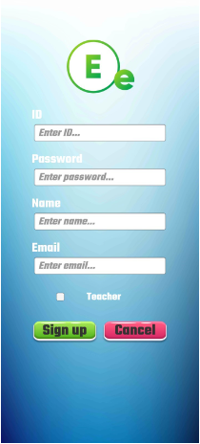

##### **5.1.4.1.4. Registration Function Module Implementation**

This section describes the main functionalities related to the registration feature. For security purposes, the researcher also has applied the code from Figure 5.14 to the password input-field used in the registration screen. Figure 5.18 provides the code that stores the input-field values and toggle button written by the user on the registration screen in the DB. Additionally, this code executes when the user clicks the Sign-up button. The code in Figure 5.18 initially takes the values entered by the user, stores them as variables, and checks for the ID value's existence in the DB user table. Subsequently, this code denies registration if the value exists and stores the user information in the DB if the value does not exist. Additionally, this code transitions to the login scene after saving the values.

**Figure 5.18**

*Code that registers user information in the DB*

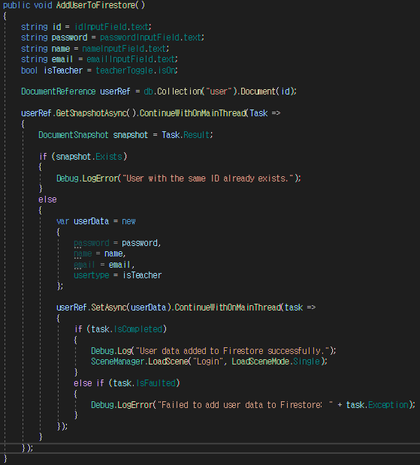

When the user clicks the Cancel button, the system uses the code from Figure 5.16 to transition to the login scene. Furthermore, as this click event is the event for transitioning to the login scene, this code obtains the name of the login scene as a parameter.

#### **5.1.4.2. Learner Module Implementation**

This section explains the implementation of the learner module. The learner module includes learner UI, word education using MLT and IMG tracking technologies, AR sentence education, AR scenario education, AR quiz education, AR puzzle education, and access authorization for educators.

##### **5.1.4.2.1. Learner UI**

This section explains the implementation of the learner UI. Figure 5.19 provides the learner's main screen that they can see after logging in. This UI consists of a text element displaying the user's ID, six buttons for transitioning to different education scenes, a button for granting access to educators, and a logout button. Furthermore, for scene transitions with each button, the researcher used the code from Figure 5.16, and when a click event occurs, it gets the name of the scene corresponding to each button as a parameter.

**Figure 5.19**

*Learner Main Screen*

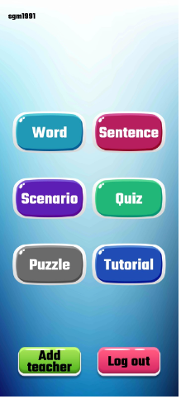

Figure 5.20 provides the word education selection screen that learners see when they click the Word button on the main screen. On this screen, learners can choose between marker-less technology-based word education and IMG tracking technology-based go-over word education. Furthermore, the buttons on this screen also transition to other screens using the code from Figure 5.16.

**Figure 5.20**

*Learner Word Education Selection Screen*

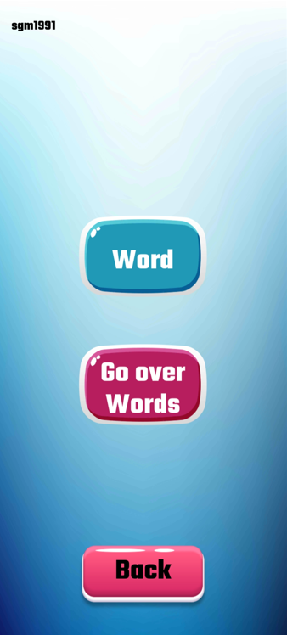

Additionally, when logging in using the Figure 5.21 code, it retrieves the saved user ID using the Figure 5.15 code and displays the user ID on the screen.

**Figure 5.21**

*Displaying User’s ID*

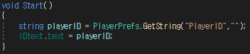

##### **5.1.4.2.2. AR Word Education Module Implementation (MLT)**

This section describes the implementation of word learning based on MLT technology. This learning is when learners practice listening to audio from the system and reading the word aloud. Additionally, this system recognizes the learner's speech to verify its accuracy. Figure 5.22 provides a screen for learning words based on MLT technology. This screen consists of four buttons and three texts. Each of the four buttons includes the following functions: word pronunciation audio output, audio input, word description audio output, and returning to the main screen. Furthermore, the two texts include the display of the user ID, the phonetic symbol of a word, and the output of the correct answer results, respectively. Moreover, the audio of word descriptions used in this learning is for visually impaired individuals who cannot see 3DO, while the phonetic symbol of a word is for individuals with hearing impairments who cannot hear the pronunciation of words.

**Figure 5.22**

*MLT Technology-Based Word Learning Screen*

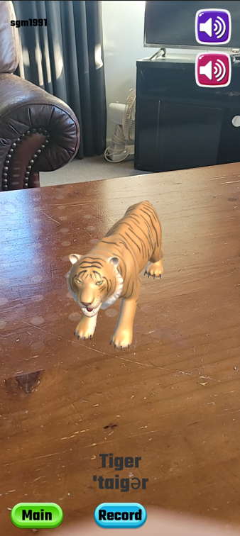

Figure 5.23 represents the MLT implementation code. Firstly, when the scene begins, it utilizes AR Foundation's ARPlaneManager to recognize surfaces and display points on these surfaces. Next, by touching the surface where the points are displayed, it records the position of that touch in the touch variable. Afterwards, it creates the corresponding 3DO using the Instantiate function. Moreover, to maintain only one 3DO, it stores the value of the Instantiate function in the m_LastSpawnedObject variable; the system deletes the previous object every time the researcher creates a new object. Additionally, the researcher has included code to activate learning-related buttons when the system creates a 3DO, allowing learning to begin.

**Figure 5.23**

*Maker less Implementation Code*

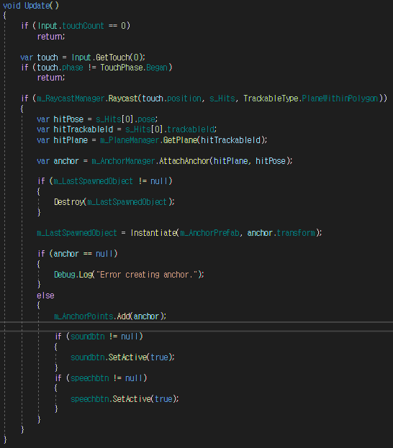

Figure 5.24 demonstrates the audio output implementation. The researcher used the AudioSource function to put the respective pronunciation and word description sound file into an AudioClip variable, allowing audio output when users click the audio output button.

**Figure 5.24**

*Audio Output Implementation*

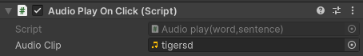

Figure 5.25 illustrates the implementation of STT. The researcher implemented STT using the STT API obtained from the Unity Asset Store **(**Unity Technologies, n.d.p.**).** When the user clicks the audio input button to record their voice, the API converts the voice into text and calls the STTResultCallback function. In this case, the parameter of the STTResultCallback function is the text converted from the voice. Moreover, this code compares the value of the parameter with the word, changing the font colour of the answer result text to green if they match and to red if they do not.

**Figure 5.25**

*STT Implementation*

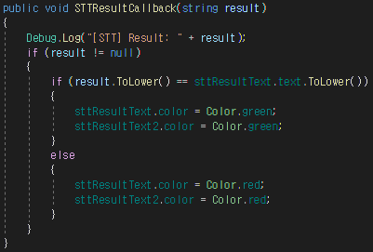

Figure 5.26 displays the code for ending the learning process, transitioning to a word main scene, and saving the progress to the DB. First, this code gets the user's ID displayed on the screen and accesses the DB's achievement table. Moreover, this code stores the progress as a boolean in the word1 field of the corresponding user ID. This code saves true if the colour of the correct answer result text is green and false if it is red. Next, after the saving process is complete, it transitions the scene to the word main scene.

**Figure 5.26**

*Code to move scenes and store progress in the DB.*

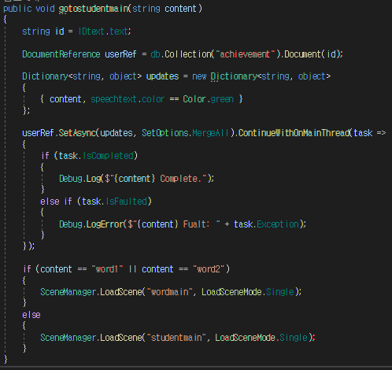

##### **5.1.4.2.3. AR Word Education Module Implementation (IMG Tracking)**

This section describes the implementation of content to go over learned words based on IMG tracking technology. In this learning approach, when learners scan their word cards with the camera, the system generates a 3DO of the corresponding word on top of the card. This learning approach helps learners quickly and easily review the words they have learned. Figure 5.27 provides a screen for learning words based on IMG tracking technology. This screen consists of one button and two texts. The button serves as the one to return to the main screen. The two texts display the user's ID and the usage description, respectively.

**Figure 5.27**

*IMG Tracking Technology-Based Word Learning Screen*

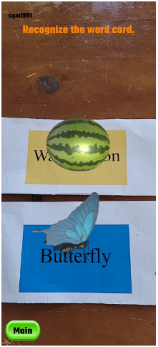

Figure 5.28 represents the XR Reference Image Library. The researcher created the image library by adding images to enable the system to track these images. Furthermore, the researcher completed the initial IMG tracking setup by setting the AR Tracked Image Manager in AR Foundation to reference this image library.

**Figure 5.28**

*Word XR Reference Image Library*

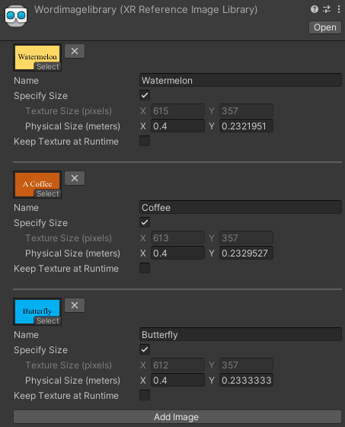

Figure 5.29 provides the event code that occurs when the system starts tracking a new image or when there are updates to previously tracked images. First, when the system starts tracking an image, it adds it to a list called _trackedImg. The researcher used this list to add tracked images, and if the system cannot track any of these added images anymore, the researcher used it to remove the corresponding objects. This code, when calling the image update event, uses the code of the UpdateImage function in Figure 5.30 to display objects on the screen. Additionally, in the Figure 5.30 code, the researcher searches for the name of the tracked image received as a parameter and displays the 3DO with the same name on the screen. Moreover, suppose the system achieves successful IMG tracking for as many images as are in the image library. In that case, this code uses PlayerPrefs to create a global variable called word2check and store the value 1.

**Figure 5.29**

*IMG Tracking Event Implementation Code*

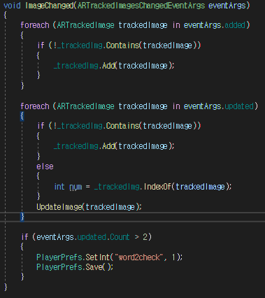

**Figure 5.30**

*3DO Generation Code*

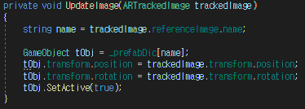

Figure 5.31 provides the code that removes 3DO with the same name as the images stored in the _trackedImg list when the system can no longer track these images. Through this approach, when the system successfully tracks an image, a 3DO is displayed on top of it. If the system can no longer track the image, it removes previously activated objects.

**Figure 5.31**

*Code to remove 3DO if IMG Tracking is Impossible*

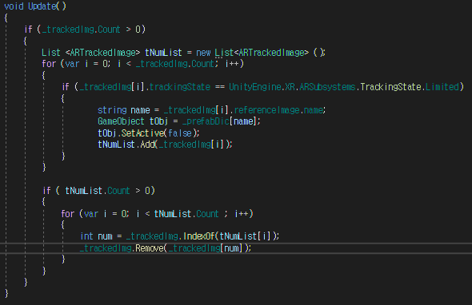

Figure 5.32 represents the code for concluding the IMG tracking based word learning process, transitioning to the word main scene, and saving the progress to the DB. This code is quite similar to Figure 5.26, with the main difference being that when saving values to the DB, the word2check global variable's value is true if it is 1, and it is false if it is others.

**Figure 5.32**

*Code to move scenes and store progress in the DB (IMG Tracking)*

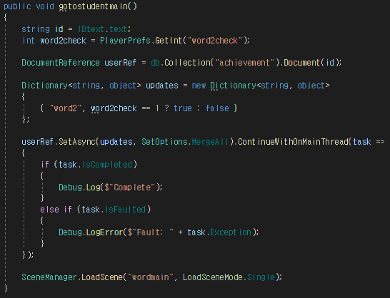

##### **5.1.4.2.4. AR Sentence Education Module Implementation**

This section describes the implementation of sentence learning. Sentence learning is when learners practice listening to audio from the system and reading sentences aloud. Additionally, this system recognizes the learner's speech to verify its accuracy. Figure 5.33 provides a screen for learning sentences. This screen consists of three buttons and two texts. Each of the three buttons include the following functions: sentence audio output, audio input, and returning to the main screen. Furthermore, the three texts include the display of the user ID, phonetic symbol and the output of the correct answer results, respectively. The phonetic symbol is for individuals with hearing impairments who cannot hear.

**Figure 5.33**

*Sentence Learning Screen*

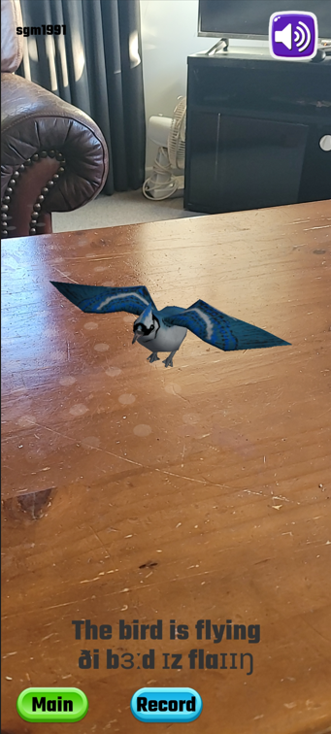

The sentence-learning process is similar to MLT based word learning. The researcher implemented MLT using the Figure 5.23 code, and when the user creates 3DO, the system enables buttons for learning. Furthermore, the researcher used Figure 5.24 for audio output and Figure 5.25 code to implement STT. Finally, the researcher uses the Figure 5.26 code to save sentence learning progress in the DB.

##### **5.1.4.2.5. AR Scenario Education Module Implementation**

This section describes the implementation of scenario learning. Scenario learning is when the system and the user have conversations following a script for practising English. Figure 5.34 provides a screen for the learning scenario. This screen consists of two buttons and three texts. Each button includes functions such as scenario start and returning to the main screen. Furthermore, the three texts include the display of the user ID, the display of the system script and the display of the learner script, respectively.

**Figure 5.34**

*Scenario Learning Screen*

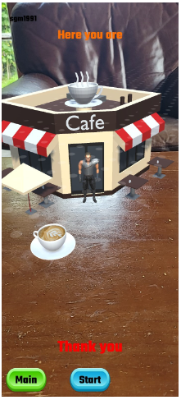

Figure 5.35 represents the MLT implementation code used in the scenario scene. This code is similar to Figure 5.23, but there are some differences in certain parts. This code, unlike Figure 5.23 code, recognizes planes using ARPlaneManager and positions objects at the centre of the screen using ARRaycastManager. Through this method, the system immediately creates objects when it recognizes a plane without user touch input. Additionally, in this code, when the system creates objects, the start button becomes active for learning.

**Figure 5.35**

*Maker less Implementation Code (Scenario)*

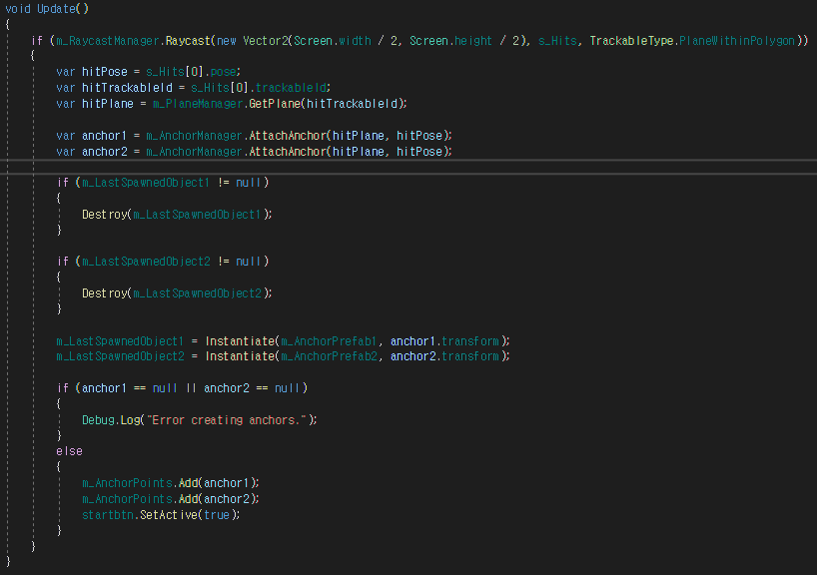

Figure 5.36 represents the code for the scenario's first script progress. This code outputs audio and calls voice recording functionality. Next, when the learner records their voice, the STT callback function from Figure 5.37 is called. This callback function receives the learner's voice converted into text as a parameter. Additionally, this callback function compares the parameter with the correct answers, enabling the transition to the appropriate script. Figure 5.38 represents the code for the scenario second script progress. This code is similar to Figure 5.36 but calls the Figure 5.39 function to create objects. Figure 5.39 provides the code for adding new objects while the learner progresses through the scenario. This code allows the creation of new objects during the interaction between the learner and the system. Next, following the Figure 5.36 code, the final script is executed. If the learner provides a correct answer, the font colour of the user script text turns green, and if it is incorrect, it turns red.

**Figure 5.36**

*Voice Output and Start Recording for Scenario*

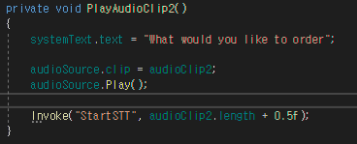

**Figure 5.37**

*Implement STT Result Callback for Scenario*

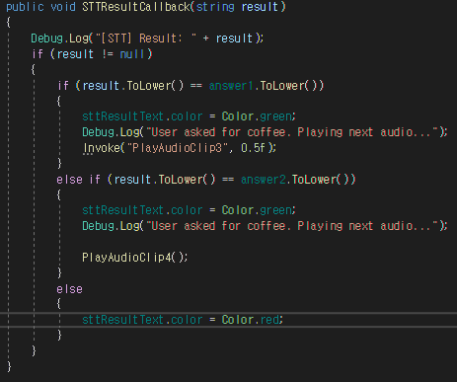

**Figure 5.38**

*Strat Next Script and Calling Instantiate Functions*

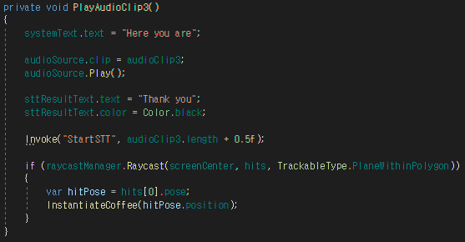

**Figure 5.39**

*Create Coffee 3DO*

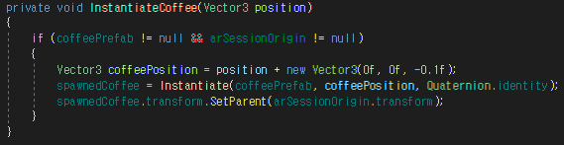

Following this flow, once the scenario learning is complete, learners can go to the learner's main scene by using a button to transition to the learner's main scene. The researcher used the Figure 5.26 code for scene transitions. Additionally, this code saves scenario learning progress to the DB while transitioning to a new screen.

##### **5.1.4.2.6. AR Quiz Module Implementation**

This section describes the implementation of AR quiz content. AR quiz is where the system raises a question for the learners, and the learners respond with answers orally. Figure 5.40 provides the AR quiz screen. This screen consists of three buttons and three texts. Each of the three buttons includes functions: quiz start, correct answer audio output and return to the main screen. Furthermore, the three texts display the user ID, the question, and the learner's answer, respectively.

**Figure 5.40**

*AR Quiz Screen*

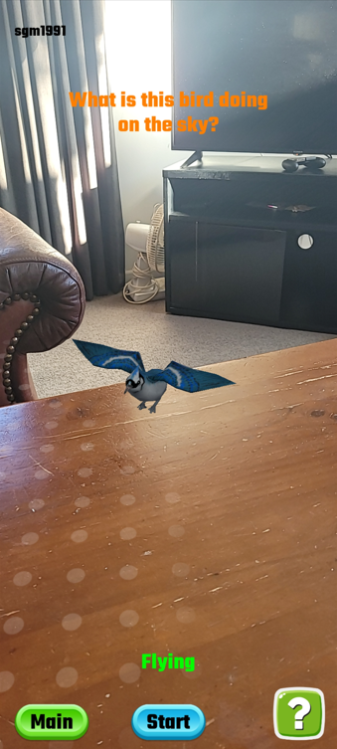

The researcher made this quiz question based on MLT technology. Therefore, we use the Figure 5.23 code to create 3DO. Additionally, when the user creates an object, the system activates the start button to allow the learner to begin the quiz and enables the correct answer audio output button for the user to check the quiz answers. When the user clicks the activated start button, the system calls the function of Figure 5.41. This code outputs the quiz question as audio and calls voice recording functionality.

**Figure 5.41**

*Implement Quiz Start*

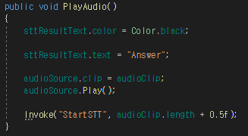

Figure 5.42 provides the STT Result Callback function for the quiz. This function receives the learner's voice converted into text as a parameter and compares it with the correct answer using this parameter. This function displays the learner's answer in the answer text and changes the font colour to green if the learner's answer is correct or red if it is incorrect.

**Figure 5.42**

*Implement Quiz Result Output*

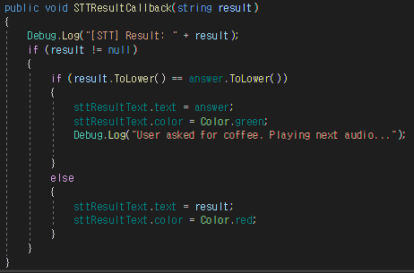

Furthermore, if the user is unsure about the answer to the quiz, they can use the answer audio output button to check the answer. The researcher added this feature to assist people with limited vision, who find it challenging to infer answers, unlike typical users who can see the movements of objects and the displayed answer results. Furthermore, the researcher implemented this feature through the method in Figure 5.24. Following this flow, once the learner completes the quiz, they can transition to the learner's main scene using the scene transition button. Furthermore, similar to other learning scenes, the researcher used the code from Figure 5.26 to save the learner's achievement to the DB in the quiz scene.

##### **5.1.4.2.7. AR Puzzle Module Implementation**

This section describes the implementation of AR puzzle content. In AR puzzle, the system gives the learners a puzzle, and the learners solve the puzzle orally. Figure 5.43 provides the AR puzzle screen. This screen consists of three buttons and three texts. Each of the three buttons includes functions: puzzle start, correct answer audio output, and return to the main screen. Furthermore, three texts display the user ID, the question, and the learner's answer, respectively.

**Figure 5.43**

*AR Puzzle Screen*

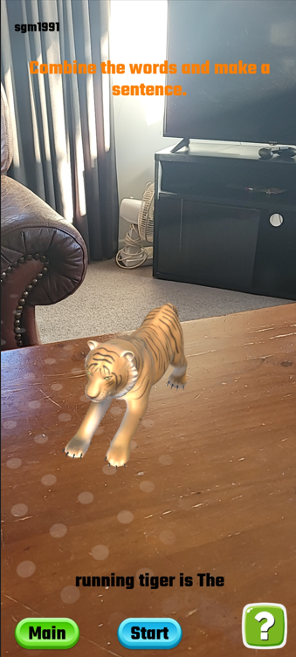

The researcher made this puzzle question based on MLT technology. Therefore, we use the Figure 5.23 code to create 3DO. Additionally, when the user creates an object, the system activates the start button to allow the learner to begin the puzzle and enables the correct answer audio output button for the user to check the quiz answers. When the user clicks the activated start button, the system calls the function of Figure 5.44. This code outputs the puzzle question and the question options as audio and then invokes the voice recording functionality.

**Figure 5.44**

*Implement Puzzle Start*

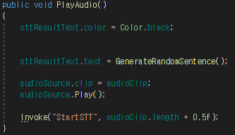

Additionally, this puzzle's next process is similar to the quiz process. So, the researcher used the Figure 5.42 code. Moreover, this code displays the learner's answer in the answer text and changes the font colour to green if the learner's answer is correct or red if it is incorrect. Furthermore, if the user is unsure about the answer to the puzzle, they can use the answer audio output button to check the answer. The researcher added this feature to assist people with limited vision, who find it challenging to infer answers, unlike typical users who can see the movements of objects and the displayed answer results. Furthermore, the researcher implemented this feature through the method in Figure 5.24. Following this flow, once the learner completes the puzzle, they can transition to the learner's main scene using the scene transition button. Furthermore, similar to other learning scenes, the researcher used the code from Figure 5.26 to save the learner's achievement to the DB.

##### **5.1.4.2.8. Data Access Authorization Implementation**

This section explains the implementation of features that allow learners to grant access to their progress and achievement data to educators. Figure 5.45 provides the screen where learners grant access to their data to educators. This screen has two buttons, one input-field, and one text element. The two buttons are for adding an educator and returning to the main scene. An input-field allows the entry of the educator's ID, and a text element displays the user's ID. On this screen, learners enter the educator's ID, and when they click the Add button, the respective educator gains access to the learner's data.

**Figure 5.45**

*Grant Educators Access to Progress and Achievement Data*

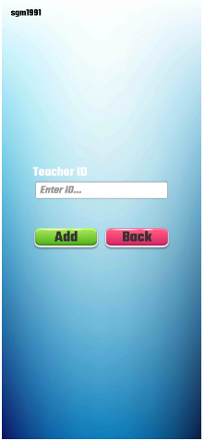

Figure 5.46 is the code that saves the learner's ID, who is using this system, in the educator's student list. First, the system checks whether the ID entered by the learner corresponds to an educator through the user information table. If the entered ID belongs to an educator, the system searches for the educator's ID in the access permission table. Then, the system saves the learner's ID in the student list of that educator. Next, this code transitions the scene to the main scene.

**Figure 5.46**

*Enter a Learner's ID in the DB's access permission table*

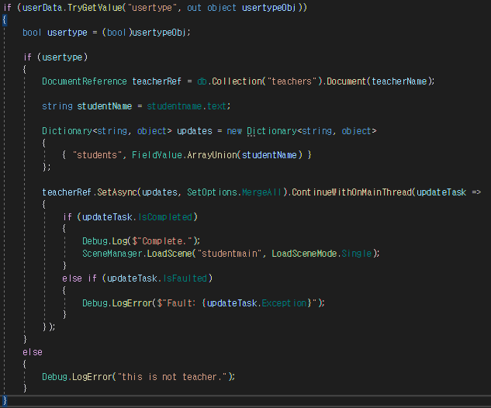

Furthermore, the researcher made it so that when the user clicks the Back button, it transitions to the main scene using the Figure 5.16 code.

#### **5.1.4.3. Educator Module Implementation**

This section explains the implementation of the educator module. The educator module includes educator UI, student achievement display, and student access permission remove.

##### **5.1.4.3.1. Educator UI**

This section explains the educator's UI. Figure 5.47 represents the educator's main screen. This screen contains a tutorials button, a logout button, user ID display text, and dynamically generated buttons. Moreover, the dynamically generated buttons are buttons used to access the data of students.

**Figure 5.47**

*Educator Main Screen*

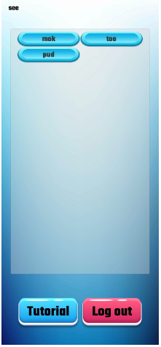

First, to create dynamic buttons, the researcher uses the Figure 5.48 code to retrieve the students' list of this educator from the DB, store it in a list, and create dynamic buttons using the UpdateScrollViewWithStudents function. Figure 5.49 provides code that a part of the UpdateScrollViewWithStudents function. It is responsible for creating dynamic buttons and adding them to the ScrollView. Moreover, this code also sets the text and events for the buttons. The researcher used the student's name as the button text, and the researcher obtained this name by searching the student's ID from the DB. Furthermore, the researcher has set up the event so that when a user clicks a button, it transitions to a scene where they can view the data of the respective student and then stores the student's ID in a global variable named studentID.

**Figure 5.48**

*Code to Import Educator's Student List from DB*

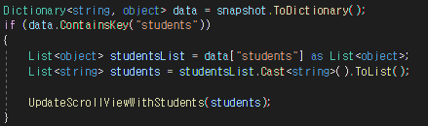

**Figure 5.49**

*Code to Create Dynamic Buttons and Add to Scrollview*

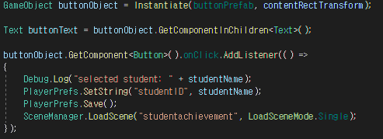

Through this method, educators gain access to the data of all their students. Additionally, for the logout button and tutorial buttons, the researcher used the Figure 5.16 code to ensure they transition to the respective scenes when clicked.

##### **5.1.4.3.2. Selected Student Achievement Display Implementation**

This section explains the implementation of displaying the progress and achievements of the educator's selected student. Figure 5.50 provides the screen where educators can display the data of the selected student. This screen consists of various elements, including a button to remove the selected student from the student list, a button to return to the main screen, displaying scroll views for word progress state, sentence progress state, and scenario progress state, the display of achievements in quizzes and puzzles, and the display of the selected student's ID and the user's ID.

**Figure 5.50**

*Implement the Progress and Achievement Display of Selected Student*

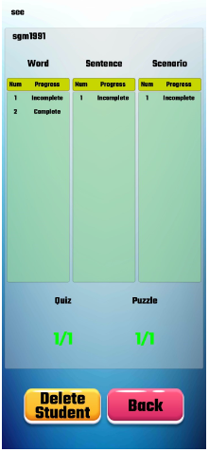

First, the researcher retrieves the user ID and student ID from Playerprefs using the Figure 5.21 code and displays them. Then, search for the selected student's ID in the achievement table from the DB and save all their progress and achievements into respective education arrays. Then, the researcher used the Figure 5.51 code to update the scroll view.

**Figure 5.51**

*Update Student Progress and Achievement State in Scroll View*

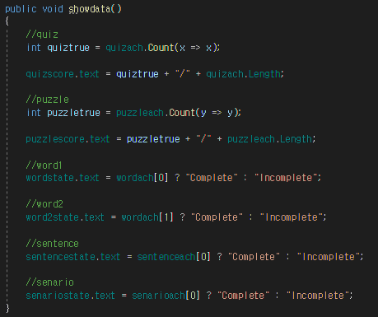

Figure 5.52 shows the screen when an educator clicks the Delete Student button. In this screen, educators can remove the selected student from their list of students. Moreover, when educators delete this student from their list, they will no longer have access to this student's data. Additionally, the researcher has added a pop-up window to this feature to allow educators to confirm their decision again.

**Figure 5.52**

*Implementing the Feature to Remove Selected Students from the Student List*

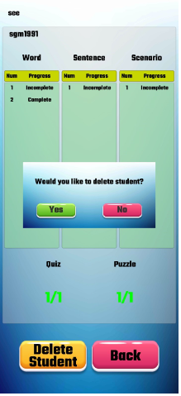

This pop-up window remains disabled when the initial scene starts. It becomes active and visible when the user clicks the Delete Student button. Additionally, the researcher made it so that when the user clicks the No button in this pop-up window, it becomes disabled again. However, if the user clicks the Yes button, the system updates the DB using the Figure 5.53 code and deactivates the pop-up window using the Figure 5.53 code. Figure 5.53 shows that first, the code retrieves the list of students for that educator from the DB and stores it in a list. Furthermore, the cord removes the selected student ID in this list and then updates this list to the educator's list of students in the DB. Moreover, the code transitions this scene to the educator's main scene.

**Figure 5.53**

*Cord of Delete Selected Student from Educator's Student List*

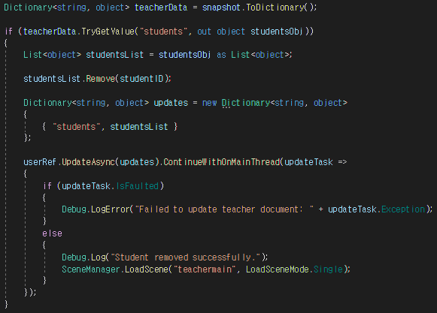

Furthermore, when users click the Back button, the researcher has implemented it to transition to the educator’s main scene using the code from Figure 5.16.

#### **5.1.4.4. Tutorial Implementation**

This section explains the implementation of tutorials to assist users in using the AR English education system. Figure 5.54 provides the AR tutorial screen. This screen consists of a button to return to the main screen, a text displaying the user ID, four images that assist the tutorial, and a text displaying the instructions. This tutorial is accessible to both educators and learners. Furthermore, the researcher designed this tutorial in the format of experiencing MLT based AR. However, the researcher has not created a separate tutorial for AR based on IMG tracking, like Figure 5.27, because the researcher added usage instructions text in the content, making it easy to use.

**Figure 5.54**

*AR Tutorial Screen*

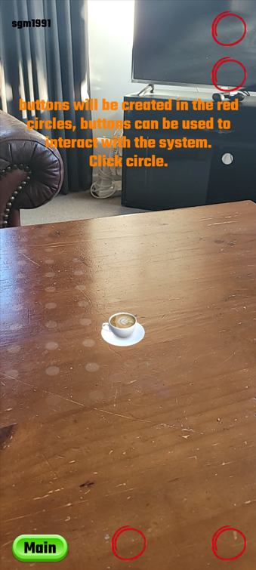

The implementation of MLT in this tutorial used the code from Figure 5.23, and the system would change the explanatory text and the images to fit the context. Furthermore, by adding a click event to the image, when users click on the active image, represented by a red circle, the system outputs the role of an image through audio. The researcher implemented the audio output using the method in Figure 5.24, playing the audio file corresponding to the image. Moreover, at the end of the tutorial, the user can click the Main button to invoke the Figure 5.16 code and transition back to the main screen.

#### **5.1.4.5. Accessibility Features for Students with Disabilities**

This section describes the implementation of accessibility features for students with disabilities. These features include vibration feedback, drag-and-drop functionality, and audio descriptions. Furthermore, the researcher applies these features to all elements, such as buttons, input-fields, and objects, within all scenes students use.

##### **5.1.4.5.1. Vibration Feedback**

The researcher implemented vibration feedback when users touched buttons or input-fields or when users created AR objects in all scenes used by students. The researcher utilized the vibration API created by Distriqt Pty Ltd, available on the Unity Asset Store, to implement this vibration feedback **(**Unity Technologies, n.d.q.**)**. First, the researcher created a C# script and defined a function that executes when an event occurs. Then, the researcher added a vibration code to this function, like Figure 5.55. Next, the researcher generated event triggers for all buttons and input-fields, as shown in Figure 5.56, to apply the functionality described in Figure 5.55. Figure 5.56 sets event triggers to pointer-down, ensuring that the event occurs when users press down on the corresponding button or input-field. Furthermore, the researcher added a vibration code similar to Figure 5.55 to the AR object creation code described in Figure 5.23, allowing users to experience vibration when creating objects.

**Figure 5.55**

*Cord of Vibration Feedback*

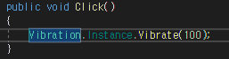

**Figure 5.56**

*Pointer-Down Event Trigger of Button and Input-Field*

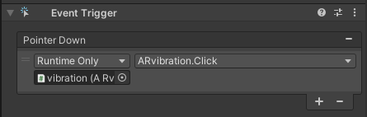

##### **5.1.4.5.2. Drag-and-Drop Feature**

The researcher implemented drag-and-drop functionality because students with physical disabilities find it challenging to click buttons. The researcher used the end-drag event trigger to implement this functionality, as shown in Figure 5.57. Additionally, the researcher configured events such as onclick within the end-drag event to ensure that events occur when users click buttons or input-fields or when they perform drag-and-drop actions.

**Figure 5.57**

*End-Drag Event Trigger of Button and Input-Field*

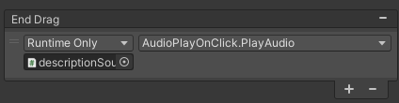

##### **5.1.4.5.3. Audio Description Feature**

The researcher implemented features to make it easier for students with visual impairments to understand the role of elements such as buttons or input-fields when clicked. Furthermore, the researcher implemented audio descriptions to provide helpful explanations in audio format for students with visual impairments, aiding them in creating AR objects and progressing through the learning process. First, the researcher placed the sound files for audio descriptions corresponding to each element into audio clip variables using a method similar to Figure 5.24. Then, they utilized event triggers, as shown in Figure 5.58, to play the audio description when the user clicks on the respective element. The researcher structured the audio description playback code as shown in Figure 5.59, and it stops any currently playing audio before starting a new one to prevent audio overlap. Furthermore, the researchers incorporated code similar to Figure 5.59 into Figure 5.23 to enable the playback of audio descriptions when creating AR objects.

**Figure 5.58**

*On-Click Event Trigger of Button and Input-Field*

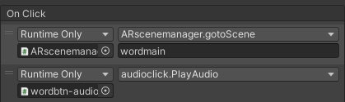

**Figure 5.59**

*Code of Audio Description*

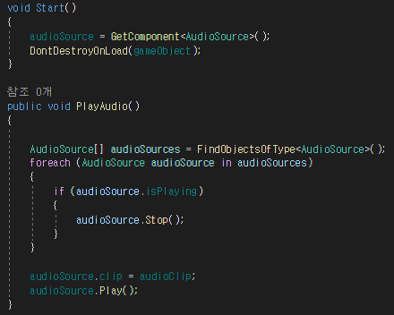

The researcher successfully completed the development of the AR English educational system by implementing its main features, as described in this section.

## **5.2. Result of AR English Educational System**

This section is the final stage of system implementation, and the researcher is conducting tests to ensure that the AR English educational system's various functions are working correctly. The tests the researcher will conduct include system functional testing, system compatibility testing, system performance testing, system content testing, system integration testing, and user acceptance testing. First, in the system functional testing, the researcher tests the core functionalities of the AR system. Moreover, this test includes MLT, IMG tracking, rendering, and interaction. Secondly, in system compatibility testing, the researcher tests whether or not the system operates smoothly on various hardware. Thirdly, in the system performance testing, the researcher tests whether the system operates smoothly on the devices. This test includes frame rate, latency, and battery consumption. Fourthly, in the system content testing, the researcher evaluates whether 3D models, animations, and the UI are appropriate and consistent with the content. Fifthly, in the system integration testing, the researcher tests whether the system's APIs are functioning correctly and if the system connects properly to the DB. Lastly, in the user acceptance testing, the researchers involve users in testing, gather feedback to identify improvement areas and assess the system's effectiveness.

### **5.2.1. System Functional Testing**

In this section, the researcher describes the test results for the system's key functionalities. For this test, the researcher used an Android-based Samsung Galaxy smartphone and utilized the Android Logcat debugging tool, supported by Unity, as a supplementary means. This process is running the program on an Android phone and monitoring the system's log data in real-time through Android Logcat. Through these log data, the researcher validated whether the respective functionalities were working correctly.

Table 5.2 provides the test results for the education content related to MLT. When the researcher executed each content, the system accurately recognized the plane. When the user touched the recognized plane, the system promptly identified the coordinates and created an AR object at that location. Moreover, the researcher could verify the coordinates through Android Logcat.

**Table 5.2**

*MLT test results table*

|  |  |  |  |
| --- | --- | --- | --- |
| No | Description | Result | pass/fail |
| 1 | Word education MLT test | Successfully created AR object on plane | pass |
| 2 | Sentence education MLT test | Successfully created AR object on plane | pass |
| 3 | Scenario education MLT test | Successfully created AR object on plane | pass |
| 4 | Quiz evaluation MLT test | Successfully created AR object on plane | pass |
| 5 | Puzzle evaluation MLT test | Successfully created AR object on plane | pass |

Table 5.3 provides the test results for the education content related to IMG tracking. When the researcher aimed the camera of the Android phone at the word cards, the system recognized these cards and promptly generated AR objects corresponding to them. Additionally, the researcher could use Android Logcat to verify whether the system accurately recognized the word cards.

**Table 5.3**

*IMG tracking test results table*

|  |  |  |  |
| --- | --- | --- | --- |
| No | Description | Result | pass/fail |
| 1 | Test IMG tracking with watermelon word card | Successfully created AR object on the word card | pass |
| 2 | Test IMG tracking with butterfly word card | Successfully created AR object on the word card | pass |
| 3 | Test IMG tracking with coffee word card | Successfully created AR object on the word card | pass |

Table 5.4 provides the results of the testing conducted to determine if the system rendered 3DO without errors. The researcher individually inspected the 3DO for each content using the Android phone, and the system created the 3DO without any issues.

**Table 5.4**

*Rendering test results table*

|  |  |  |  |
| --- | --- | --- | --- |
| No | Description | Result | pass/fail |
| 1 | 3DO rendering associated with word education based on MLT | Successfully created 3DO | pass |
| 2 | 3DO rendering associated with word education based on IMG tracking | Successfully created 3DO | pass |
| 3 | Sentence education associated 3DO rendering | Successfully created 3DO | pass |
| 4 | Scenario education associated 3DO rendering | Successfully created 3DO | pass |
| 5 | Quiz evaluation related 3DO rendering | Successfully created 3DO | pass |
| 6 | Puzzle evaluation related 3DO rendering | Successfully created 3DO | pass |

Table 5.5 provides the results of the testing conducted to assess the interaction between the user and the system. The researcher inputted voice input for each education content, and the system correctly displayed the corresponding output for all contents. Furthermore, the researcher validated through the debug log that the system correctly received the voice input. Additionally, the researcher used debug logs to verify that the system correctly read and wrote values to the DB when the researcher clicked buttons. The researcher also confirmed the values in the DB to ensure their accuracy.

**Table 5.5**

*Interaction test results table*

|  |  |  |  |
| --- | --- | --- | --- |
| No | Description | Result | pass/fail |
| 1 | In the learning process, users interact with the system by inputting their voices | The system produced a result that corresponds to the user's voice. | pass |
| 2 | During the learning process, users click the main button to save the results to the DB | The system stored user result data in the DB. | pass |
| 3 | The educator retrieves a student's data from the DB by clicking the student's name button in the UI | The system took the student's data from the DB and displayed it. | pass |

Table 5.6 presents the test results to assess whether the accessibility features for individuals with disabilities are functioning correctly. The researcher conducted the tests using an Android phone and validated whether vibration feedback and audio descriptions occurred when clicking elements such as buttons and input-fields within the system or when they created AR objects. Furthermore, the researcher validated whether these elements triggered the same events when performing drag-and-drop actions instead of simple clicks. The researcher confirmed that vibration feedback, audio descriptions, and drag-and-drop functionality were working correctly based on the results of these tests.

**Table 5.6**

*Disability Accessibility test results table*

|  |  |  |  |
| --- | --- | --- | --- |
| No | Description | Result | pass/fail |
| 1 | Does the drag-and-drop function of a button or input-field trigger the same event as a button or input-field click? | The system invoked the same event. | pass |
| 2 | Does the vibration function occur when the user clicks the button, input-field or creates the AR object? | The system triggered vibration in all conditions. | pass |
| 3 | Do audio descriptions occur when users click a button or input-field or progress through the study? | The system played audio descriptions in all conditions. | pass |

### **5.2.2. System Compatibility Testing**

In this section, the researcher conducted tests to determine whether the system functions correctly on various hardware, and the researcher explained the results. Table 5.7 presents the test results for assessing whether the system operates correctly on three Android-based smartphones and one tablet PC. The researcher conducted tests using various hardware to keep possibilities open and ensure system compatibility. Additionally, the researcher conducted tests on both smartphones and tablet PCs. Furthermore, the researcher conducted tests using not only Samsung's Android phones but also low-cost smartphones from the Chinese company Realme to ensure a comprehensive assessment. As a result, the researcher confirmed that all the system's features operated correctly on all the smartphones and tablet PCs used in the experiments. Hence, this system is likely compatible with most Android smartphones, whether low-cost or high-end.

**Table 5.7**

*Compatibility test results table*

|  |  |  |  |
| --- | --- | --- | --- |
| No | Description | Result | pass/fail |
| 1 | System operation on Samsung Galaxy S20 FE | All functions operate normally | pass |
| 2 | System operation on Samsung Galaxy tab S8 | All functions operate normally | pass |
| 3 | System operation on Realme 7 Pro | All functions operate normally | pass |
| 4 | System operation on Samsung Galaxy Z Flip3 | All functions operate normally | pass |

### **5.2.3. System Performance Testing**

In this section, the researcher is conducting tests to determine whether the system operates smoothly on the devices, and the researcher is explaining the results. Table 5.8 presents the results of the performance testing. Furthermore, the researcher validated the frame rate and latency through Android Logcat when the system's most critical functions were in operation for this performance test. Additionally, the researcher conducted tests using the AccuBattery app to measure battery consumption while the system was in operation. The system's frame rate, which is close to 30, indicates that the system exhibits satisfactory performance. The plane recognition took an average of 1.3 seconds, which suggests that it consumes a typical amount of processing time. Furthermore, the test revealed that plane recognition did not work well when the plane reflected light or when the surroundings were dark. Through these cases, the researcher understood that the surrounding environment significantly influences plane recognition. In contrast, the object creation latency after recognition was 111 milliseconds, resulting in rapid object generation. Image recognition also demonstrates good performance, with a latency of 370 milliseconds. However, image recognition was faster when the images were complex. The implication is that if the images are simple, the system may easily confuse similar images, resulting in slower recognition speeds. Furthermore, AR object creation based on IMG tracking also exhibited fast performance, with a 75-millisecond latency. Finally, based on our real-time system monitoring, the researcher confirmed that the average battery consumption amounted to approximately 750 milliamperes. The researcher also deemed this consumption to be acceptable. Through these results, the researcher was able to confirm that the system exhibits satisfactory performance.

**Table 5.8**

*Performance test results table*

|  |  |  |
| --- | --- | --- |
| No | Description | Result |
| 1 | Frame rate | 29.53734 |
| 2 | Plane recognition latency based on MLT | 1.3s |
| 3 | AR object creation latency based on MLT | 111ms |
| 4 | Image recognition latency based on IMG tracking | 370ms |
| 5 | AR object creation latency based on IMG tracking | 75ms |
| 6 | Battery consumption | 750mA |

### **5.2.4. System Content Testing**

In this section, the researcher is testing whether the elements used in the system, such as AR objects, audio files, UI, text, audio description, drag-and-drop feature, and vibration feedback, are suitable for the system's content, and the researcher is explaining the results. Table 5.9 presents the results of the content test. The researcher executed the program through Android devices and checked each content individually for this test. Firstly, the researcher confirmed whether the AR objects generated for each educational content and their animations suit the educational material. As a result, the researcher determined that all AR objects and animations were suitable for the educational content. Secondly, the researcher examined the audio output for each educational content, and the researcher confirmed that all audio outputs were appropriate for the educational material and accurately pronounced in British English. Thirdly, the researcher confirmed that the UI elements were in the appropriate positions on each educational content screen. Consequently, the researcher determined that they had positioned all UI elements in a manner that did not interfere with the educational process. Fourthly, the researcher confirmed the design of buttons in all the content and determined that the button designs were user-friendly and easy for users to understand. Fifthly, the researcher checked whether there were any typos in all the text used in the system and confirmed no typos. Sixthly, the researcher validated whether the educator's UI was suitable through Android devices, and the researcher validated that it was easy to view the student's progress and achievements on a single screen. Seventhly, the researcher confirmed that audio descriptions, which convert visual information into audio, benefit individuals with visual impairments. Furthermore, the researcher ensured that all audio descriptions used in this system were easy to understand. Eighthly, the researcher confirmed that individuals with physical disabilities find it challenging to click buttons; hence, the drag-and-drop feature benefits them. Furthermore, the researcher confirmed whether they had applied drag-and-drop functionality to all clickable elements of the system. Lastly, the researcher confirmed that vibration feedback helps convey simple information tactually, making it beneficial for individuals with visual and auditory impairments. Furthermore, the researcher confirmed whether they had applied vibration feedback to all clickable elements of the system.

**Table 5.9**

*Content test results table*

|  |  |  |
| --- | --- | --- |
| No | Description | Result |
| 1 | Is the AR object generated in each education content and the AR object's animation suitable for the respective educational content? | Yes |
| 2 | Is the audio output of each educational content appropriate for the educational material and pronounced accurately in English? | Yes |
| 3 | Are the UI elements such as audio output buttons, education start buttons, question text, and answer text appropriately positioned in each educational content screen? | Yes |
| 4 | Is the button design used in the system user-friendly and easy to understand the button function? | Yes |
| 5 | Are there any typos in the text used in each content? | No |
| 6 | Can the user, from the educator's UI, view a student's progress and achievements on a single screen? | Yes |
| 7 | Is the audio description useful for students with visual impairments using this educational system? | Yes |
| 8 | Is the drag-and-drop helpful feature for students with physical disabilities using this educational system? | Yes |
| 9 | Using this educational system, is vibration feedback useful for students with visual and auditory impairments? | Yes |

### **5.2.5. System Integration Testing**

In this section, the researcher conducted tests to check whether the API functions correctly in the AR English education system and whether the system accurately reads and writes data from the DB. Additionally, the researcher is explaining the results. Table 5.10 presents the results of the integration test for this system. The researcher used Android devices to conduct this test and utilized Android Logcat, supported by Unity, to examine the log data. Firstly, the researcher clicked the voice input button for each educational content, entered voice, and confirmed through the log data whether the callback functions were functioning. As a result, when the researcher entered voice, the system successfully called the STT API's callback functions, and the researcher confirmed that the system accurately converted the user's voice into text. However, the researcher also observed that if the user inputs voice in a language other than English, the system does not invoke the callback functions. Secondly, the researcher validated whether the DB API was functioning correctly through all the data reading and writing functions of this system. The researcher used log data to monitor the process of this system reading and writing data, and the researcher went further to confirm the data in the DB. As a result, this system accurately reads and writes all data using the API. Lastly, the researcher validated whether the vibration functionality through the Vibration API was functioning correctly on Android devices. As a result, the system successfully generated vibrations through Android devices.

**Table 5.10**

*Integration test results table*

|  |  |  |
| --- | --- | --- |
| No | Description | Result |
| 1 | Is the STT API functioning properly in word education content? | Yes |
| 2 | Is the STT API functioning properly in sentence education content? | Yes |
| 3 | Is the STT API functioning properly in scenario education content? | Yes |
| 4 | Is the STT API functioning properly in quiz evaluation content? | Yes |
| 5 | Is the STT API functioning properly in puzzle evaluation content? | Yes |
| 6 | In word education content, is the system correctly storing the learner's progress in the DB using the Firestore API? | Yes |
| 7 | In sentence education content, is the system correctly storing the learner's progress in the DB using the Firestore API? | Yes |
| 8 | In scenario education content, is the system correctly storing the learner's progress in the DB using the Firestore API? | Yes |
| 9 | In quiz evaluation content, is the system correctly storing the learner's progress in the DB using the Firestore API? | Yes |
| 10 | In puzzle evaluation content, is the system correctly storing the learner's progress in the DB using the Firestore API? | Yes |
| 11 | In the Educator UI, is the system correctly loading the list of educators' students into the DB using the Firesore API? | Yes |
| 12 | In Educator UI, is the system using Firesore API to load student progress and achievement into the DB correctly? | Yes |
| 13 | Is the vibration API functioning properly on all clickable elements? | Yes |

### **5.2.6. User Acceptance Testing**

In this section, the researcher engages users in system testing and assesses improvements and the system's effectiveness. Users who have used the system fill out the surveys in Table 4.10 and Table 4.11. Additionally, the researcher conducted the test with users who are students at the Southern Institute of Technology in New Zealand.

As a result, users reported that the system helped improve learning abilities and greatly enhanced concentration. Furthermore, users mentioned that using the system sparked interest in education and proved beneficial for progressing in their learning. Users expressed their belief that students will continue to use this AR education system in the future. However, users emphasized the need for a broader range of content to ensure the AR education system's continued use in the future. Additionally, users also expressed the need for diverse educational methods utilizing AR. Users noted that the tutorial helped them use the system but suggested needing more details. Furthermore, users stated that audio descriptions, vibration feedback, and drag-and-drop functionality would be beneficial for individuals with disabilities in using this system and would also be beneficial for general users. Additionally, users mentioned that vibration feedback and audio description help facilitate learning and compensate for any shortcomings in the tutorial.

Users highlighted that a notable advantage of the AR English educational system is the ease of learning and memorization facilitated through AR objects. However, users pointed out a limitation as an improvement area: iPhone users cannot utilize this system. Furthermore, users expressed the need for a greater variety of learning methods. Therefore, users recommended the inclusion of a real-time language translation feature that can recognize text in the surrounding environment and translate it into the desired language. Users noted that this feature would be a great way to learn English, even in real life. Additionally, users suggested improvements for the system's tutorial, proposing that it would be beneficial to have a way to address questions or feedback that users may encounter while using the tutorial. Furthermore, users suggested that enabling voice commands or gesture recognition instead of touch could make the system more convenient for individuals with disabilities. Through the UAT results, the researcher discovered the potential for this system to be very beneficial for learning English for both general users and users with disabilities. Furthermore, the researcher learned from various user feedback how to improve this system in the future to enhance its effectiveness in English education and make it more accessible for individuals with disabilities. These approaches will also contribute to the future development of various AR educational systems.

### **5.2.7. Analysis of Test Results**

In this section, the researcher analyses the results of functional, compatibility, performance, content, integration, and UATs conducted on this system. Based on this analysis, they address the research questions of this thesis.

The researcher analysed the UAT results to identify the advantages of the AR educational system in education. The researcher found that the AR education system significantly enhances learners' concentration, stimulates interest in education, and facilitates memorisation when using AR objects.

Furthermore, the researcher identified challenges that the AR educational system currently faces through the UAT results. The researcher concluded that one of the system's challenges is the need for a broader range of content and diverse educational methods utilizing AR.

Next, the researcher drew conclusions on which frameworks or tools to use for developing the AR system based on the integration, performance, compatibility, and functional test results. Through integration testing, the researcher discovered that the APIs and DBs used in this system are sufficiently available for AR development. Performance testing revealed that developing an AR system using ARCore and ARFoundation can yield satisfactory performance. Furthermore, through compatibility testing, the researcher discovered that using Unity allows the system to be easily compatible with various hardware devices. Additionally, functional testing revealed that Unity enables the implementation of AR technologies such as MLT or IMG tracking.

Next, the researcher analysed the results of content tests to understand how to develop UI and GD for building an innovative AR English educational system. The researcher's analysis of the content test results revealed the importance of positioning various UI elements appropriately so as not to interfere with education using AR objects. Additionally, button designs should be user-friendly and evoke a gaming-like feel.

Furthermore, the researcher learned from the content test results how educators can quickly assess students' learning abilities. The researcher suggested implementing UI so educators can easily view students' progress and achievements on a single screen.

Moreover, the researcher analysed the UAT results to find ways to make it easier for educators to use the AR system. In conclusion, the researcher found that the tutorial and audio descriptions made it easy for users to understand how to use the system.

Next, the researcher analysed the results of the functional tests to understand how to design the AR education system considering various stages of learning in education. The researcher concluded that AR technology enables the creation of various learning stages, such as word, sentence, and scenario learning. Additionally, implementations such as precise word learning using MLT technology and rapid word review utilising IMG tracking technology are achievable, enabling the creation of diverse learning stages through such techniques.

Additionally, the researcher found from the functional test results how to build an AR education system tailored to the preferences of various learners. The researcher confirmed from the functional test results that multiple AR technologies can be applied within one system. This approach enables the creation of various educational content using different AR technologies, catering to the preferences of diverse learners.

Next, the researcher analysed the results of the content test and UAT to determine which convenience features the system could implement for people with disabilities during development. Consequently, the researcher discovered that vibration feedback, audio descriptions, and drag-and-drop functionalities greatly benefit people with disabilities when using the system.

Furthermore, the researcher discovered through user acceptance testing that convenience features such as audio descriptions and vibration feedback not only complemented the deficiencies in the tutorial but also enhanced users' concentration during system interaction, thus positively impacting general users.

The researcher analysed the results of these various tests to address the research questions posed in this thesis.

## **5.3. Conclusion**

This chapter consists of an implementation section explaining the methods to implement an AR English educational system accessible to individuals with disabilities and a results section detailing the testing of the system and the analysis of the outcomes. The implementation section comprises four main sections. Furthermore, it includes system development environment set up, system structure, DB construction and set up, and main functional module implementation. The first section contains an explanation of setting up the system development environment. The second section includes an explanation of the structure of this system. The third section encompasses the DB structure and set up. The final section explains how to implement this system's main functionalities. Furthermore, the final section explains how to implement the following components: Login and registration, learner module, educator module, tutorial, and accessibility features for students with disabilities. The results section comprises seven main sections. The first six sections consist of functional tests, compatibility tests, performance tests, content tests, integration tests, and UATs, each demonstrating the progress and results of the respective tests conducted on the system. Moreover, the final section is the analysis of test results, which analyses the results of the tests conducted on this system to address the research questions posed in this thesis. The researcher has completed implementing an accessible AR English educational system through this chapter and has found answers to the research questions posed in this paper through testing of this system.

# **6. Conclusion and Future Work**

This chapter presents the conclusion of this thesis and outlines future work. This chapter consists of four sections: summary, findings, limitations, and future works. The first section provides a summary of the research conducted in this thesis. The second section presents the knowledge found through the research in this thesis. The third section outlines the limitations encountered during the progression of this thesis. The final section discusses the future research researchers will conduct after this thesis. The researcher can conclude this chapter to wrap up the paper.

## **6.1. Summary**

This thesis presents the implementation of an AR English educational system to enhance the learning efficiency of diverse students. This thesis has a total of six objectives. The first objective is to implement English educational content using AR technology, and the researcher achieved this objective by implementing the AR English educational system. Next, the second objective is to personalise the AR educational system to accommodate various learning styles of students. The researcher achieved this objective by adding various content such as vocabulary, sentences, scenario learning, quizzes, and puzzles. Furthermore, the third objective is to develop a mobile system, and the researcher achieved this objective by developing it based on the Android platform. The fourth objective is to use voice commands to interact with the system and students. The researcher achieved this objective by allowing students to learn words and sentences, progress through scenarios, and input answers for quizzes and puzzles using voice input during the learning process. The fifth objective is implementing student data analysis features to enable teachers to assess the students' levels quickly. The researcher achieved this objective by separately implementing an educator module, allowing educators to view students' data easily. The last objective is to implement accessibility features to enable individuals with disabilities to use the system. The researcher achieved this objective by implementing vibration feedback, audio description, and drag-and-drop functionality features. Furthermore, the researcher conducted the following tasks to implement this innovative AR English educational system.

* The researcher first acquired background knowledge of AR, including its concepts, characteristics, types of technology, and structure, through various literature. Therefore, results revealed that AR can be broadly classified into marker-based and MLT categories, prompting an exploration of various AR technologies corresponding to these categories. Firstly, within the marker-based category, typical methods included marker tracking and IMG tracking, while within the MLT category, there existed techniques for surface detection by device, then placing objects on detected surfaces by users. The researcher identified these technologies and explored methods to implement them in the AR English educational system. As a result, the researcher found Unity as the development platform, AR Foundation as the AR support tool, and ARKit and ARCore as the mobile development platforms for implementing these AR technologies. Additionally, the researcher confirmed the methods of utilisation of these tools. Next, the researcher identified accessibility features to make these AR systems usable for individuals with disabilities. These accessibility features include STT, Vibration Notification, Audio Guide, and UI Design. With this knowledge, the researcher laid the foundation for implementing the AR English educational system.
* Next, the researcher conducted a literature review by searching for relevant prior studies similar to the objectives of this paper to implement a user-friendly and innovative AR English educational system. The researcher created six themes for this literature review and searched for relevant papers accordingly. Through the first theme, the researcher gained insights into the strengths and challenges of current AR educational systems. Next, the researcher identified the requirements, platforms, and roadmap for implementing AR educational systems through the second theme. Furthermore, the researcher identified educators' perceptions of the AR educational system and explored ways to address educators' negative perceptions toward AR educational systems through the third theme. Next, the researcher identified methods for developing an AR educational system tailored to the needs of students with diverse requirements through the fourth theme. Furthermore, through the fifth theme, the researcher gained insights into the impact of AR educational systems on individuals with disabilities. Lastly, through the sixth theme, the researcher identified methods for enabling easy access to AR systems for individuals with disabilities. Moreover, the researcher verified that these approaches also positively impact general users. The researcher gained insights into implementing an innovative and user-friendly AR English educational system through this literature review.
* Next, the researcher utilised the background knowledge of AR and insights obtained from the literature review to design the implementation of the AR English educational system. The researcher utilised the Kanban methodology to make Kanban cards for the key features of the AR English educational system and prioritised them into high, medium, and low-priority categories. Furthermore, the researcher created the system's structure and complemented it using an architecture diagram. Additionally, the researcher created requirements for the system's key features and established the system's operation and data flow by crafting use case diagrams, data flow diagrams, and activity diagrams. Next, the researcher formulated non-functional and external interface requirements. Furthermore, the non-functional requirements encompassed performance, reliability, and accessibility, while the external interface requirements included system interfaces, development tools, and APIs. Next, the researcher created use cases for each main function and supplemented this with sequence diagram writing. Additionally, the researcher structured the data processed by the system and designed the DB accordingly. Finally, the researcher wrote performance requirements, design constraints, and quality attributes to maintain the minimum quality of the system. Additionally, the researcher completed the design for system implementation by drafting a preliminary test plan to evaluate the finalised system.
* In the next step, the researcher implemented an AR English educational system based on the design they created, which can be easily accessible for people with disabilities. This implementation consists of four main sections: system development environment set up, system structure, DB construction and set up, and implementation of main functional modules. Moreover, in the first section, the researcher wrote an explanation about setting up the system development environment. In the second section, the researcher wrote an explanation of the structure of this system, and in the third section, they provided an explanation of the DB structure and configuration. Furthermore, in the last section, the researcher implemented the main functions of this system and described the implementation methods. Furthermore, the main functions of this system include login and registration, learner module, educator module, tutorial, and accessibility features for students with disabilities. Thus, the researcher has completed implementing the AR English educational system.
* Additionally, the researcher conducted tests based on the design previously established to review this system after its implementation. The tests conducted by the researchers consist of six categories: functional tests, compatibility tests, performance tests, content tests, integration tests, and UATs. Furthermore, the researcher analysed the results of the six tests to address the research problems proposed in this paper. As a result, the researcher found answers to the research problems proposed in this paper. Furthermore, Table 6.1 presents the research problem and its corresponding solutions in this paper. With this, the researchers have successfully completed this paper.

**Table 6.1**

*research questions and answers for this thesis*

|  |  |  |
| --- | --- | --- |
| Num | Research Question | Answer |
| 1-1 | What are the advantages of the AR educational system to help with education? | The learners' concentration increases, and they can easily immerse themselves in learning, enhancing their learning abilities. |
| 1-2 | What are the challenges of the AR educational system? | AR educational system needs a wide range of content and diverse teaching methods for effective learning. |
| 2-1 | What AR application development framework or tools should the researcher use? | The researcher can use Unity as the development framework and ARFoundation and ARCore to develop Android-based AR systems. |
| 2-2 | How does the researcher create a UI and GD to build an innovative AR English educational system? | The researcher should appropriately arrange UI elements to avoid interfering with education using AR objects. Designing the UI to resemble a game can enhance user-friendliness. |
| 3-1 | How does the researcher make it easier for educators to grasp a student's learning ability? | Implementing the UI to allow educators to view student data on one screen easily is advisable. |
| 3-2 | What are ways to make using AR systems easier for educators? | The researcher should use tutorials and audio descriptions to ensure that users understand how to use the system easily. |
| 4-1 | How should an AR educational system be designed to consider the various learning stages in education? | The researcher can use AR technology to create various learning stages, such as word, sentence, and scenario learning, to classify learners' learning stages. |
| 4-2 | How should an AR educational system be built to accommodate the preferences of diverse learners? | The researcher confirmed that multiple AR technologies can be applied within one system, enabling the creation of various educational contents using AR technologies tailored to the preferences of diverse learners. |
| 5-1 | When developing the system, what additional convenience features could the researcher implement for people with disabilities? | The researcher confirmed that vibration feedback, audio description, and drag-and-drop features are constructive for individuals with disabilities who are using the system. |
| 5-2 | Which convenience features for people with disabilities might also be helpful for general users? | The audio description complements the deficiencies in the tutorial, while vibration feedback enhances the user's concentration. |

## **6.2. Findings**

The researcher has learned a lot by implementing the AR English educational system. Table 6.2 summarises the findings obtained by the researcher during this thesis. The researcher discovered that the AR educational system significantly enhances learners' concentration and stimulates interest in education when utilising AR objects. However, the researcher also realised that despite these advantages, the AR educational system still requires a broader range of content and diverse educational methods to leverage its full potential. Additionally, the researcher discovered the usefulness of tools like Unity, ARFoundation, and ARCore in developing the AR English educational system. Particularly, the researcher confirmed that Unity allows for easy compatibility with various hardware devices. Furthermore, the researcher learned that when using ARFoundation and ARCore, it is possible to implement marker-based and marker less AR experiences. Moreover, the researcher confirmed that constructing the UI with a game-like design in education utilising AR can produce more positive effects. Next, the researcher found that tutorials can make using the AR English educational system more accessible. Additionally, the researcher discovered that accessibility features like audio descriptions could complement any tutorial deficiencies, making the system more user-friendly. Furthermore, the researcher realised that incorporating various AR technologies into the AR educational system makes it more flexible to create diverse content that meets users' demands. This approach also ensures that many users can effectively engage with the AR educational system. Lastly, the researcher found that accessibility features such as vibration feedback, audio description, and drag-and-drop functionality enable students with disabilities to access the system easily. Furthermore, the researcher observed that these features have a positive impact not only on users with disabilities but also on general users. The researcher has gained a wealth of knowledge through implementing the AR English educational system.

**Table 6.2**

*Summary of findings for this thesis*

|  |  |
| --- | --- |
| Num | Findings |
| 1 | Using AR objects for learning greatly enhances learners' concentration and stimulates their interest in education. |
| 2 | To maximize the potential of AR educational systems, the researcher needs a broader range of content and diverse educational methods. |
| 3 | Unity can easily be compatible with various hardware devices when developing an AR system. |
| 4 | Using ARFoundation and ARCore, developers can implement both marker-based and MLT functionalities. |
| 5 | Designing the UI with a gaming-like interface when implementing an AR educational system allows for creating a user-friendly system. |
| 6 | Tutorials assist users in more easily utilizing the system. Moreover, accessibility features like audio descriptions can supplement any tutorial deficiencies. |
| 7 | Developers can make the content more flexible by implementing AR educational systems using various AR technologies such as IMG tracking or MLT techniques. |
| 8 | Accessibility features like vibration feedback, audio description, and drag-and-drop functionality enable individuals with disabilities to use the system more easily. |
| 9 | Accessibility features also positively impact general users, contributing to enhanced concentration and facilitating ease of system use. |

## **6.3. Limitations**

This section presents the limitations encountered during the progression of this thesis. The researcher developed the AR English educational system based on the Android platform, which imposes limitations as iPhone users cannot use this system. While Unity is a cross-platform framework, enabling iPhone users to access this system would require rebuilding the system using ARKit, an iOS-specific mobile platform. Another limitation is that visually impaired individuals cannot fully utilise this system. The reason is that the characteristic of AR systems is to provide visual information to users through AR objects, allowing users to access information quickly. These features pose some limitations for visually impaired individuals when using AR systems. The researcher encountered these limitations during the progression of this thesis.

## **6.4. Future Works**

This section presents areas for future research. The researcher has completed implementing this system, but they have noted limitations in the depth and diversity of educational content. Therefore, the researcher believes that in future work, it would be beneficial to add more diverse educational content to the system to better cater to the needs and preferences of various learners. Additionally, the researcher mentioned that such educational content includes features like real-time language translation. Moreover, the researcher noticed that the system's interaction with users was somewhat limited. Therefore, the researcher believes that adding gamification elements or interactive storytelling techniques in future work could make the system more user-friendly. Furthermore, based on the feedback from UATs, the researcher recognised that constructing a cross-platform system, usable on both Android and iPhone platforms, would benefit in reaching a diverse range of users. Additionally, the researcher believes that building methods to address questions or feedback users may encounter while using the tutorial could make the system even more user-friendly. Lastly, the researcher believes adding more accessibility features for individuals with disabilities would make using the system easier. Hence, the researcher thinks that in the future, addressing accessibility concerns could be sufficiently resolved by enabling voice commands or gesture recognition instead of touch-based interactions. The researcher believes that in the future, implementing these methods could significantly enhance the user-friendliness of the AR English educational system.

## **6.5. Conclusion**

Through this chapter, the researcher summarised and organised the process of this thesis, aiding the audience in understanding the thesis more easily. Furthermore, the researcher documented the knowledge discovered during the progression of this thesis, allowing the audience to verify the research results. Next, the researcher outlined the limitations encountered during this research and documented what additional tasks they need to undertake in the future. Through this process, the audience can confirm the future tasks that researchers will undertake. Through these efforts, the researcher was able to complete this thesis successfully.

# **7. Reference**

Alam, M. A., Hasan, M. M., Faiyaz, I. H., Bhuiyan, A., Joy, S. F. A., & Islam, S. M. U. (2019). Augmented reality education system in developing countries. *Electronic imaging*, *31*, 1-11. <https://library.imaging.org/admin/apis/public/api/ist/website/downloadArticle/ei/31/2/art00010>

Ali, N. A., Sadiq, M. H., Albabawat, A. A., & Salah, R. M. (2022, March). Methods and Applications of Augmented Reality in Education: A Review. In *2022 International Conference on Computer Science and Software Engineering (CSASE)* (pp. 175-181). IEEE. [10.1109/CSASE51777.2022.9759807](https://doi.org/10.1109/CSASE51777.2022.9759807)

Biswas, P., Orero, P., Swaminathan, M., Krishnaswamy, K., & Robinson, P. (2021, May). Adaptive accessible AR/VR systems. In *Extended Abstracts of the 2021 CHI Conference on Human Factors in Computing Systems* (pp. 1-7). <https://doi.org/10.1145/3411763.3441324>

Boonbrahm, S., Boonbrahm, P., & Kaewrat, C. (2020). The use of marker-based augmented reality in space measurement. *Procedia Manufacturing*, *42*, 337-343. <https://doi.org/10.1016/j.promfg.2020.02.081>

Cai, S., Jiao, X., Li, J., Jin, P., Zhou, H., & Wang, T. (2022). Conceptions of learning science among elementary school students in AR learning environment: A case study of “The magic sound”. *Sustainability*, *14*(11), 6783. <https://doi.org/10.3390/su14116783>

Campos-Pajuelo, E., Vargas-Hernandez, L., Sierra-Liñan, F., Zapata-Paulini, J., & Cabanillas-Carbonell, M. (2022). Learning the chemical elements through an augmented reality application for elementary school children. *Advances in Mobile Learning Educational Research*, *2*(2), 493-501. [10.25082/AMLER.2022.02.018](https://doi.org/10.25082/AMLER.2022.02.018)

Carmigniani, J., Furht, B., Anisetti, M., Ceravolo, P., Damiani, E., & Ivkovic, M. (2011). Augmented reality technologies, systems and applications. *Multimedia tools and applications*, *51*, 341-377. <https://doi.org/10.1007/s11042-010-0660-6>

Cevikbas, M., Bulut, N., & Kaiser, G. (2023). Exploring the Benefits and Drawbacks of AR and VR Technologies for Learners of Mathematics: Recent Developments. *Systems*, *11*(5), 244. <https://doi.org/10.3390/systems11050244>

Chen, Y., Wang, Q., Chen, H., Song, X., Tang, H., & Tian, M. (2019, June). An overview of augmented reality technology. In *Journal of Physics: Conference Series* (Vol. 1237, No. 2, p. 022082). IOP Publishing. <https://iopscience.iop.org/article/10.1088/1742-6596/1237/2/022082>

Cheng, J. C., Chen, K., & Chen, W. (2017, July). Comparison of marker-based AR and markerless AR: A case study on indoor decoration system. In *Lean and Computing in Construction Congress (LC3): Proceedings of the Joint Conference on Computing in Construction (JC3)* (pp. 483-490). <https://www.researchgate.net/profile/Weiwei-Chen-5/publication/318440535_Comparison_of_marker-based_AR_and_markerless_AR_A_case_study_on_indoor_decoration_system/links/5d3bcb164585153e592532a0/Comparison-of-marker-based-AR-and-markerless-AR-A-case-study-on-indoor-decoration-system.pdf>

Creed, C., Al-Kalbani, M., Theil, A., Sarcar, S., & Williams, I. (2023a). Inclusive augmented and virtual reality: A research agenda. *International Journal of Human–Computer Interaction*, 1-20. <https://doi.org/10.1080/10447318.2023.2247614>

Creed, C., Al-Kalbani, M., Theil, A., Sarcar, S., & Williams, I. (2024b). Inclusive AR/VR: accessibility barriers for immersive technologies. *Universal Access in the Information Society*, *23*(1), 59-73. <https://doi.org/10.1007/s10209-023-00969-0>

Daling, L. M., Khoadei, S., Kalkofen, D., Thurner, S., Sieger, J., Shepel, T., ... & Isenhardt, I. (2022, June). Evaluation of mixed reality technologies in remote teaching. In *International Conference on Human-Computer Interaction* (pp. 24-37). Cham: Springer International Publishing. [https://doi.org/10.100](https://doi.org/10.1007/978-3-031-05675-8_3)7/978-3-031-05675-8_3

Dudley, J., Yin, L., Garaj, V., & Kristensson, P. O. (2023). Inclusive Immersion: a review of efforts to improve accessibility in virtual reality, augmented reality and the metaverse. *Virtual Reality*, *27*(4), 2989-3020. <https://doi.org/10.1007/s10055-023-00850-8>

Ekanayake, I., & Gayanika, S. (2022, May). Data visualization using augmented reality for education: A systematic review. In *2022 7th International Conference on Business and Industrial Research (ICBIR)* (pp. 533-537). IEEE. [10.1109/ICBIR54589.2](https://doi.org/10.1109/ICBIR54589.2022.9786403)022.9786403

El Barhoumi, N., Hajji, R., Bouali, Z., Ben Brahim, Y., & Kharroubi, A. (2022). Assessment of 3D models placement methods in augmented reality. *Applied Sciences*, *12*(20), 10620. <https://doi.org/10.3390/app122010620>

Freeman, R. M., Julier, S. J., & Steed, A. J. (2007, November). A method for predicting marker tracking error. In *2007 6th IEEE and ACM International Symposium on Mixed and Augmented Reality* (pp. 157-160). IEEE. [10.1109/ISMAR.2007.4538841](https://doi.org/10.1109/ISMAR.2007.4538841)

Gattullo, M., Laviola, E., Boccaccio, A., Evangelista, A., Fiorentino, M., Manghisi, V. M., & Uva, A. E. (2022). Design of a mixed reality application for STEM distance education laboratories. *Computers*, *11*(4), 50. <https://doi.org/10.3390/computers11040050>

Google. (n.d.a). Google Developers: ARCore - Develop. Retrieved from <https://developers.google.com/ar/develop>

Google. (n.d.b). Cloud Firestore. Retrieved from <https://firebase.google.com/docs/firestore>

Gorovyi, I. M., & Sharapov, D. S. (2017, September). Advanced image tracking approach for augmented reality applications. In *2017 Signal Processing Symposium (SPSympo)* (pp. 1-5). IEEE. [10.1109/SPS.2017.8053687](https://doi.org/10.1109/SPS.2017.8053687)

Guedes, L. S., Marques, L. A., & Vitório, G. (2020). Enhancing interaction and accessibility in museums and exhibitions with augmented reality and screen readers. In *Computers Helping People with Special Needs: 17th International Conference, ICCHP 2020, Lecco, Italy, September 9–11, 2020, Proceedings, Part I 17* (pp. 157-163). Springer International Publishing. <https://doi.org/10.1007/978-3-030-58796-3_20>

Hassan, L. (2024). Accessibility of Educational Games and Game-Based Approaches to People with Learning and Physical Disabilities: A Systematic Literature Review. <https://hdl.handle.net/10125/106580>

Hatta, H. R., Hakim, M., Maharani, S., Khairina, D. M., & Setyadi, H. J. (2022). Using Augmented Reality to Learn English for Children. *Proceedings of the International Conference on Industrial Engineering & Operations Management*, 5293–5298. <https://ieomsociety.org/proceedings/2022istanbul/1068.pdf>

Henrysson, A., Billinghurst, M., & Ollila, M. (2005). Face to Face Collaborative AR on Mobile Phones. In Proceedings of the International Symposium on Augmented and Mixed Reality (ISMAR'05) (pp. 80-89). <https://ir.canterbury.ac.nz/bitstream/handle/10092/2339/12602118_2005-ISMAR-ARMobilePhones.pdf>

Indriani, R., Sugiarto, B., & Purwanto, A. (2016). Pembuatan Augmented Reality Tentang Pengenalan Hewan Untuk Anak Usia Dini Berbasis Android Menggunakan Metode Image Tracking Vuforia. *SEMNASTEKNOMEDIA ONLINE*, *4*(1), 4-7. <https://ojs.amikom.ac.id/index.php/semnasteknomedia/article/view/1224>

Kato, H., & Billinghurst, M. (1999). Marker Tracking and HMD Calibration for a video-based Augmented Reality Conferencing System. In Proceedings of the 2nd International Workshop on Augmented Reality (IWAR 99) (pp. 85-94).

Kung, Y. C., Huang, Y. L., & Chien, S. Y. (2016). Efficient surface detection for augmented reality on 3d point clouds. In *Proceedings of the 33rd computer graphics international* (pp. 89-92). <https://doi.org/10.1145/2949035.2949058>

Lai, J. W., & Cheong, K. H. (2022). Adoption of virtual and augmented reality for mathematics education: A scoping review. *IEEE Access*, *10*, 13693-13703. [10.1109/ACCESS.2022.3145991](https://doi.org/10.1109/ACCESS.2022.3145991)

Lopes, J. B. (2001, May). Designing user interfaces for severely handicapped persons. In *Proceedings of the 2001 EC/NSF workshop on Universal accessibility of ubiquitous computing: providing for the elderly* (pp. 100-106). <https://doi.org/10.1145/564526.564553>

Lu, F., Zhou, H., Guo, L., Chen, J., & Pei, L. (2021). An ARCore-based augmented reality campus navigation system. *Applied Sciences*, *11*(16), 7515. <https://doi.org/10.3390/app11167515>

Marrahí-Gómez, V., & Belda-Medina, J. (2022). The application of augmented reality (AR) to language learning and its impact on student motivation. *International Journal of Linguistics Studies*, *2*(2), 07-14. <https://doi.org/10.32996/ijls.2022.2.2.2>

Meccawy, M. (2022). Creating an immersive xr learning experience: A roadmap for educators. *Electronics*, *11*(21), 3547. <https://doi.org/10.3390/electronics11213547>

Möhring, M., Lessig, C., & Bimber, C. (2004). Video See-Through AR on Consumer Cell Phones. In Proceedings of International Symposium on Augmented and Mixed Reality (ISMAR'04) (pp. 252-253).

Omata, M., & Kuramoto, M. (2020). Design of Syllabic Vibration Pattern for Incoming Notification on a Smartphone. In *CHIRA* (pp. 27-36). <https://www.scitepress.org/Papers/2020/100641/100641.pdf>

Petrie, H. L., Weber, G., & Fisher, W. (2005). Personalization, interaction, and navigation in rich multimedia documents for print-disabled users. *IBM Systems Journal*, *44*(3), 629-635. [10.1147/sj.443.0629](https://doi.org/10.1147/sj.443.0629)

Quintero, J., Baldiris, S., Rubira, R., Cerón, J., & Velez, G. (2019). Augmented reality in educational inclusion. A systematic review on the last decade. *Frontiers in psychology*, *10*, 467496. <https://doi.org/10.3389/fpsyg.2019.01835>

Radu, I., Joy, T., Bott, I., Bowman, Y., & Schneider, B. (2022, May). A Survey of Educational Augmented Reality in Academia and Practice: Effects on Cognition, Motivation, Collaboration, Pedagogy and Applications. In *2022 8th International Conference of the Immersive Learning Research Network (iLRN)* (pp. 1-8). IEEE. [10.23919/iLRN55037.2022.9815979](https://doi.org/10.23919/iLRN55037.2022.9815979)

Rahman, N. A., Mailok, R., & Husain, N. M. (2020). Mobile augmented reality learning application for students with learning disabilities. *International Journal of Academic Research in Business and Social Sciences*, *10*(2), 133-141. <https://rims.upsi.edu.my/public/pub/articles/evidence/11006-2020-11-28-16-13-30.pdf>

Rekimoto, J. (1998). Matrix: A Realtime Object Identification and Registration Method for Augmented Reality. In Proceedings of Asia Pacific Computer-Human Interaction (APCHI) (pp. 63-68). <https://www2.sonycsl.co.jp/person/rekimoto/rekimoto/papers/apchi98.pdf>

Rohs, M., & Gfeller, B. (2004). Using Camera-Equipped Mobile Phones for Interacting with Real-World Objects. In Advances in Pervasive Computing, Austrian Computer Society (OCG) (pp. 265-271). <https://www.academia.edu/download/43227333/rohs-gfeller-visualcodes-2004.pdf>

Sáez-López, J. M. (2022). Application of the ubiquitous game with augmented reality in Primary Education. *Sáez-López, JM & Sevillano-García, ML & Pascual-Sevillano, MA (2019). Application of the ubiquitous game with augmented reality in Primary Education. Comunicar*, *61*, 71-82. <https://ssrn.com/abstract=4103578>

Salmiyanti, S., ERITA, Y., PUTRI, R. S., & NIVETIKEN, N. (2023). Augmented Reality (Ar) In Learning Social Science (Ips) In Elementary Schools. *JOURNAL OF DIGITAL LEARNING AND DISTANCE EDUCATION*, *1*(10), 298-305. <https://doi.org/10.56778/jdlde.v1i10.51>

Seel, M., Andorfer, M., Heller, M., & Jakl, A. (2022, March). KARLI: Kid-friendly Augmented Reality for Primary School Health Education. In *2022 IEEE Conference on Virtual Reality and 3D User Interfaces Abstracts and Workshops (VRW)* (pp. 610-611). IEEE. [10.1109/VRW55335.2022.00156](https://doi.org/10.1109/VRW55335.2022.00156)

Seigneur, J. M., & Choukou, M. A. (2022, May). How should metaverse augment humans with disabilities?. In *13th Augmented human international conference* (pp. 1-6). <https://doi.org/10.1145/3532525.3532534>

Shadiev, R., Hwang, W. Y., Chen, N. S., & Huang, Y. M. (2014). Review of speech-to-text recognition technology for enhancing learning. *Journal of Educational Technology & Society*, *17*(4), 65-84. <https://www.jstor.org/stable/jeductechsoci.17.4.65>

Shaghaghian, Z., Burte, H., Song, D., & Yan, W. (2022, June). Learning spatial transformations and their math representations through Embodied Learning in Augmented Reality. In *International Conference on Human-Computer Interaction* (pp. 112-128). Cham: Springer International Publishing. <https://doi.org/10.1007/978-3-031-05675-8_10>

Sırakaya, M., & Alsancak Sırakaya, D. (2022). Augmented reality in STEM education: A systematic review. *Interactive Learning Environments*, *30*(8), 1556-1569. <https://doi.org/10.1080/10494820.2020.1722713>

Soraya, S. (2022, November). Implementation of Augmented Reality (AR) using Assembler in High School Applied Physics Education with the ADDIE Model Approach. In *Journal of Physics: Conference Series* (Vol. 2377, No. 1, p. 012072). IOP Publishing. [10.1088/1742-6596/2377/1/012072](https://ui.adsabs.harvard.edu/link_gateway/2022JPhCS2377a2072S/doi:10.1088/1742-6596/2377/1/012072)

Terzopoulos, G., Kazanidis, I., & Tsinakos, A. (2021). Building a General Purpose Educational Augmented Reality Application: The Case of ARTutor. In *Interactive Mobile Communication, Technologies and Learning* (pp. 168-179). Cham: Springer International Publishing. <https://doi.org/10.1007/978-3-030-96296-8_16>

Unity Technologies. (2021). Asset Store. Unity. Retrieved from <https://docs.unity3d.com/kr/2021.1/Manual/AssetStore.html>

Unity Technologies. (n.d.a). AR Foundation Manual. Retrieved from <https://docs.unity3d.com/Packages/com.unity.xr.arfoundation@5.1/manual/index.html>

Unity Technologies. (n.d.b). AR Foundation Session. Retrieved from <https://docs.unity3d.com/Packages/com.unity.xr.arfoundation@5.1/manual/features/session.html>

Unity Technologies. (n.d.c). AR Foundation Device Tracking. Retrieved from <https://docs.unity3d.com/Packages/com.unity.xr.arfoundation@5.1/manual/features/device-tracking.html>

Unity Technologies. (n.d.d). AR Foundation Camera. Retrieved from <https://docs.unity3d.com/Packages/com.unity.xr.arfoundation@5.1/manual/features/Camera/camera.html>

Unity Technologies. (n.d.e). AR Foundation Plane Detection. Retrieved from <https://docs.unity3d.com/Packages/com.unity.xr.arfoundation@5.1/manual/features/plane-detection/plane-detection.html>

Unity Technologies. (n.d.f). AR Foundation Image Tracking. Retrieved from <https://docs.unity3d.com/Packages/com.unity.xr.arfoundation@5.1/manual/features/image-tracking.html>

Unity Technologies. (n.d.g). AR Foundation Object Tracking. Retrieved from <https://docs.unity3d.com/Packages/com.unity.xr.arfoundation@5.1/manual/features/object-tracking.html>

Unity Technologies. (n.d.h). AR Foundation Face Tracking. Retrieved from <https://docs.unity3d.com/Packages/com.unity.xr.arfoundation@5.1/manual/features/face-tracking.html>

Unity Technologies. (n.d.i). AR Foundation Point Clouds. Retrieved from <https://docs.unity3d.com/Packages/com.unity.xr.arfoundation@5.1/manual/features/point-clouds.html>

Unity Technologies. (n.d.j). AR Foundation Raycasts. Retrieved from <https://docs.unity3d.com/Packages/com.unity.xr.arfoundation@5.1/manual/features/raycasts.html>

Unity Technologies. (n.d.k). AR Foundation Anchors. Retrieved from <https://docs.unity3d.com/Packages/com.unity.xr.arfoundation@5.1/manual/features/anchors.html>

Unity Technologies. (n.d.l). AR Foundation Meshing. Retrieved from <https://docs.unity3d.com/Packages/com.unity.xr.arfoundation@5.1/manual/features/meshing.html>

Unity Technologies. (n.d.m). AR Foundation Environment Probes. Retrieved from <https://docs.unity3d.com/Packages/com.unity.xr.arfoundation@5.1/manual/features/environment-probes.html>

Unity Technologies. (n.d.n). AR Foundation Occlusion. Retrieved from <https://docs.unity3d.com/Packages/com.unity.xr.arfoundation@5.1/manual/features/occlusion.html>

Unity Technologies. (n.d.o). AR Foundation Participant Tracking. Retrieved from <https://docs.unity3d.com/Packages/com.unity.xr.arfoundation@5.1/manual/features/participant-tracking.html>

Unity Technologies. (n.d.p). STTS. Retrieved from Unity Asset Store: <https://assetstore.unity.com/packages/tools/integration/stts-206827>

Unity Technologies. (n.d.q). Vibration. Retrieved from Unity Asset Store: <https://assetstore.unity.com/packages/tools/integration/vibration-190518>

Wagner, D., Langlotz, T., & Schmalstieg, D. (2008, September). Robust and unobtrusive marker tracking on mobile phones. In *2008 7th IEEE/ACM International Symposium on Mixed and Augmented Reality* (pp. 121-124). IEEE. [10.1109/ISMAR.2008.4637337](https://doi.org/10.1109/ISMAR.2008.4637337)

Wikipedia contributors. (n.d.a). Unity (game engine). In Wikipedia. Retrieved from <https://en.wikipedia.org/wiki/Unity_(game_engine)>

Wikipedia contributors. (n.d.b). Visual Studio. In Wikipedia. Retrieved from <https://en.wikipedia.org/wiki/Visual_Studio>

Wikipedia contributors. (n.d.c). Android (operating system). In Wikipedia. Retrieved from <https://en.wikipedia.org/wiki/Android_(operating_system)>

Wikipedia contributors. (n.d.d). iOS. In Wikipedia. Retrieved from <https://en.wikipedia.org/wiki/IOS>

Wu, Y., You, S., Guo, Z., Li, X., Zhou, G., & Gong, J. (2023, April). MR. Brick: Designing A Remote Mixed-reality Educational Game System for Promoting Children’s Social & Collaborative Skills. In *Proceedings of the 2023 CHI Conference on Human Factors in Computing Systems* (pp. 1-18). <https://doi.org/10.1145/3544548.3581041>

Zayat, W., & Senvar, O. (2020). Framework study for agile software development via scrum and Kanban. *International journal of innovation and technology management*, *17*(04), 2030002. <https://doi.org/10.1142/S0219877020300025>

Žilak, M., Car, Ž., & Čuljak, I. (2022). A Systematic Literature Review of Handheld Augmented Reality Solutions for People with Disabilities. *Sensors*, *22*(20), 7719. <https://doi.org/10.3390/s22207719>

Zuniari, N. I., Ridlo, Z. R., Wahyuni, S., Ulfa, E. M., & Dharmawan, M. K. S. (2022, December). The effectiveness of implementation learning media based on augmented reality in elementary school in improving critical thinking skills in solar system course. In *Journal of Physics: Conference Series* (Vol. 2392, No. 1, p. 012010). IOP Publishing. <https://iopscience.iop.org/article/10.1088/1742-6596/2392/1/012010/meta>